**St. Philip Catholic Church**

**All Souls’ Day Candlelit Masses**

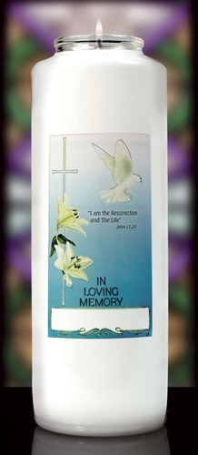**Starts Saturday, November 1st at 5:30 pm**

**And continues through the Sunday Masses**

**Join us in prayer. Light a candle.**

**Reserve a candle in memory of a loved one.**

**Name of Buyer: _______________________________________________**

**Number of Candles: _________ ($10 donation per candle)**

***We will write names on the candles for you. (Please print clearly)***

**Name for Candle ________________________________________________________________________________________**

**Name for Candle ________________________________________________________________________________________**

**Name for Candle ________________________________________________________________________________________**

**Name for Candle ________________________________________________________________________________________**

**Reserve Your Candles:**

* **Online at stphilipfc.org Or use the QR Code below***Please note: Online candle reservations will end Friday, October 31, at noon*
* **In the Rectory Office**

**“Let us not hesitate to help those who have died   
and to offer our prayers for them.”**

*Pick up your candles in hallway starting November 3.

**Iglesia Católica San Felipe**

**Misas del día de los Difuntos**

**Comienza el sábado 1 de noviembre a las 5:30 pm**

**y continúa durante las Misas Dominicales.**

**Acompáñenos en oración. Encienda una vela.**

**Reserve una vela en memoria de un ser querido.**

**Nombre del Comprador: _____________________________________**

**Cantidad de Velas: _________ ($10 donación por vela)**

***Nosotros escribiremos los nombres en la vela. (Por favor escriba claro)***

**Nombre para la vela____________________________________________________________________________________**

**Nombre para la vela ____________________________________________________________________________________**

**Nombre para la vela___________________________________________________________________________________**

**Nombre para la vela____________________________________________________________________________________**

**Reserve Sus Velas:**

* **En Line en stphilipfc.org. O use el código QR**

*Por favor tome nota: Las reservaciones en línea terminan el viernes 31, de octubre al medio día*

* **En la Oficina de la Rectoría**

**“No dudemos en ayudar a los que han fallecido**

**y ofrecer nuestras oraciones por ellos.”**

*Recoja su vela en el pasillo a partir de noviembre 3.