WEEKLY MENU

WEEK 2 | MONDAY | TUESDAY | WEDNEDAY | THURSDAY | FRIDAY
BREAK  FAST | - Selection of cereals  - Kiwi  - Toast with various toppings | - Selection of cereals  - Orange  - Toast with various toppings | - Selection of cereals  - Banana  - Toast with various toppings | - Selection of cereals  - Apple  - Toast with various toppings | - Selection of cereals  - Pear  - Toast with various toppings
SNACK | - Fruit platter with milk or water | - Vegetable platter with milk or water | - Fruit platter with milk or water | - Vegetable platter with milk or water | - Fruit platter with milk or water
LUNCH | - Persian Saffron Chicken with Rice | - Persian Khoreshte Bamieh with Rice  (Okra with lamb stew) | - Creamy Broccoli Pasta | - Vegetable Biryani | 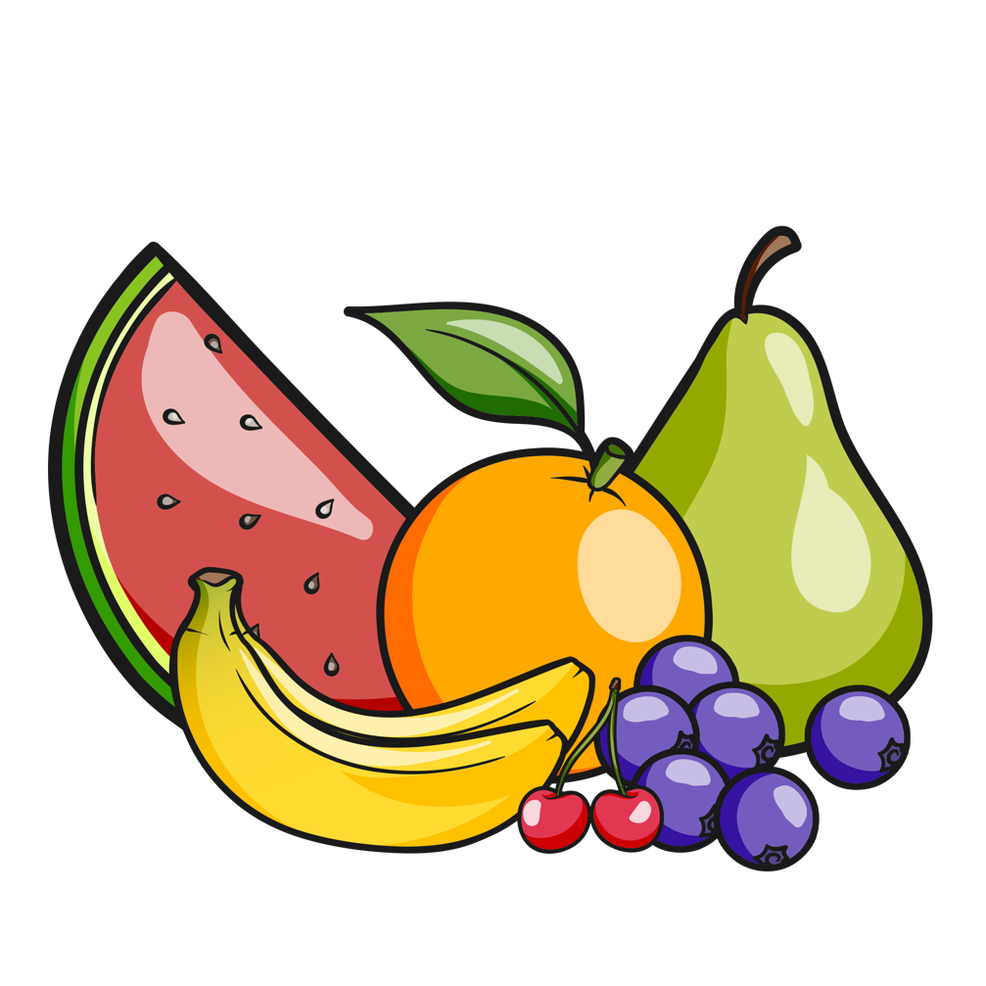  - Persian Sabzi Polo with Fish  (Herbed rice with fish)
SNACK | - Rice cakes with cheese  - Fruit platter | - Breadsticks with hummus  - Fruit platter | - Cheese with tomato  - Fruit platter | - Bagels with Philadelphia  - Fruit platter | - Carrot sticks with hummus  - Fruit platter
TEA & PUDDING | - Ravioli | - Tomato Soup | - Tuna Pasta | - Chicken Wrap | - Beans on toast with cheese

