WEEKLY MENU
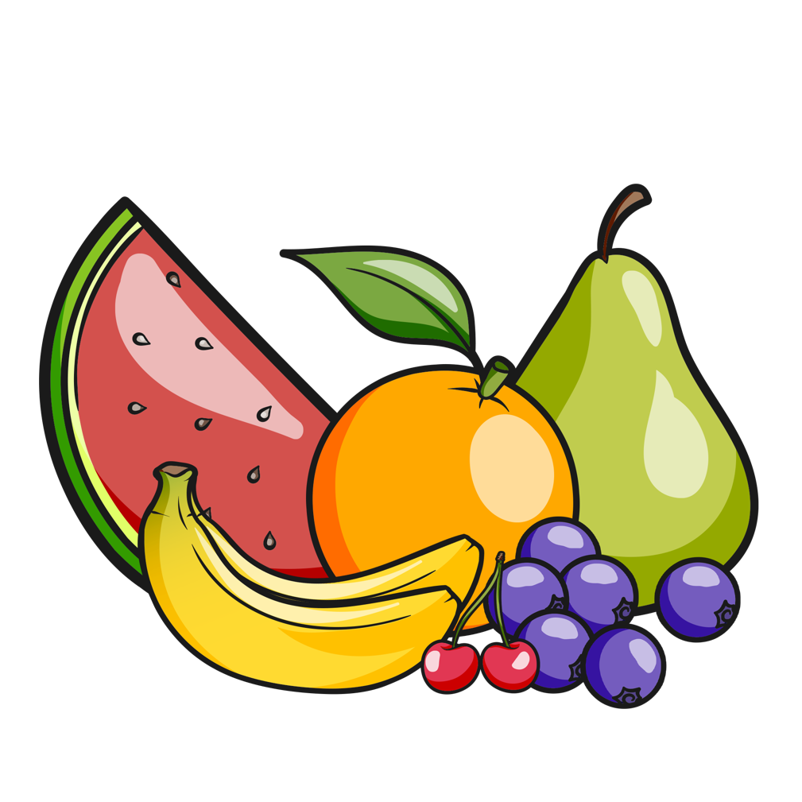
WEEK 1 | MONDAY | TUESDAY | WEDNEDAY | THURSDAY | FRIDAY
BREAK  FAST | - Selection of cereals  - Banana  - Toast with various toppings | - Selection of cereals  - Apple  - Toast with various toppings | - Selection of cereals  - Pear  - Toast with various toppings | - Selection of cereals  - Orange  - Toast with various toppings | - Selection of cereals  - Kiwi  - Toast with various toppings
SNACK | - Fruit platter with milk or water | - Vegetable platter with milk or water | - Fruit platter with milk or water | - Vegetable platter with milk or water | - Fruit platter with milk or water
LUNCH | - Persian Chelo Goosht  (White rice with kebab) | - Spaghetti Bolognese with garlic bread | - Persian Khoreshte Esfenaj  (Rice and spinach herb stew) | - Chicken noodles with vegetables | - Persian inspired saffron chicken with basmati rice
SNACK | - Rice cakes with cheese  - Fruit platter | - Breadsticks with hummus  - Fruit platter | - Cheese with tomato  - Fruit platter | - Bagels with cheese  - Fruit platter | - Carrot sticks with hummus  - Fruit platter
TEA & PUDDING | - Cous Cous with roasted cod and broccoli | - Chicken Soup | - Fish fingers with beans | - Sweet potato and kale with pita bread | - Tomato Pasta

