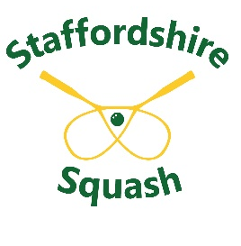
STAFFORDSHIRE SQUASH RACKETS
ASSOCIATION

FUNDING APPLICATION FORM

Project Cost:

Club Contribution:

Funding Amount Applied For:

Project Description:

What squash and racketball projects do you currently run at your facility?

How many squash coaches do you currently have at your facility?

What coach level are they?

WHEN?
Start date
How often
Length of sessions, etc.

WHERE?
Venue
No. of courts at venue
No. of courts needed for project

WHO?
Type of project eg. Junior101
Focus of activity
(age and gender)

HOW?
Names of coaches
Coach levels
Volunteers names

EQUIPMENT BEING USED?
Rackets, balls, goggles, etc.
EQUIPMENT NEEDED?
Rackets, balls, goggles, etc.
State quantity of any items needed

TARGETS?
Number of people planned to take part

FOLLOW UP
How will success be measured and what are the long-term goal

- For assistance with applications email our Chair Chris Dawson - squashcoachchris@gmail.com

- Awards will normally be paid AFTER projects have been done

- To be eligible for funding, clubs should be actively supporting Staffordshire Squash initiatives and events

- Participants must be entered on the appropriate England Squash App:

  - Squash 101
  - Junior101
  - Squash57 or
  - Squash Girls Can

