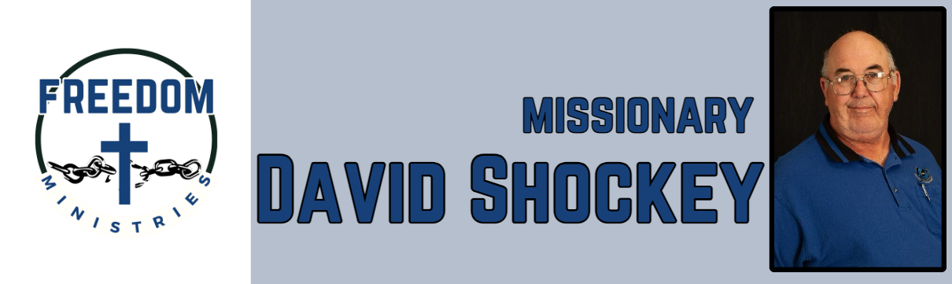
October 2026

This month was another great, busy month of ministry. I was able to make 24 visits into the facilities, including Ester, Telford, Benton, Randall L Williams, Ouachita River, Cummins Mod, Pine Bluff, Hawkins, Magness, Delta Regional. I ministered to over 1300 inmates, through Bible Study, Church Services, and One on One.

I also had the opportunity to attend the Hopewell Association Meeting, North East Texas Baptist Mission Council, and the I filled in at Pleasant Hill MBC in Lockesburg, AR. I also had the chance to share a devotion at Men’s Prayer Breakfast at Nevills Chapel.

I will be ministering at the following facilities and attending the following meetings –
Havins, Randall L Williams, Benton, Arkansas State Meeting, Pine Bluff, Ouachita River, Cummins Mod, Texas State Meeting, Ester, Delta Regional, Varner, Telford.

David Shockey

Sending Church:
Nevill’s Chapel Missionary Baptist Church
PO Box 1334
Mt. Pleasant, TX 75456
Pastor: Shawn Findley
Phone Number:
501-276-8183
Email:
david89440@aol.com
Website:
freedom-ministires.org

