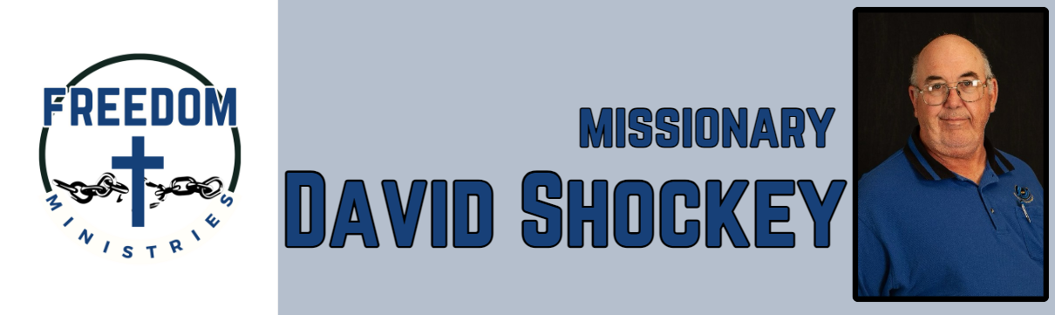 May 2025

God blessed with another great month of ministry, I made 15 visits into the facilities including Hawkins Unit,

Ester Unit, Ouachita River Correctional Unit, Benton Unit, Cummins Mod Unit, Randall L. Williams Correctional Facility,

North Central Unit, and the Cummins Unit.

I ministered to 736 inmates, spent 90.50 hours in the facilities and visiting churches, and traveled 2,586 miles. I also

visited 2 churches, Fellowship MBC in Joaquin, Texas and Oak Grove MBC in Ore City, Texas. At Fellowship I gave a ministry update and

at Oak Grove I presented the ministry.

Some upcoming services/events include:

June 1 – Ouachita River Correctional Unit June 4 – Benton Unit June 14 – Cummins Mod Unit

June 16-20 – American Baptist Association (Springfield, MO) June 22 – Pleasant Hill MBC (Lockesburg, AR)

June 23 – Delta Regional Unit June 29 – Pine Bluff Unit

|  |  |
| --- | --- |
| **Sending Church:**  Nevill’s Chapel MBC  PO Box 1334  Mt. Pleasant, TX 75456  Pastor: Shawn Findley  **Phone Number:**  903-572-5664 church  **Email:**  david89440@aol.com  **Website:**  freedom-ministires.org | David Shockey |
|  |