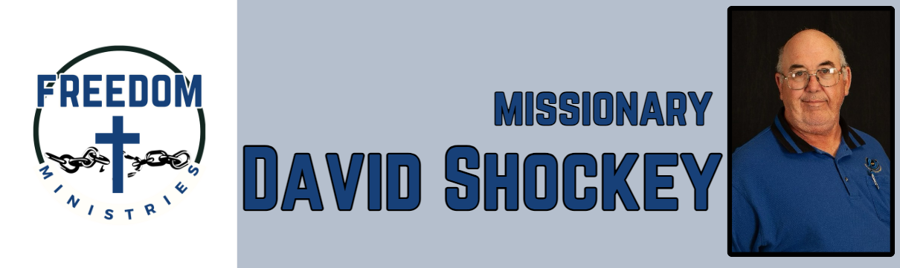 January 2025

|  |  |
| --- | --- |
| **Sending Church:**  Nevill’s Chapel Missionary Baptist Church  PO Box 1334  Mt. Pleasant, TX 75456  Pastor: Shawn Findley  **Phone Number:**  501-276-8183  **Email:**  david89440@aol.com  **Website:**  freedom-ministires.org | 2025 has started off well, I started off by filling in, and training the new Chaplain, at the Delta Regional Unit. I also visited a new (for me) facility, the Barry Telford Unit, in New Boston. Looking forward to ministering at a new facility.  I had the opportunity to speak to the youth a Nevill’s Chapel MBC, I shared about Paul and Silas in jail.  I made 17 visits to the prison, ministering to 675 inmates, spent 85 hours in prison, and traveled 3,078 miles.  I visited the following units – Delta Regional, Hawkins, Ester, Randall L. Williams, Varner, Benton, North Central, Ouachita River, and Barry Telford.  February 6-9, I will be attending the Faith Promise Mission Conference at Nevill’s Chapel MBC.      David Shockey |
|  |