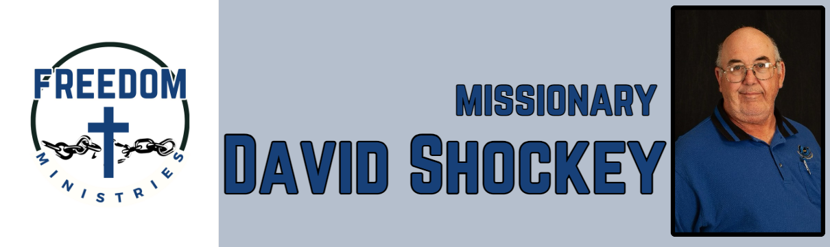 February 2025

|  |  |
| --- | --- |
| **Sending Church:**  Nevill’s Chapel MBC  PO Box 1334  Mt. Pleasant, TX 75456  Pastor: Shawn Findley  **Phone Number:**  903-572-5664 church  **Email:**  david89440@aol.com  **Website:**  freedom-ministires.org | This month continued to be busy, I made 14 visits into the prisons plus I attended the Faith Promise Missions Conference hosted by Nevill’s Chapel MBC.  I visited the following units Hawkins, Ester, Benton, Cummins, Cummins Mod, North Central, Ouachita River.  I spent 79.50 hours ministering to 712 inmates, and traveled 2, 594 miles.  I was also blessed to share a devotion with the Men’s Brotherhood at Nevill’s Chapel MBC.  March will see me attending the MTM Training in Arlington, and the Faith Promise Missions Conference hosted by Creekmont MBC in La Porte.    David Shockey |
|  |