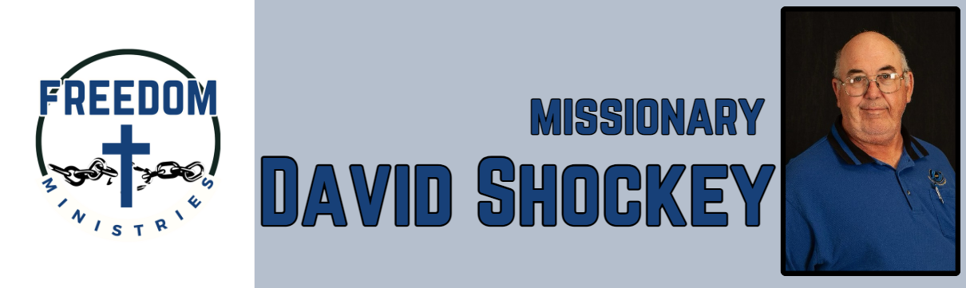 April 2025

And he said unto them, Go ye into all the world, and preach the gospel to every creature. (Mark 16:15). I am so thankful that I get to go and preach the gospel to those who are incarcerated. It is such a privilege and honor. April provided me many opportunities to visit the units and minister. At the Delta Regional Unit, had 1 accept Jesus as Lord and Savior, that was truly a blessing. In addition to visiting the prisons, I also had the opportunity to attend the North Texas Baptist Mission Council in Hughes Springs, Texas. Brother Chris and Hughes Springs MBC were great host, and provided an awesome fish meal with all the fixings.

I would like to say thanks to my ministry partners, I could not do what I do if it was not for your prayers and financial support. So thanks to Nevill’s Chapel MBC, Bethlehem MBC, Fellowship MBC, Union Heritage MBC, Antioch MBC, Pleasant Hill MBC, Hughes Springs MBC, The Catha’s, The Lane’s, The Mattingly Family.

Upcoming services/events –

May 4 – Hawkins Unit May 6 – Ouachita River Correctional Unit May 7 – Benton Unit May 10 – Cummins Mod Unit May 13 – Randall L. Williams Correctional Facility

May 23 – North Central Unit May 24 – Cummins Mod Unit May 25 – Oak Grove MBC (Ore City, TX) May 27 – Cummins Unit

|  |  |
| --- | --- |
| **Sending Church:**  Nevill’s Chapel MBC  PO Box 1334  Mt. Pleasant, TX 75456  Pastor: Shawn Findley  **Phone Number:**  903-572-5664 church  **Email:**  david89440@aol.com  **Website:**  freedom-ministires.org | David Shockey |
|  |