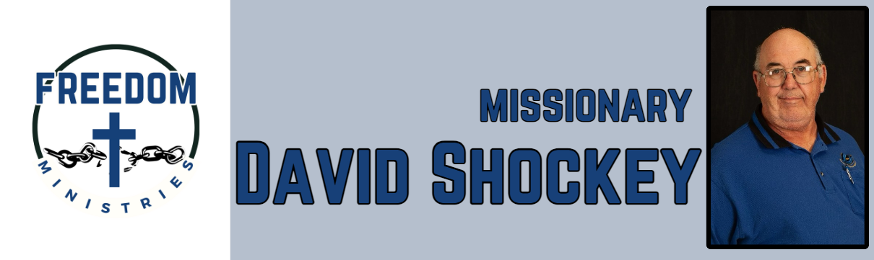
September 2025
This month proved to be another busy month of ministry. I had the blessing of making 18 visits into the prisons, ministered to 970 inmates, and spent 112 hours in the prisons and churches.
I visited the following units – Ester Unit, Benton Unit, Ouachita River Correctional Unit, Central Office, Telford Unit, North Central Unit, Cummins Mod Unit, Hawkins Unit, Delta Regional Unit.
I also had the opportunity to share the ministry with Journey Baptist Church (Alabaster, AL), New Vision Baptist Church (Searcy, AR), and Grace Church (Nash, TX).
Some more blessings occurred at my home and sending church (Nevill’s Chapel), I got ordained, got the chance to preach and share a devotion.
Upcoming services/events in October:
1 – Benton Unit 4 – Cummins Mod 5 – Ester Unit 6-10 – MTM (Mtn. View, AR) 12 – Pleasant Hill MBC (Lynn, AR) 17 – Hawkins Unit 19 – Sublett Road MBC (Arlington, TX)
20 – Delta Regional Unit 24 – North Central Unit 25 – Cummins Mod Unit 28 – Randall L Williams Correctional Facility 30 – Cummins Unit

Sending Church:  Nevill’s Chapel MBC  PO Box 1334  Mt. Pleasant, TX 75456  Pastor: Shawn Findley  Phone Number:  903-572-5664 church  Email:  david89440@aol.com  Website:  freedom-ministires.org | David Shockey

