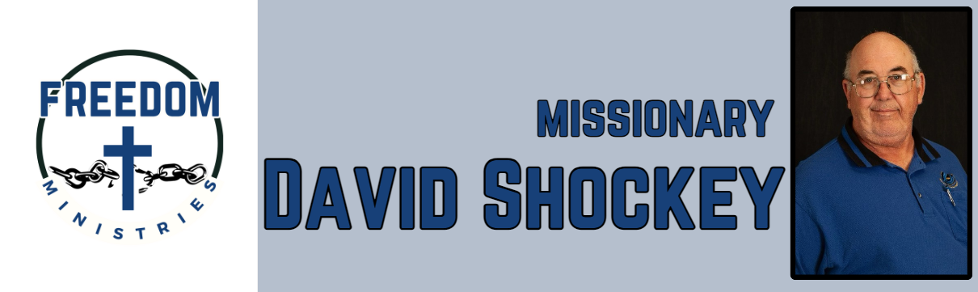
October 2025
God is good all the time and all the time God is good. It was another great month of ministry inside and outside of prison. I am so thankful for the doors and opportunities that He has opened for me in prison and in churches. This month I was able to make 13 visits into the prison, spent 84 hours, ministering to inmates and sharing the ministry in churches. I was able to minister to 765 inmates and travel 3,446 miles.
I was blessed to be able to attend MTM (Module 3) in Mountain View, attend the Hopewell Association Meeting in Pittsburg, and share the ministry with Sublett Road MBC in Arlington. Some upcoming services/events include the Arkansas, Louisiana, and Texas State Meetings, Harris Chapel MBC (Mt. Pleasant), Magness MBC (Magness), Pleasant Hill MBC (Lynn), Havins Unit (Brownwood).

Sending Church:  Nevill’s Chapel MBC  PO Box 1334  Mt. Pleasant, TX 75456  Pastor: Shawn Findley  Phone Number:  903-572-5664 church  Email:  david89440@aol.com  Website:  freedom-ministires.org | David Shockey

