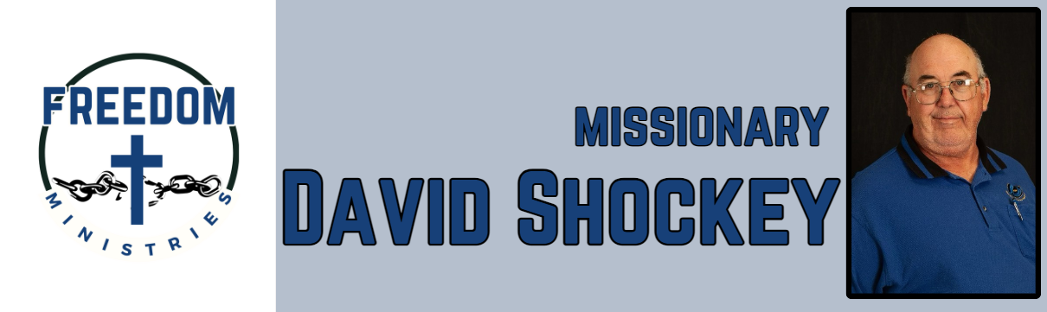
November 2025
God continues to bless me and the ministry. I was able to make 15 visits to the facilities, which included Hawkins, Ester, Delta Regional, Benton, Cummins Mod, Ouachita River Correctional, Havins, Pine Bluff, and Telford. I spent 91.75 hours in the prison, churches, and meetings. I ministered to 508 inmates. I also had the opportunity to attend the Arkansas, Louisiana, and Texas State Meetings, with the chance to share the ministry. I also had the opportunity to share the ministry with Magness MBC, Pleasant Hill MBC, and Harris Chapel MBC.

Upcoming Services/Events –
December 4 – Benton Unit December 7 – Ten Mile MBC December 13 – Cummins Mod December 23 – Pine Bluff Unit December 26 – North Central Unit December 27 – Cummins Mod December 28 – Ester Unit (am) Benton Unit (pm) December 30 – Pine Bluff Unit

Sending Church:  Nevill’s Chapel MBC  PO Box 1334  Mt. Pleasant, TX 75456  Pastor: Shawn Findley  Phone Number:  903-572-5664 church  Email:  david89440@aol.com  Website:  freedom-ministires.org | David Shockey

