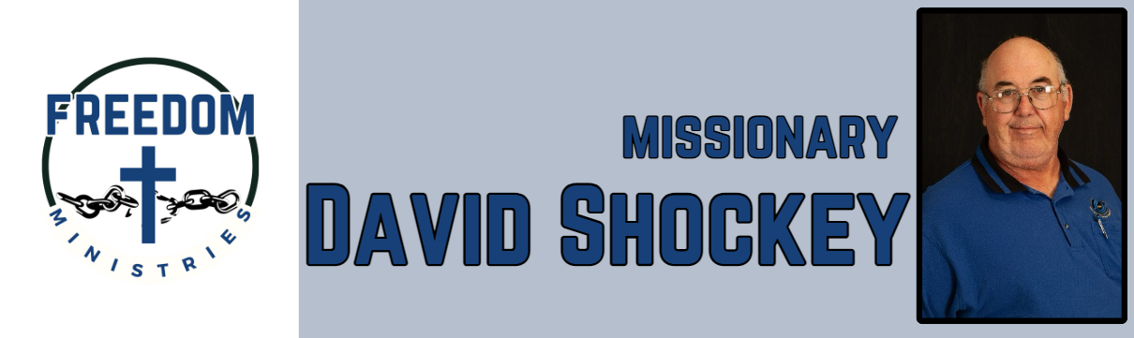
May 2026
Sending Church:  Nevill’s Chapel MBC  PO Box 1334  Mt. Pleasant, TX 75456  Pastor: Shawn Findley  Phone Number:  903-572-5664 church  Email:  david89440@aol.com  Website:  freedom-ministires.org | May was another great month of ministry. I was blessed to visit 16 times in the facilities, including the Hawkins Unit, Ester Unit, Benton Unit, Cummins Mod Unit, Ouachita River Correctional Unit, Randall L Williams Correctional Facility, Varner Unit, Magness Unit, and Telford Unit.  I spent 67.50 hours, ministering 775 inmates and traveled 2742 miles, I was blessed to have my pastor with me at the Telford Unit. I am blessed to have a great sending church and pastor.  Some upcoming events include Faith MBC (Ozark, AR), American Baptist Association Meeting (Hot Springs), along with visits to the units. If you are attending the ABA Meeting, make sure you stop by our booth. Also visit the ABA Media and Nevill’s Chapel Facebook pages to view the newest promo video.  David Shockey

