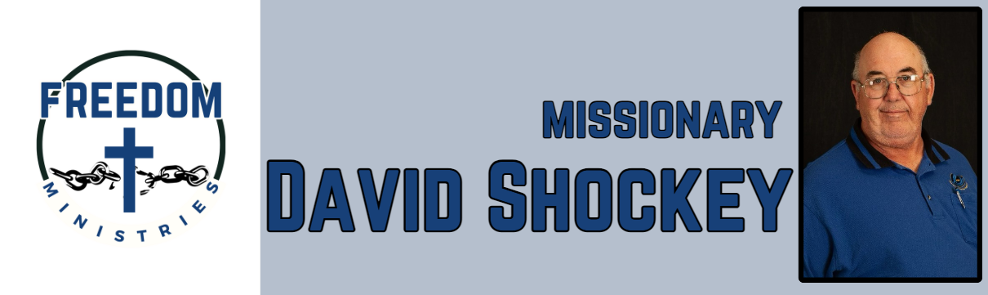
March 2026
Sending Church:  Nevill’s Chapel MBC  PO Box 1334  Mt. Pleasant, TX 75456  Pastor: Shawn Findley  Phone Number:  903-572-5664 church  Email:  david89440@aol.com  Website:  freedom-ministires.org | God continued to bless me and the ministry. This month I was blessed to complete MTM in Arlington. This ministry (MTM) is a real blessing and help. I am thankful that I was able to get this much needed help. I was also blessed to make 12 visits into the prisons, which included Ester, Benton, Cummins Mod, Hawkins, Ouachita River, Delta Regional, Pine Bluff, and Magness Units.  I traveled 2,170 miles, to spend 65 hours, to be able to minister to 477 inmates. I also had the opportunity to share a devotion, at my home church, at our Men’s Brotherhood.  Upcoming services/events include Benton Unit, Ester Unit, Union Heritage MBC (LA), Bible Baptist (LA), Delta Regional Unit, Eastside MBC, Magness Unit, Crestview MBC (TX), NE Texas Baptist Mission Council.  David Shockey

