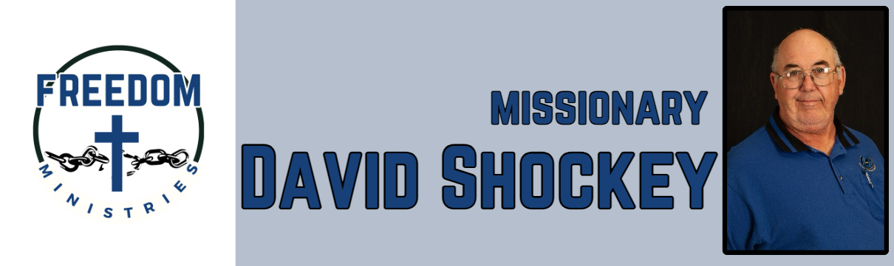
June 2026
Sending Church:  Nevill’s Chapel MBC  PO Box 1334  Mt. Pleasant, TX 75456  Pastor: Shawn Findley  Phone Number:  903-572-5664 church  Email:  david89440@aol.com  Website:  freedom-ministires.org | O give thanks unto the Lord; for he is good: for his mercy endureth for ever. (Ps. 118:29). God continued to bless me and the ministry. I was blessed to make several visits to the facilities, minister to several inmates and had 1 salvation,  In addition to visiting the prison, I also had the blessing of sharing the ministry with Faith MBC (Ozark, AR) and the American Baptist Association 100th Meeting (Hot Springs). I also completed some training at the Telford Unit.  Looking forward to sharing the ministry with more churches, made some good contacts at the ABA Meeting. Some of my upcoming services/events include Telford, Havins, Hawkins, Benton, Ester, Delta, Varner, Cummins, Magness, and PTF.  David Shockey

