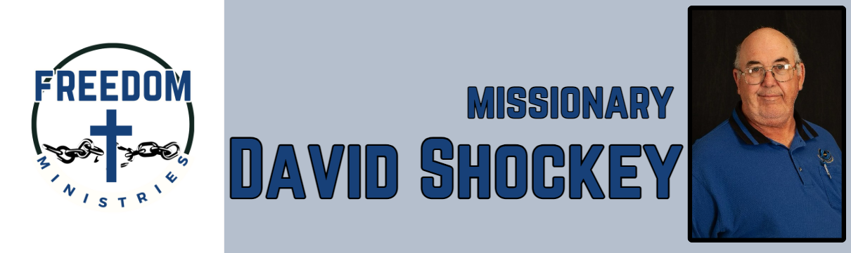 June 2025

|  |  |
| --- | --- |
| **Sending Church:**  Nevill’s Chapel MBC  PO Box 1334  Mt. Pleasant, TX 75456  Pastor: Shawn Findley  **Phone Number:**  903-572-5664 church  **Email:**  david89440@aol.com  **Website:**  freedom-ministires.org | June was another good month, I was able to make 12 visits into the prisons including Ouachita River Correctional Unit, Benton Unit, Ester Unit, Telford Unit, and the Delta Regional Unit.  I ministered to 479 inmates, spent 81.50 hours in prison, churches, and meetings, and traveled 2,586 miles. I also had the opportunity to visit 2 churches (Bethlehem MBC and Pleasant Hill MBC) to give a ministry update and preach a message.  I also was able to attend the American Baptist Association in Springfield, Missouri, talked to several people and got 3 ministry appointments.  Some upcoming services/events include –  July 2 – Benton Unit, July 9 – Telford Unit, July 10 – Ouachita River Corr. Unit, July 12 – Cummins Mod Unit, July 15-21 – Antioch MBC (Dexter, Maine), July 22 – Randall L. Williams Corr. Fac., July 25 – North Central Unit, July 27-30 – Mission Conference (Thomas, Louisiana)  David Shockey |
|  |