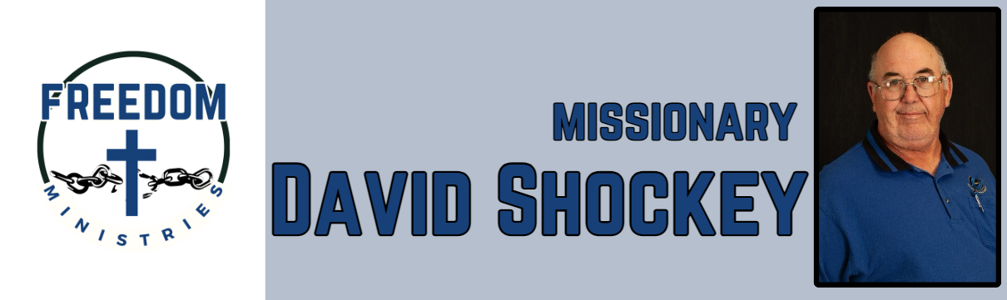
July 2026
Sending Church:  Nevill’s Chapel MBC  PO Box 1334  Mt. Pleasant, TX 75456  Pastor: Shawn Findley  Phone Number:  903-572-5664 church  Email:  david89440@aol.com  Website:  freedom-ministires.org | The Lord blessed me with another great month of ministry. I am so thankful for my sending church and ministry partners, because of your support I was able to make 25 visits to the prisons, including Telford, Havins, Ester, Hawkins, Varner, Magness, Pine Bluff, Benton, Cummins Mod, Delta Regional, Cummins, and Pathway to Freedom. I spent 109.50 hours, ministering to 1384 inmates and traveled 4152 miles.  Upcoming services/events include Pathway to Freedom, Benton, Magness, Ouachita River, Ester, Delta Regional, Cummins Mod, Telford, Pine Bluff, Creekmont MBC, and Pleasant Hill MBC.  David Shockey

