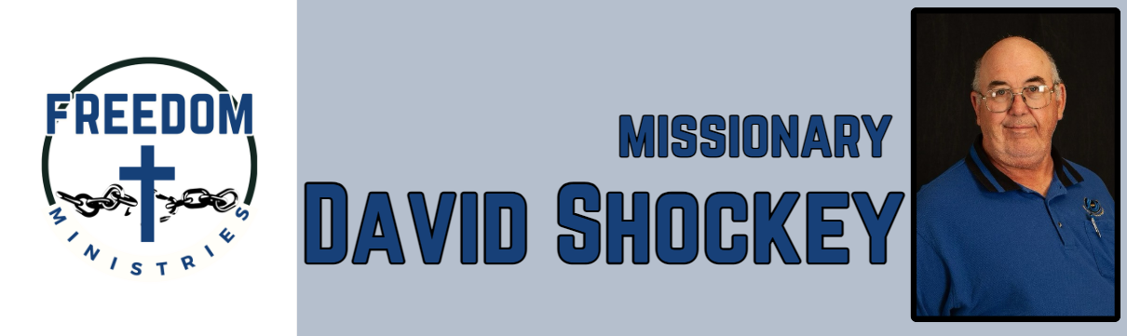 July 2025

|  |  |
| --- | --- |
| **Sending Church:**  Nevill’s Chapel MBC  PO Box 1334  Mt. Pleasant, TX 75456  Pastor: Shawn Findley  **Phone Number:**  903-572-5664 church  **Email:**  david89440@aol.com  **Website:**  freedom-ministires.org | God is good, all the time and all the time God is good. He truly blessed with another great month of ministry. I was blessed to make 9 visits into the facilities, spent 68.25 hours, ministering to 463 inmates and traveled 2376 miles.  I also had the privilege to visit Antioch MBC in Dexter, Maine for the Northeast Assoc. Meeting, also got to see my first church organization. I was able to share a ministry update with them. I also had the privilege to attend a mission conference/revival at Bible Baptist Church in Franklinton, Louisiana.  While in Louisiana, I was able to share the ministry and my testimony, witnessed 6 young people get baptized, and heard what God is doing in Mexico, Phillipines, and Honduras.  Upcoming services/events – August 1 – Hawkins Unit August 3 – Telford Unit August 5 – Ouachita River Correctional Unit August 6 – Benton Unit August 9 – Cummins Mod Unit August 10 – Oak Grove MBC (Benton) August 11 – Delta Regional Unit August 17 – Telford Unit August 22 – North Central Unit August 24 – Havins Unit August 31 – Pine Bluff Unit  David Shockey |
|  |