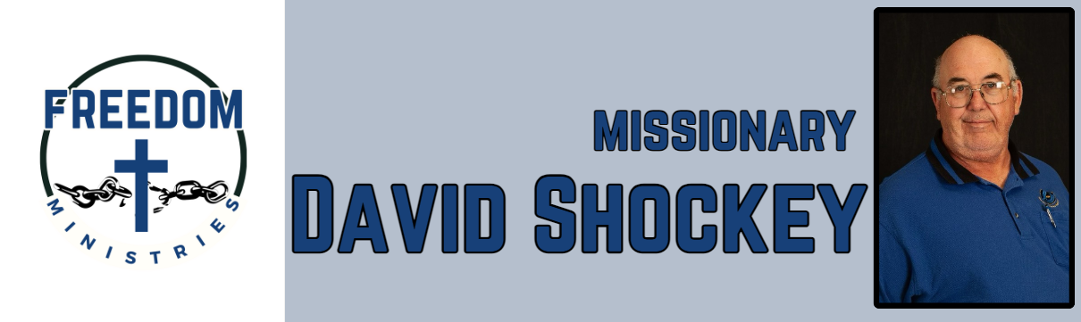
January 2026
Sending Church:  Nevill’s Chapel MBC  PO Box 1334  Mt. Pleasant, TX 75456  Pastor: Shawn Findley  Phone Number:  903-572-5664 church  Email:  david89440@aol.com  Website:  freedom-ministires.org | Despite the winter storm limiting my travels, still had a great month of ministry. I was blessed to see 1 salvation, at the Telford Unit, following a great message preached by my pastor. I also gained another ministry partner, thanks Sublett Road MBC for voting to partner with the ministry.  I was blessed to make 7 visits to the facilities, including the Benton Unit, Pine Bluff Unit, Ester Unit, Delta Regional Unit, and the Telford Unit. I also was blessed to visit Hughes Springs MBC to give a ministry update and to preach.  I spent 29.50 hours in prison and church, ministering to 393 inmates and traveled 1364 miles.  Upcoming services/events include Benton Unit, Unity MBC (Hattiesburg, MS), Ebenezer MBC (Wiggins, MS), Flatwoods MBC (Mtn. View, AR), Magness Unit, Ouachita River Correctional Unit, Hawkins Unit, Delta Regional Unit, and Nevill’s Chapel MBC (Mt. Pleasant, TX)* * Faith Promise Mission Conference  David Shockey

