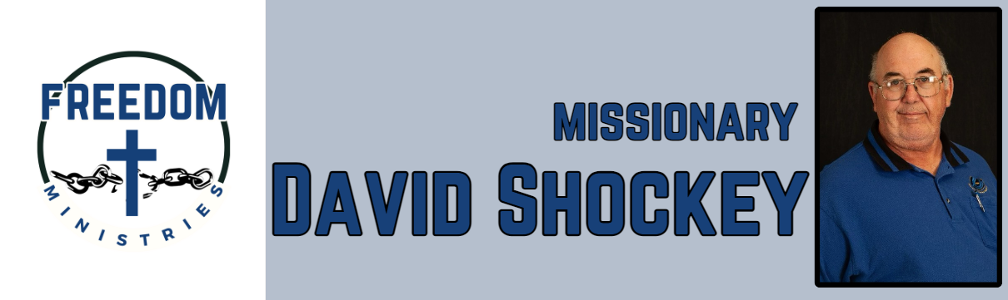
February 2026
Sending Church:  Nevill’s Chapel MBC  PO Box 1334  Mt. Pleasant, TX 75456  Pastor: Shawn Findley  Phone Number:  903-572-5664 church  Email:  david89440@aol.com  Website:  freedom-ministires.org | This was another busy and blessed month of ministry. I was blessed to make 11 visits into the prison, including the following units – Ester, Pine Bluff, Benton, Telford, Ouachita River, Magness, Hawkins, and Delta Regional.  I spent 67 hours in the prison and churches, ministered to 415 inmates and traveled 3,394 miles. I was also blessed to visit the following churches to share the ministry – Unity MBC in Hattiesburg, Ms, Ebenezer MBC in Wiggins, Ms, and Flatwoods MBC in Mountain View, Ar.  Also blessed to attend the Faith Promise Mission Conference, at my sending church (Nevill’s Chapel MBC). Here is some upcoming services/events – Benton Unit, Hawkins Unit, Cummins Mod, Ouachita River Corr. Unit, Ester Unit, Delta Regional Unit, Magness Unit, Telford Unit, Pine Bluff Unit, and MTM.  David Shockey

