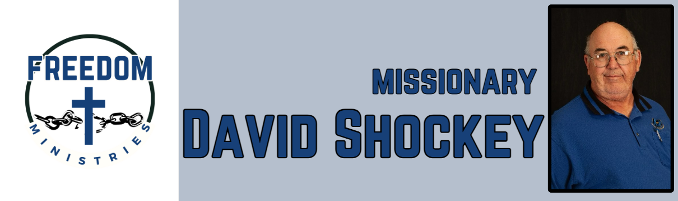
December 2025

Praise the Lord! He blessed with another great month of ministry. I was blessed with the opportunity to make 17 visits, into the units, including the Benton Unit, Telford Unit, Delta Regional Unit, Cummins Mod Unit, Ester Unit, and Pine Bluff Unit. I ministered to 662 inmates, while spending 56.75 hours sharing in prison and churches. I was blessed to share a devotion at my home church, and I was able to visit Fellowship MBC in Joaquin, to give a ministry update, and Ten Mile MBC in Benton to share the ministry. I traveled 2904 miles for the month.

Upcoming services/events:
January 6 – Pine Bluff Unit January 7 – Benton Unit January 12 – Delta Regional Unit January 14 – Hughes Springs MBC January 18 – Telford Unit (am) January 18 – Benton Unit (pm) January 20 – Pine Bluff Unit January 23 – North Central Unit
January 25 – Union Heritage MBC January 29 – Ouachita River Correctional Unit

Sending Church – Nevill’s Chapel MBC
P.O. Box 1334
Mt. Pleasant, TX 75456
Shawn Findley – Pastor

Freedom Ministries
P.O. Box 3375
Hot Springs, AR 71914

