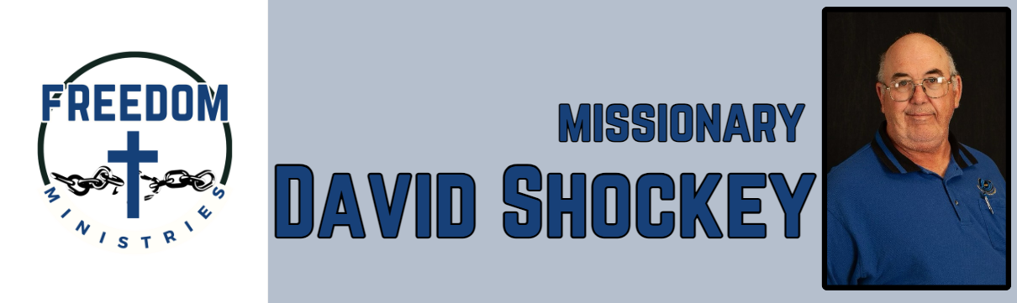 August 2025

|  |  |
| --- | --- |
| **Sending Church:**  Nevill’s Chapel MBC  PO Box 1334  Mt. Pleasant, TX 75456  Pastor: Shawn Findley  **Phone Number:**  903-572-5664 church  **Email:**  david89440@aol.com  **Website:**  freedom-ministires.org | Praise God! I am thankful He called me into Prison Ministry. He continues to open doors and opportunities to share the Word and ministry. I was blessed with another church partnering with us, thank you Bible Baptist Church.  I was blessed with the opportunity to make 17 visits into the facilities, including Hawkins Unit, Telford Unit, Ester Unit, Ouachita River Correctional Unit, Benton Unit, Cummins Mod Unit, Delta Regional Unit, North Central Unit, Havins Unit, Pine Bluff Unit. I spent 78.25 hours ministering to 1086 inmates, and traveled 3,580 miles. I was blessed to have my pastor go to the Telford Unit with me.  Upcoming services/events  September 2 – Ester Unit September 3 – Benton Unit September 7 – Ouachita River Correctional Unit September 14 – Journey MBC (Alabama) September 21 – New Vision MBC (Searcy) September 26 – North Central Unit September 27 – Cummins Mod Unit September 28 – Hawkins Unit September 29 – Delta Regional Unit  David Shockey |
|  |