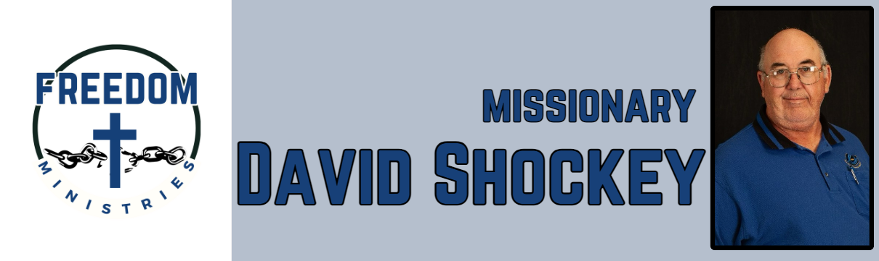
April 2026
Sending Church:  Nevill’s Chapel MBC  PO Box 1334  Mt. Pleasant, TX 75456  Pastor: Shawn Findley  Phone Number:  903-572-5664 church  Email:  david89440@aol.com  Website:  freedom-ministires.org | Also I heard the voice of the Lord, saying, Whom shall I send, and who will go for us? Then said I, Here am I; send me. (Isa. 6:8). I am so thankful and blessed that I said send me.  I was blessed to make 9 visits into the prisons, including Benton, Delta Regional, Magness, Ester, Telford. I spent 55 hours in the prisons and churches, I ministered to 313 inmates.  I visited 4 churches including Union Heritage MBC, Bible Baptist, Eastside MBC, and Crestview MBC. I also shared a devotion with 2 groups at my home church (Mens Brotherhood and Young at Heart).  May will see me at Hawkins, Benton, Cummins Mod, Delta, Ouachita River, Telford, Randall L Williams, Magness, Varner.  David Shockey

