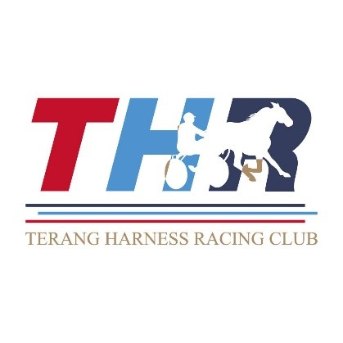

TERANG HARNESS RACING CLUB INC
MEMBERSHIP 2026

The Terang Harness Racing Club (THRC) welcomes all those who wish to apply for membership.

The THRC Committee has decided the 2026 membership fee is $50.

We invite you to renew your Membership of the Terang Harness Racing Club Inc for 2026; you will receive a 2026 Trots Card and an annual guest pass in the form of another Trots Card. The Trots Card entitles you to attend most Victorian Trots Meetings for the 2026 season, all THRC race meetings and voting rights at the AGM.

There are 2 tiers of payment for track use:
- casual defined as no more than twice a week at $150 gst incl and
- resident trainer $250 gst incl.

Participants are reminded that they are required to be a member of the Club and paid track user to use the track for training purposes. Please include the appropriate track fees and membership fee with your payment.

Please see below membership form and payment options. You are welcome to either fill out the form and return it to the office in person or post (cash and cheque can be received) or complete your payment online.

Thank you for your support of the Terang Harness Racing Club and Harness Racing and we look forward to enjoying another season of racing with you.

TERANG HARNESS RACING CLUB INC
MEMBERSHIP 2026

TROTS CARD APPLICATION & RENEWAL FORM
INCLUDING FEES PAYABLE BY TRACK USERS

Title (Please circle) Mr. Mrs. Ms. Other
Surname: |  | Given Name/s:
Address:
Town: |  |  | Postcode:
Phone: |  | Mobile:
Email:
- Please include your email address so that the Club can distribute relevant information.

MEMBERSHIP OPTIONS |  |  |  | Please tick ONLY ONE option
1 | Membership Renewal 2026 |  | Membership Card + Yearly Guest Pass | $50 GST Incl
 | Membership New 2026 |  | Membership Card + Yearly Guest Pass | $50 GST Incl
2 | Membership/Casual Track User 2026 |  | Membership Card + Yearly Guest Pass | $200 GST Incl
3 | Membership/Resident Track User 2026 |  | Membership Card + Yearly Guest Pass | $300 GST incl.
 |  |  |  | TOTAL DUE: | $

Please tick payment option:
 | Online | Online | www.teranghr.com.au
 | Direct Debit | Terang Harness Racing Club  National Australia Bank | BSB 083 884  Account No: 51 602 9955 | Please use reference: (SurnameInitial) e.g. SMITHJ
 | Cheque | Payable to Terang H.R.C.
 | Cash/Eftpos | Payable at the office

Please return this Application Form irrespective of your method of payment to
Email teranghr@bigpond.net.au | Post:  Terang Harness Racing Club  P.O. Box 54  Terang 3264

