October 4, 2026

Welcome to Union this morning! This morning we will begin our worship service with baptism and then worship of our Savior and Lord through song, followed by a message about something that will make us more aware of how we use it. - Bro. Mark

THIS WEEK AT UBC
10/04 Today 9:00am Sunday School
10:00am Worship Service
11:15am Directory Pictures
11:30am Homecoming Com. Mtg.
1:00pm Archery
5:00pm MBA Annual Mtg.

10/06 Tuesday 8:00am Coffee Fellowship
6:00pm WMU

10/07 Wednesday 4:30pm Archery
6:00pm Midweek Bible Study
6:50pm Choir Practice

10/08 Thursday 10:00am Nominations Mtg
3:00pm By Laws Com. Mtg.
6:30pm Youth Pastor Search Mtg.

10/09 Friday Office Closed

10/10 Saturday 10:00am Homecoming Com. Mtg.
5-8:00pm Youth Bon Fire
Today’s Nursery Workers:
Cheyanne O., Tonette M. & Marilyn M.
Next week Nursery Workers:
Michele S. & Terri G.
October 18th Nursery Workers:
Cheyanne O., Marlo D. & Alex H.
Union Baptist Church
5151 Grand Bay Wilmer Rd. S.
Grand Bay, AL. 36541
“In Christ’s Service Since 1868”
Website: www.ubcgrandbay.org
Email: ubcgrandbay@outlook.com
Bro. Mark’s Email: brothermark1967@gmail.com
Church Staff
Brother Mark Griffin – Pastor 251-404-6236
Tim Herring – Worship Pastor 251-599-8264
Helen Hines – Children’s Director 251-802-0755
Erica Hines – Secretary (Church Phone) 251-257-9532
Linda Nelson – Pianist 251-510-5322
Lori Hines – Organist
Bright Beginnings Preschool Ministry 251-257-8556
Deacon of the Week: Sterling Hines 251-459-2623

Sunday, September 27, 2026
Attendance: Worship – 135, Sunday School – 68

Weekly Budget Deposit: $6,638.00
Food Pantry: $360.00
Archery: $80.00
Myers-Mallory: $250.00
Children’s Ministry: $90.00
Backpack Ministry: $100.00
Samaritans Purse: $250.00
Online Giving: $544.12

Current Needs at UBC
Operation Christmas Child (Samaritans Purse)
A paper with “gift suggestions” will be in the foyer in the CLC.
Staying in the Know at UBC
Tech & Media Help Needed:
UBC is looking for some people interested in helping with our tech & media teams, specifically some extra people, to help work the sound board and slides during our services on Sunday mornings and Wednesday nights. If interested, see Brett Matthews or Glenn Wallace. We are also in need of some people to help with our social media presence as well (Website, Facebook, etc…) If interested please see Melissa Wallace or Jeannie Flowers.
On the Horizon at UBC
Homecoming at UBC
Save the Date: Sunday, October 18th, 2026 will be the 158th year of being a light for the gospel in the Union Community. We will have a special service that day along with lunch.
Discipleship Classes:
The “One Accord” Bible study Class - Tuesdays @ 9:15am - Subject: Prayer
Begins 10/13/26 - Leader: Melissa Wallace, Book cost is $5.00. Sign-up sheet is in CLC and sanctuary foyers.
“Master Life” Study – Sundays @ 4:00pm – Subject: Spiritual Growth Basics
Begins 11/1 – Leader: Bro. Mark Griffin, Book cost is $15.00. Sign up sheet for interest will be available 10/11/26
Morning Worship
Call to Worship: Linda Nelson
“I Will Bless the Lord”

Observance of Baptism
Lauren Anderson & Camille Smith

Hymn: Congregation
“A Mighty Fortress is Our God”
Pg. 656

Greetings & Announcements: Bro. Tim Herring
Song: Congregation
“Amazing Grace (My Chains are Gone)”

Song: Tim Herring, Tonette Mills &
Congregation
“Holy Forever”
Offertory Hymn: Congregation
“It is Well”
Pg. 447 vs 1, 3 & 4

*Children dismissed to Children’s Church
4 years to 2nd grade meet by the piano*

Offertory Prayer: Sterling Hines
Offertory Special: Linda Nelson
“Be Still, My Soul”

Today’s Message: Bro. Mark
“In the Meantime”
James 5:7-12
Invitation Song: Congregation
“As the Deer”
Benediction:
Postlude: Linda Nelson
Sermon Notes

Aim: This morning we want to answer four questions about waiting.

- When is it that we are waiting for?
- How does waiting affect us?
- What should we do and not do while we are waiting?
Who are some good examples for us and why?

“But they who wait for the Lord shall renew their strength;
they shall mount up with wings like eagles; they shall run and not be weary;
they shall walk and not faint.” Isaiah 40:31 (ESV)
Union Baptist Church
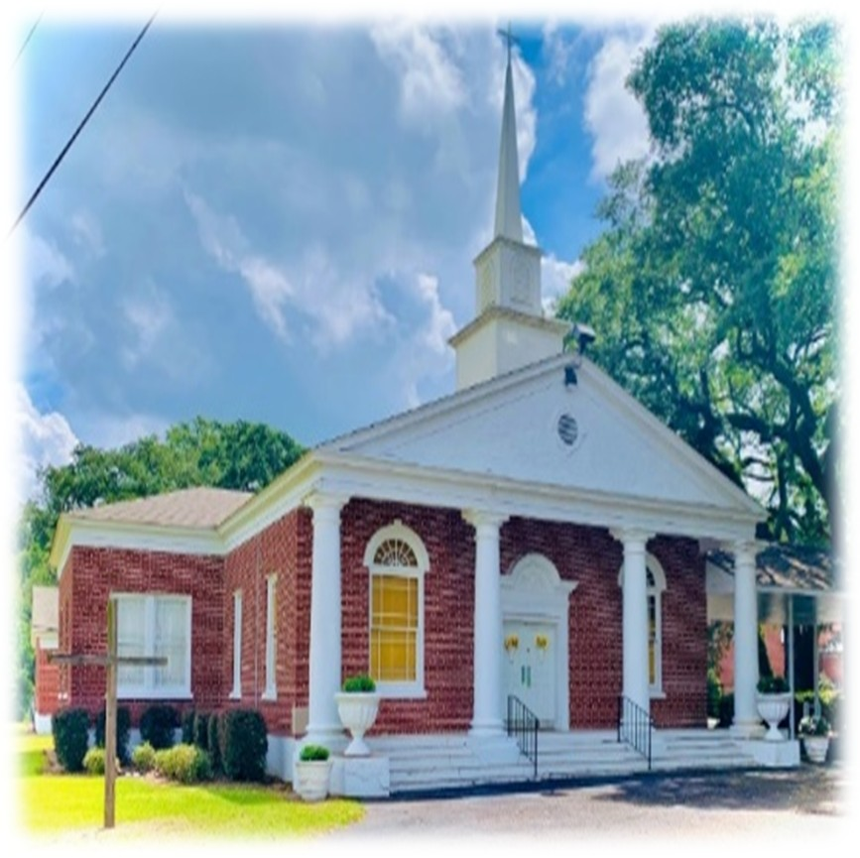

October 4, 2026

