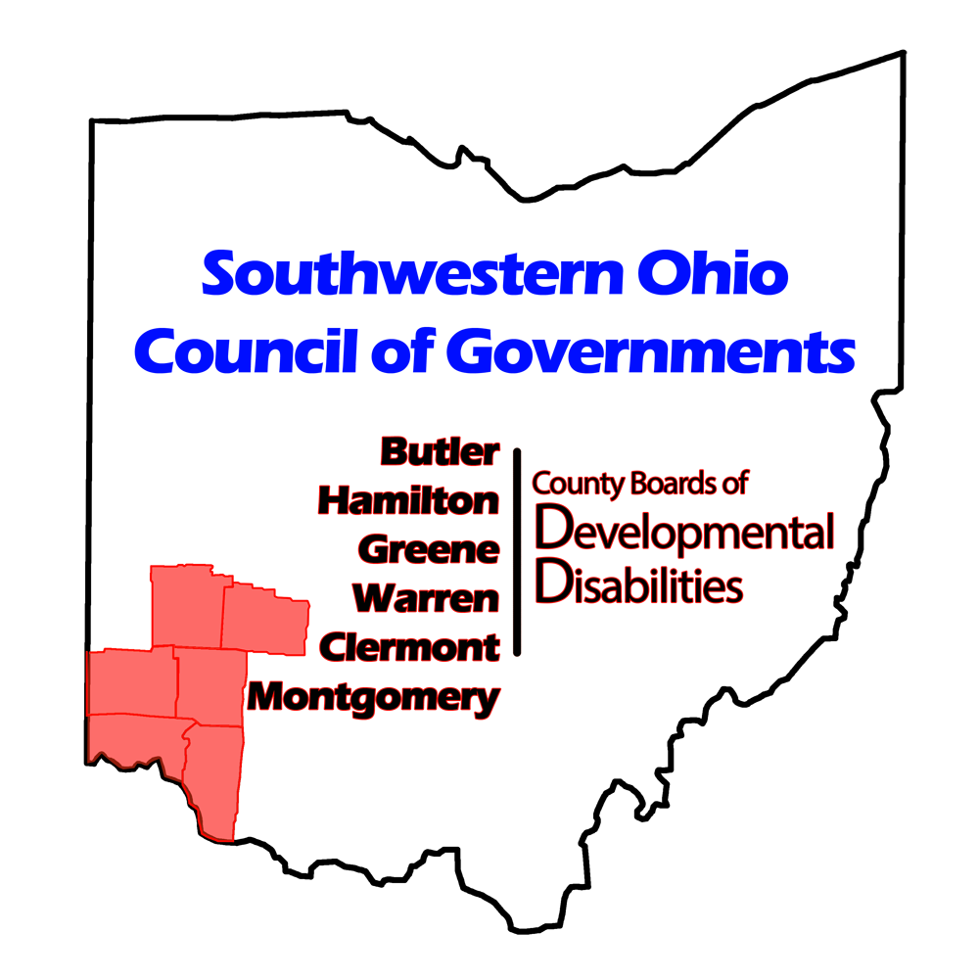

**ANNUAL REPORT**

**2024**

## Vision Statement

SWOCOG will be the center of excellence in Southwestern Ohio for **regional supports** to people with developmental disabilities and their stakeholders who support them.

## Mission Statement

To provide support and solutions to county boards of developmental disabilities through cost effective shared services that deliver value, satisfaction, and maximization of resources.

## Core Values

* Mutual Respect
* Personal Responsibility
* Collaboration and Teamwork
* Commitment
* Innovation
* Integrity and Trust

## Board Members

* John LaRock, (President), Superintendent of the Greene County Board of Developmental Disabilities
* Megan Manuel, (Vice-President), Superintendent of the Warren County Board of Developmental Disabilities
* Dan Ottke, (Secretary/Treasurer), Superintendent of the Clermont County Board of Developmental Disabilities.
* Pamela Combs, Superintendent of the Montgomery County Board of Developmental Disabilities Services
* Leia Snyder, Superintendent of the Hamilton County Developmental Disabilities Services
* Lee Ann Emmons, Superintendent of the Butler County Board of Developmental Disabilities

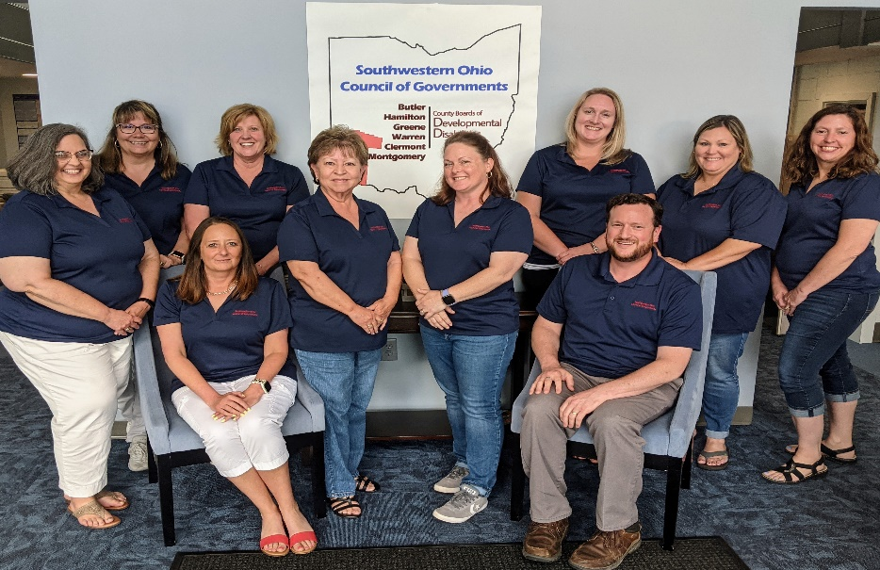

## Operating Highlights

* Two full-time positions were added to the Table of Organization: Multi-System Coordinator and a Service and Support Administrator.
* At the end of 2024, SWOCOG had 19 full-time employees and one part-time employee.
* Besides the six-member counties boards, SWOCOG contracted with twenty-three other entities to support the needs of the counties.
* SWOCOG contracted with the Clark County Board of Developmental Disabilities to provide Service and Support Administration. This contract ended on the last day of December 2024.

## Financial Highlights

* SWOCOG fiscal team supported County Boards with the largest pass-through budgets on record.
  + In 2024 there was a 337% increase in interest earnings.
    - SWOCOG and the County Boards together earned $439,563.98 more in interest than in 2023.
  + Pass through expenditures grew by $10,042,298.52.
    - SWOCOG check production increased by 1,295.
* Financial operations staff mailed out 851 1099s.  This is an increase of 49 more than in 2023.
* The annual Financial Report was filed with the State Auditor.
* The 2024 cost report audit was completed.

Statement of Financial Position

* SWOCOG Revenue
* 2024 total revenue: **$2,590,450**
* SWOCOG received 87.97% of the budgeted income.
* SWOCOG Expenses
* 2024 total expenses: **$2,275,722**
* SWOCOG spent 75.99% of the budgeted expenses.

## Services Highlights

Environmental Accessibility Adaptations/Specialized Medical Equipment

* There were 347 total referrals for equipment and home modification, however one referral can lead to multiple jobs.
* The number of referrals for Occupational Therapy (OT) Assessments were as follows:

|  |  |  |  |  |
| --- | --- | --- | --- | --- |
| **County** | **Referrals** | **Number of Assessments Completed by OT** | **Assessments In Process** | **Number Awaiting Assessment** |
| Butler | 110 | 118 | 6 | 33 |
| Clermont | 24 | 28 | 1 | 2 |
| Greene | 33 | 33 | 2 | 5 |
| Montgomery | 124 | 134 | 20 | 54 |
| Warren | 56 | 65 | 3 | 5 |
| **Total** | **347** | **378** | **32** | **99** |

* The number of Home Modification and Adaptive Equipment referrals were as follows:

|  |  |  |  |
| --- | --- | --- | --- |
| 2024 TOTALS | | | |
| **HOME MODIFICATIONS** | | **ADAPTIVE EQUIPMENT** | |
| Open/In Process | Closed | Open/In Process | Closed |
| 84 | 210 | 78 | 221 |
| **294** | | **299** | |

|  |  |  |  |
| --- | --- | --- | --- |
| 2024 BUTLER HME TOTALS | | | |
| Home Modifications | | Adaptive Equipment | |
| Open/In Process | Closed | Open/In Process | Closed |
| 28 | 82 | 31 | 81 |
|  |  |  |  |
| 2024 CLERMONT HME TOTALS | | | |
| Home Modifications | | Adaptive Equipment | |
| Open/In Process | Closed | Open/In Process | Closed |
| 7 | 21 | 1 | 8 |
|  |  |  |  |
| 2024 GREENE HME TOTALS | | | |
| Home Modifications | | Adaptive Equipment | |
| Open/In Process | Closed | Open/In Process | Closed |
| 6 | 16 | 9 | 20 |
|  |  |  |  |
|  |  |  |  |
| 2024 MONTGOMERY HME TOTALS | | | |
| Home Modifications | | Adaptive Equipment | |
| Open/In Process | Closed | Open/In Process | Closed |
| 34 | 59 | 25 | 67 |
|  |  |  |  |
| 2024 WARREN HME TOTALS | | | |
| Home Modifications | | Adaptive Equipment | |
| Open/In Process | Closed | Open/In Process | Closed |
| 9 | 32 | 12 | 45 |
|  |  |  |  |

Provider Support/Provider Compliance

* 44 provider compliance reviews were completed in 2024.

|  |  |  |  |
| --- | --- | --- | --- |
| **County** | **Regular** | **Special** | **Total** |
| Butler | 24 | 5 | 29 |
| Clermont | 12 | 1 | 13 |
| Clark | 0 | 2 | 2 |
| **Total** | **36** | **8** | **44** |

* Staff participated in the state provider workgroup committee.
* SWOCOG provided five regional trainings for county board and provider staff and leadership teams.  There were 345 participants, 272 unduplicated, who attended the trainings.  DODD CEUs were offered for all trainings and SHRM CPDs were offered for two of the trainings.
* SWOCOG provided three regional SSA orientations to member counties: Spring, Summer, and Fall. Three counties participated, and 23 new SSAs trained.
* SWOCOG provided independent providers with assistance in becoming certified, electronic visit verification, and billing issues. Counties made 148 referrals for provider assistance. This was a 348% increase in last year’s referrals.

|  |  |  |  |
| --- | --- | --- | --- |
| **County** | **Certification** | **EVV** | **Billing** |
| Butler | 134 | 5 | 1 |
| Clermont | 1 | 0 | 0 |
| Greene | 0 | 0 | 0 |
| Hamilton | 3 | 0 | 1 |
| Montgomery | 0 | 2 | 0 |
| Warren | 1 | 0 | 0 |
| **Total** | **139** | **7** | **2** |

* The Provider Support Coordinator held a Zoom session each month, January through December, to field questions from all providers concerning any area of their job.
* The Provider Support Coordinator developed step-by-step instructions for certification and related processes and other resources for providers that are available on the SWOCOG website, so providers have information available outside of normal business hours.
* The Provider Support Coordinator processed the remaining 16 requests for Overtime Reimbursement and the Competency & Longevity Add-On for Hamilton County that carried over into 2024.

Family Support Services (FSS) Program Administration

* During 2024, SWOCOG provided staff resources for administration and check preparation of the FSS Program for Butler, Clermont, Greene, Hamilton, and Montgomery County Boards of Developmental Disabilities. The Warren County Board received FSS check preparation only.
* A comparison of services and expenditures is as follows:

|  |  |  |  |  |
| --- | --- | --- | --- | --- |
| **County** | **Unduplicated Individuals 2024** | **Amount Spent 2024** | **Unduplicated Individuals 2023** | **Amount Spent 2023** |
| Butler | 594 | $ 461,358.60 | 579 | $ 448,513.25 |
| Clermont | 697 | $ 461,661.19 | 579 | $ 447,073.17 |
| Greene | 329 | $ 185,344.26 | 329 | $ 171,763.31 |
| Hamilton | 2,198 | $1,845,997.91 | 2,125 | $1,339,410.51 |
| Montgomery | 1,536 | $ 827,155.42 | 1,378 | $1,108,399.89 |
| **Total** | **5,354** | **$ 3,781,517.38** | **4,990** | **$3,515,160.13** |

SORTA/Metro/Uber

* SWOCOG coordinates transportation services with Hamilton County board staff to ensure compliance with program requirements and acquisition and distribution of Metro stickers.
* SWOCOG assisted Hamilton and Greene Counties in obtaining Uber Access for users through an Uber for Business platform, which is proving to be a lower cost alternative to other Non-Medical Transportation options.

|  |  |  |  |
| --- | --- | --- | --- |
| **County** | **Uber** | **Sorta** | **Total** |
| Greene | 9 | 0 | 9 |
| Hamilton | 70 | 203 | 273 |
| **Total** | **79** | **203** | **282** |

Multisystem Coordination

* SWOCOG contracted with Community Supports Inc, Rooted Compassion, Pressley Ridge, Galperin Autism Consulting, and Merakey.
* SWOCOG provided assistance to Merakey in becoming a Medicaid provider.
* A Multi-system Coordinator was hired to facilitate existing services and to assist in the development of two new respite homes.
* SWOCOG supported 15 families and a total of 54 family members. This included individual support, parent coaching, meeting facilitation, therapy for both the individuals themselves and siblings, and family counseling sessions as well. The work in therapy and counseling sessions, while not always directly working with the individual who qualifies for DD services, created significant ripple effects that allowed families to more effectively implement recommended strategies at home.
* Through the partnership with Community Supports, Inc six Resilience-Based De-Escalation trainings, two Foundations of Resilience trainings, five Trauma Informed Biographical Timelines, and facilitation of multiple trauma-responsive plans occurred in 2024. With these trainings, interventions, and coaching models an additional 93 participants received support.
* The majority of services were provided at no cost to the counties due to the significant grant funds received through the ESSER grant (which ended in June 2024), KFT funds, and CIT funds.
* SWOCOG published two Requests for Proposals (RFP). The two RFPs were seeking providers to provide support multi-system youth and adults in two new respite homes.