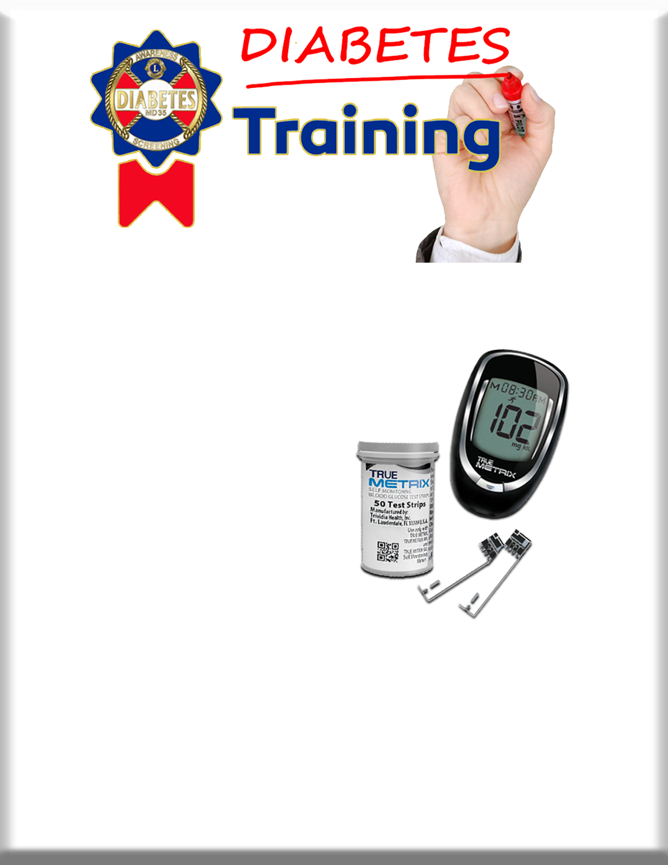

What it takes to be a trainer
1. 2 continuous years as a certified screener
2. With a 90% accuracy rate
3. 4 screenings including one with another club the second year.
4. Observation of at least one certified trainer at a different club than your own.
Certified Diabetic Screener Trainers
District L
Judi Seltzer | j.seltzer@lionssavingsight.org
District I
Erick Rumold | ericthehawk@yahoo.com
Jackie Cameron | lionsweetpea@msn.com
John Maguire | Whaler240@gmail.com
Patricia Maguire | patmaguireept@gmail.com
Penny Gregrich | pccpennygregrich@gmail.com
Rose Mary Grasso | nightengale101@tampabay.rr.com
District O
Marcia Hilliard | Besjencia7@gmail.com
Greg Evans | liongregevans@gmail.com
Nancy Gocke | nvgocke@gmail.com
Jacki Simpson | jemsfl3688@aol.com
Karen Stowers | surgnurtz0507@gmail.com
Norma Callahan | lionnormacallahan@yahoo.com
Steve Norton | stevenorton@tampabay.rr.com
Vivian Henegar | vivianhenegar64@yahoo.com
District N
Betsy Messer | bemscreener@hotmail.com
Diana Castillo | cas9673@aol.com
Jane Colona | lionjanecolona@gmail.com

