JUST DO IT….Join us for diabetes screening training
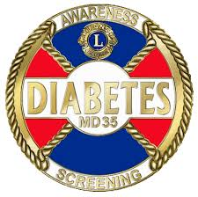
Florida Lions Diabetes Foundation

- New Screener Training : 10am-2pm
- Re-Certification Class: 1pm-3pm
When: Thursday August 13, 2026
Where: Jacksonville Arlington Lions Club House- 6523 Commerce Street, Jacksonville FL 32211

*Please bring your screening kits if applicable for updates.
*Lunch /Snacks will be provided.
* Since training will be ongoing, children are not invited.
* To avoid longer times, training will begin on time.

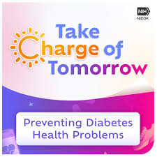

- 1 in 12 people have diabetes.
- 50% of people with diabetes do not know they have it.
- Diabetes affects every community.
- 1 in 3 adults have pre diabetes.
- To know diabetes could mean no diabetes.
- Get screened for diabetes .

