

February 2026
For winter sports enthusiasts, the 2026 Olympics also carry a strong sense of nostalgia. Fans will relive the thrill of skiing down glittering slopes, the elegance of figure skating routines, and the exhilaration of sledding through icy tracks. From alpine skiing and snowboarding to speed skating and bobsled, the Games celebrate the full spectrum of winter sports, each steeped in history and tradition.
The Milan-Cortina Olympics offer a rare combination: breathtaking scenery, rich cultural experiences, and the universal language of sport. As nations gather to compete, cheer, and share in this global festival, the event promises to leave lasting memories for athletes and spectators alike. The 2026 Winter Olympics are shaping up to be a heartwarming celebration of skill, spirit, and wintertime joy.

February Horoscopes and Birthdays
In astrology, those born between February 1–18 are Aquarian Water Bearers. Aquarians have attractive personalities, vivid imaginations, strong intuition, and a thirst for knowledge. They also share a strong desire to help humanity and create unity. Those born between February 19–29 are Pisces. These Fish are spiritual types who feel comfortable in their introspective natures. As passionate, creative dreamers, they are charitable helpers who go with the flow.

Tommy Smothers – Feb. 2, 1937
Hank Aaron – Feb. 5, 1934
Lana Turner – Feb. 8, 1921
Susan B. Anthony – Feb. 15, 1820
Hugh Downs – Feb. 14, 1921
Sidney Poitier – Feb. 20, 1927
Steve Jobs – Feb. 24, 1955
Jimmy Dorsey – Feb. 29, 1904
Dinah Shore – Feb. 29, 1916

Caraton Commons De Pere
Page 4

Celebrating February

Spirit Week!
Monday- Wear Valentines colors!

Tuesday- Twin Day!

Wednesday- Crazy Hair/ socks day!

Thursday- Sports Jersey Day!

Friday- Pajama Day! (National Comfy Day)

1500,1525,1550 Arcadian Ln.
De Pere WI 54115

🌟 

Resident of the Month: Jackie
We are delighted to celebrate Jackie as our Resident of the Month! Jackie brings a bright and lively spirit to Caraton Commons, and her presence always adds an extra bit of joy to our days. A lover of winter weather, Jackie enjoys watching the snow fall and building snowmen—activities that showcase her playful and creative nature. She also has a soft spot for a good t-bone steak and never hesitates to dance when her favorite song, “Angie” by the Rolling Stones, begins to play.
Jackie grew up in Milwaukee, where some of her favorite childhood memories include the excitement of chasing the bull around with her siblings and friends. Family remains close to her heart; she treasures her bonds with her two brothers, sister, stepmom, and stepdad. When asked to share a little life wisdom, Jackie offers her advice to smoke marijuana and wear deodorant!
One of Jackie’s favorite parts of living at Caraton Commons is the caring and friendly environment. She especially enjoys the daytime energy and the attention from staff who appreciate her warmth, positivity, and vibrant character. Jackie’s genuine spirit brightens our community, and we are proud to feature her this month.
Please join us in congratulating Jackie on this well-deserved recognition.

Chasing Winter Glory (cont. from pg. 1)
Notable Quotable

“It took me
17 years to get 3,000 hits in baseball. I did
it in one afternoon on the golf course.”

~ Hank Aaron,
born Feb. 5, 1934

Trekkies Rejoice

This year, Star Trek celebrates an incredible milestone: 60 years of exploring strange new worlds. Since its first broadcast in 1966, the franchise has captivated audiences of all ages with its stories of courage, friendship, and hope for a better future.
For longtime fans, the anniversary is a chance to reconnect with cherished memories. Special events are planned across the country, including fan conventions, commemorative exhibits, and even themed museum displays showcasing costumes and props. Streaming services will highlight favorite episodes and launch new series like Star Trek: Starfleet Academy.
A themed cruise in late February offers a fun way to join fellow fans, but the celebrations extend far beyond the ocean. Whether revisiting the adventures of Captain Kirk or discovering new stories, the 60th anniversary is a joyful reminder of the optimism and imagination that Star Trek has inspired for decades.




Staff Of The Month
Congratulations to Jolissa Reategui, our Staff of the Month! Jolissa has worked at our facility for about three years and began her caregiving career right here. She enjoys her daily routine, sharing laughs with residents, and working alongside coworkers to get things done as a team. Her positive attitude and strong work ethic make a difference every day.
Jolissa grew up in Green Bay, WI, and has been married to her husband for nearly 12 years. She’s a proud mom to Misael (10) and Luna (3) and cares for her mother at home. Inspired by her grandfather’s experience, Jolissa entered healthcare to ensure elders receive the respect they deserve. Outside of work, she enjoys singing and playing video games with her family. Her advice to coworkers: “Closed mouths don’t get fed.”

Page 3
Page 2
In hula, the hands and arms are the true storytellers, while the hips simply keep rhythm and flow.

Because their fur
traps heat so effectively, polar
bears are surprisingly hard to spot with thermal imaging.
Dancing the Divine
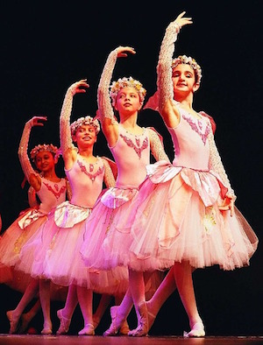
Ballet is not only a beautiful and elegant dance form, but it’s also the perfect civilizing art, says ballerina, critic, and historian Jennifer Homans.
Throughout its history, ballet has been used to refine the body, mind, and soul. Since its origins as a dance of wealthy Italians during the Renaissance, ballet grew beyond the dance floors of the rich.

To develop its fluid and balanced movements, choreographers used math and geometry, then taught by ballet teachers to their students. The dance was thought to be so harmonious and perfect that it was given religious significance. In their view, mastering ballet could actually improve the soul. With results like that, why not try a few steps on February 7, Ballet Day?

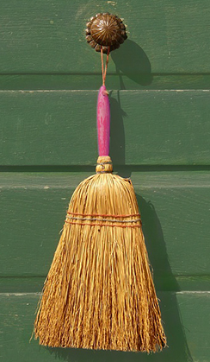
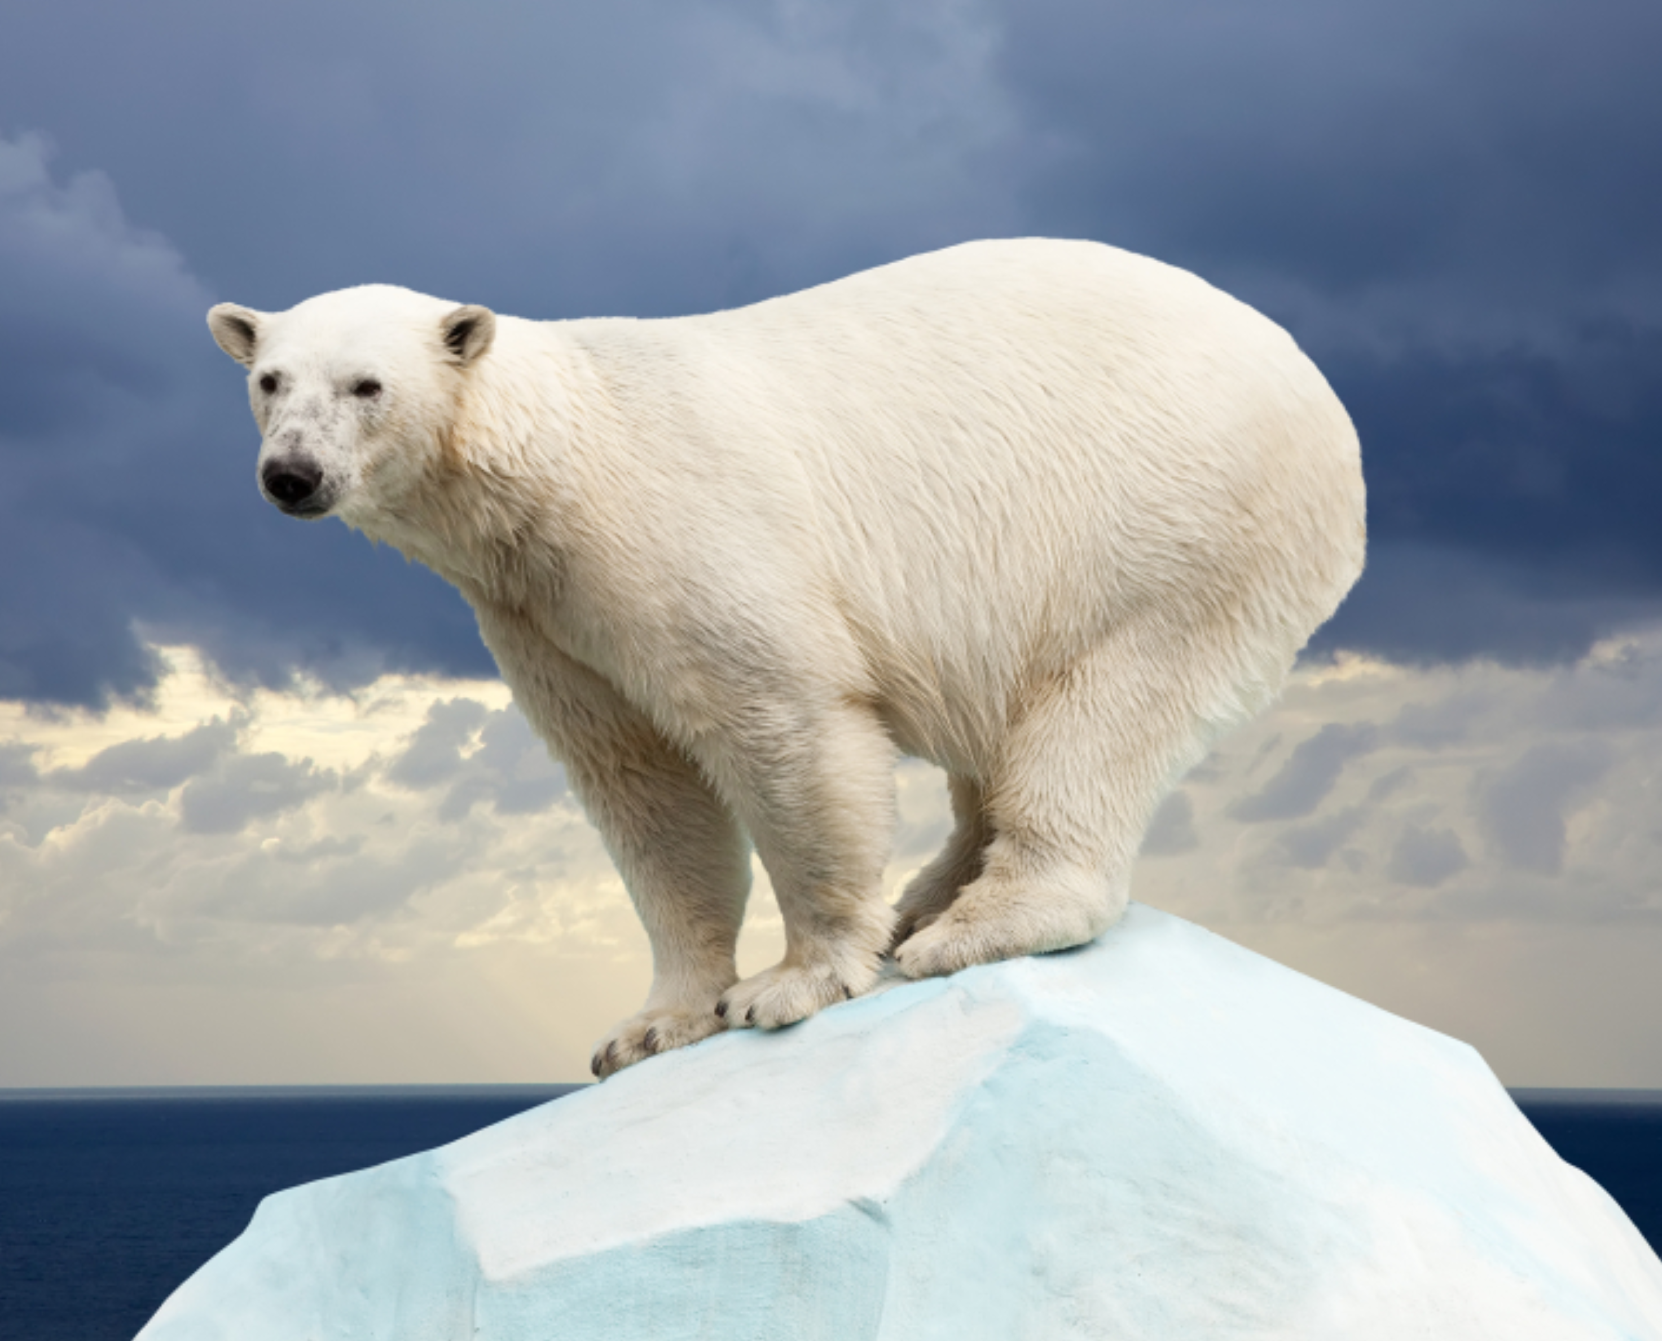
February 17 may ring in China’s new year, but preparations often begin weeks ahead of Chinese New Year’s Day. One of the most important customs is a thorough cleaning of the house. This ensures any bad luck built up over the past year is swept away. Similarly, one must not clean during the first days of the new year so as not to sweep away any new good luck. Cleaning house also means it’s time to take care of unfinished business; paying debts and resolving quarrels are all part of prepping for the new year.
Food is an important part of any Chinese New Year celebration, but most food must be prepared in advance, thanks to a popular superstition dictating that knives be put away on New Year’s.
Perhaps the most important New Year’s tradition is paying respect to ancestors. Celebrations can
begin only after proper homage has been paid.On New Year’s Eve, temples are often crowded with people bringing food, incense, and other offerings for their departed forebears.
Next door to China in neighboring Tibet, February 18 brings the new year, called Losar—Tibet’s most important holiday. Drawing from Buddhist tradition, Tibetans believe good comes only to those who do good themselves. For this reason, Losar rituals include a focus on “virtuous attitudes,” “virtuous actions,” and thus, a “virtuous new year.” For three to 15 days, depending on the locale, family and friends gather and celebrate by eating good food, telling stories, lighting fireworks, and playing games. Celebrations also involve donning one’s finest clothes to visit temples and offer good wishes to the living, dead, and spirits of the enlightened.

You don’t have to live in the Arctic to celebrate International Polar Bear Day on February 27. The polar bear is one of nature’s most awesome beasts and is the world’s biggest hunter. Polar bears spend much of their time lying in wait outside holes cut in the ice by ringed seals, which must return to the surface for air. A seal’s survival depends
on maintaining its series of breathing holes. That same survival instinct is what eventually provides the polar bear with its next meal.
As the Arctic warms and ice recedes, polar and brown bear habitats have begun to overlap, and hybrid offspring have appeared. Dubbed nanulaks by Canadian wildlife officials, the hybrid bears are whitish brown with long claws and a humped back. Offspring of a male polar bear and a female grizzly are called pizzlies; reverse the parentage and it’s a grolar bear. However, as long as there is ice to roam and seals to hunt, a polar bear’s home will always
be the Arctic.

Good Deeds and Good Fortune
Guardians of the Arctic
Special attention is given when cleaning corners, windows, and doorways—places where old energy is thought to gather.
The term ballet comes from the Italian balletto, meaning
“little dance.”

