
Caraton Commons Green Bay
February 2026

655 Woodside Rd. Green Bay WI 54311
Celebrating February  American Heart Month  Spunky Old Broads Day  February 1  Groundhog Day  February 2  National White T-shirt Day  February 11  Valentine’s Day  February 14  Random Acts of Kindness Week  February 15–21  Mardi Gras Craft  February 17  Music by Daniel Lovett  February 18  Tell a Fairy Tale Day  February 26 | Resident of the Month  Audrey is a kind and spirited woman who finds joy in life’s simple pleasures. Her favorite food is breaded shrimp with plenty of shrimp sauce, and a good waltz is all it takes to get her happily out on the dance floor. If she could choose a superpower, it would be to ensure that her family and friends are healthy and stay that way.  Springtime is Audrey’s favorite season, when flowers, trees, and plants burst into bloom, birds sing, and the grass turns its brightest shade of green. She lived in Racine for about 25 years and fondly remembers her first day of school, when her dad drove her and dropped her off at the front—only for Audrey to walk through the school, out the back door, and head home, beating him there.  Audrey was raised by very loving German parents: her dad, Henry, who worked fixing cars at Nash Garage, and her mom, Anne, who wore the pants in the house. She is the oldest of five siblings, with two brothers and three sisters, and she remembers their beautiful white blind cat with great affection. Audrey’s advice to everyone is heartfelt and simple: when making decisions, go with your heart. Today, she enjoys Caraton Commons Green Bay, where she meets many nice people, and she takes special pride in her large room, lovingly decorated by her two wonderful daughters, Carrie and Sue.  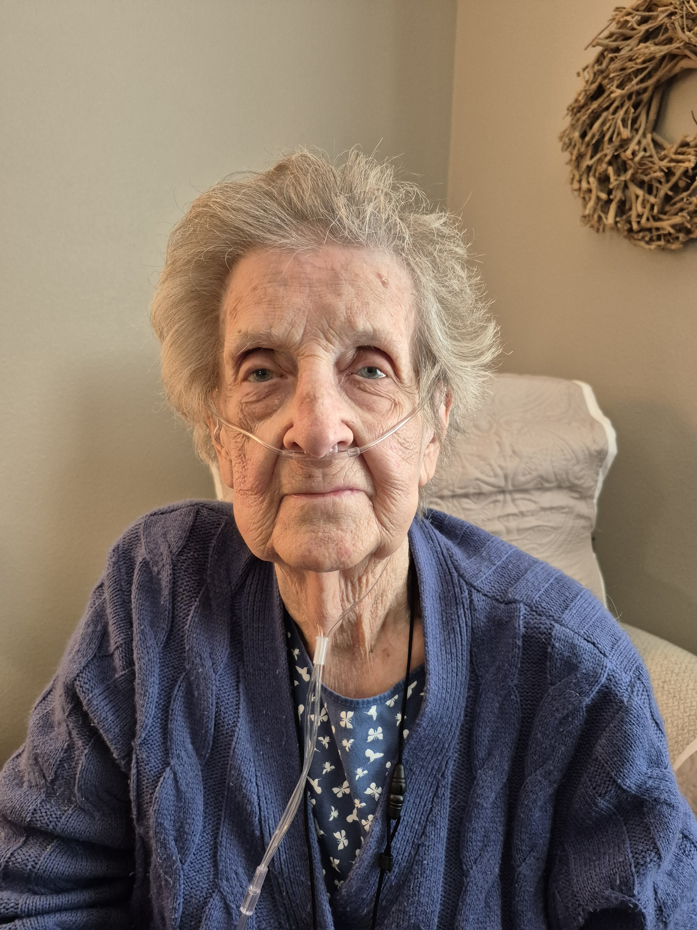
  Good Deeds and Good Fortune  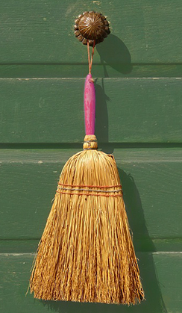  February 17 may ring in China’s new year, but preparations often begin weeks ahead of Chinese New Year’s Day. One of the most important customs is a thorough cleaning of the house. This ensures any bad luck built up over the past year is swept away. Similarly, one must not clean during the first days of the new year so as not to sweep away  any new good luck. Cleaning house also means  it’s time to take care of unfinished business;  paying debts and resolving quarrels are all part of prepping for the new year.  Food is an important part of any Chinese New Year celebration, but most food must be prepared in advance, thanks to a popular superstition dictating that knives be put away on New Year’s. Using a knife might just “cut off” the flow of good luck and prosperity to a home.  Perhaps the most important New Year’s tradition is paying respect to ancestors. Celebrations can begin only after proper homage has been paid.  On New Year’s Eve, temples are often crowded with people bringing food, incense, and other offerings for their departed forebears.  Next door to China in neighboring Tibet,  February 18 brings the new year, called Losar—Tibet’s most important holiday. Drawing from Buddhist tradition, Tibetans believe good comes only to those who do good themselves. For this reason, Losar rituals include a focus on “virtuous attitudes,” “virtuous actions,” and thus, a “virtuous new year.” For three to 15 days, depending on the locale, family and friends gather and celebrate by eating good food, telling stories, lighting fireworks, and playing games. Celebrations also involve donning one’s finest clothes to visit temples and offer good wishes to the living, the dead, and the spirits of the enlightened. Since it’s common to  hurl barley flour, known as tsampa, as a spiritual offering, it may be a good thing their neighbors have a broom handy.  February 2026 | Shining Star    Aylin has been working at Caraton Commons Green Bay for the past three months and truly enjoys her role because it allows her to bring positive energy into each day while making sure residents feel cared for and uplifted. She grew up in Coachella, California, and is the oldest of four siblings, with two younger brothers and one younger sister.  Aylin has one cat named Blicky, who she adores. She chose to go into healthcare because of her strong mindset and her genuine ability and desire to show care for others. Currently, she is attending NWTC and studying nursing. In her free time, Aylin enjoys going to the gym and playing tennis.  Her words of advice are to care for people the way you would want to be cared for. Looking ahead, Aylin sees herself in ten years working as a CRNA in California, continuing to make a positive impact in healthcare.  Dancing the Divine  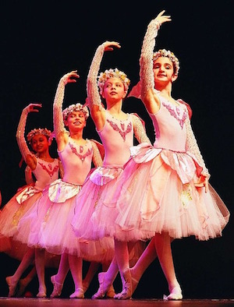  Ballet is not only a beautiful and elegant dance form, but it’s also the perfect civilizing art, says ballerina, critic, and historian Jennifer Homans. Throughout its history, ballet has been used to refine the body, mind, and soul. Since its origins as a dance of wealthy Italians during the Renaissance, ballet grew beyond the dance floors of the rich. To develop its fluid and balanced movements, choreographers used math and geometry, then taught by ballet teachers to their students. The dance was thought to be so harmonious and perfect that it was given religious significance. In their view, mastering ballet could actually improve the soul. With results like that, why not try a few steps on February 7, Ballet Day?
February Aloha    For those dwelling in the northern hemisphere, February brings a chill to both the air and the spirit. Spring is just a month away, but who can think of spring when the snow’s still falling? Drive away the chill on February 1 with Hula in the Coola Day.  Hula dancing is an integral part of Hawaii’s Polynesian history and culture. The dance is far more than swaying the hips in a grass skirt; it’s a ritual way to explain Hawaiian gods and goddesses, the history of the people, and the mysteries of natural phenomena through chanting, singing, and dancing. Hula has been performed during religious rituals, rites of passage, social gatherings, and even football games. So if you’re looking to warm your spirit this February 1 with a little aloha, find a real kumu hula teacher. Ditch the grass skirt for one made of kapa, a traditional fabric handcrafted from the bark of the paper mulberry tree.  Since hula is Hawaii’s iconic dance, the ukulele must be Hawaii’s iconic instrument. In the 1900s, the ukulele became part of the musical backdrop to hula dances, so it stands to reason that World Ukulele Day falls on February 2, the day after Hula in the Coola. Famed Hawaiian musician Samuel Kamaka explained that the ukulele was first played in the islands in 1879 by João Fernandes, an immigrant from Portugal. His fingers rapidly strummed a four-stringed braguinha, which the native Hawaiians nicknamed ukulele,  a word meaning “jumping fleas.”  Perhaps no ukulele musician was as beloved as Israel “IZ” Kamakawiwo‘ole. Raised in a musical family from Honolulu (his uncle was Moe Keale), he was exposed to entertainers like Don Ho and Palani Vaughan. His version of “Over the Rainbow” may rival Judy Garland’s. It will, no doubt, be strummed the world over on World Ukulele Day.  February 2026 | Engineering a Solution  The fields of science, technology, engineering, and mathematics, known collectively as STEM, are considered some of the most critical when it comes to industry and the economy. Research conducted by the American Association of University Women found that in many STEM fields, men outnumber women—a fact they say threatens to stifle both wage equality and creative thinking. That’s why February 26 is Introduce a Girl to Engineering Day. Dr. Maria Klawe, former president of Harvey Mudd College, says the solution is to encourage collaborative and creative problem solving in computer science fields. The lonely engineer toiling away in a dark basement may be no more. The future of STEM is unintimidating, social, bright, and equal parts female.  Trekkies Rejoice    This year, Star Trek celebrates an incredible milestone: 60 years of exploring strange new worlds. Since its first broadcast in 1966, the franchise has captivated audiences of all ages with its stories of courage, friendship, and hope for a better future.  For longtime fans, the anniversary is a chance to reconnect with cherished memories. Special events are planned across the country, including fan conventions, commemorative exhibits, and even themed museum displays showcasing classic costumes and props. Streaming services will highlight favorite episodes and launch new series like Star Trek: Starfleet Academy.  A themed cruise from February 20–27 offers a fun way to join fellow fans, but the celebrations extend far beyond the ocean. Whether revisiting the adventures of Captains Kirk and Jean-Luc Picard or discovering new stories, the 60th anniversary is a joyful reminder of the optimism and imagination that Star Trek has inspired for six decades.
The Legacy of the Birkebeiner  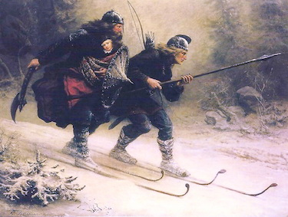  Covered in snow, north Wisconsin heats up in February, thanks to “Birkie Fever.” On February 21, around 10,000 skiers from more than 25 countries will participate in the American Birkebeiner, a cross-country skiing marathon. At 53 kilometers, Wisconsin’s “Birkie” is the largest cross-country skiing race in North America. Of the numerous cross-country ski marathons worldwide, the American Birkie is considered one of the toughest. With temperatures hovering around zero degrees Celsius and an undulating course of hills and valleys, it’s no wonder the race has been dubbed the “Greatest Show on Snow,” where world-class athletes are tested to the limits of  their endurance.  The origins of the Birkebeiner races date back to the early 1200s, commemorating an event that inspires much pride among those with Norwegian ancestry. All Birkebeiner races recall a heroic moment in Norway’s history. Historian Sigvart Sorensen told of how, on January 1, 1204, King Haakon III of Norway died suddenly, possibly  by poisoning. After the king’s death, a civil war erupted, pitting the wealthy Bagler faction  against the Birkebeiners.  A year later, it was decided that the king’s  hitherto-unknown heir, an 18-month-old prince, would have to flee. This could be done only  with the help of long-distance skiers. Two skiers from the Birkebeiner faction, Torstein Skjevla  and Skjervald Skrukka, struck out on a 60-mile journey in the midst of a storm over treacherous mountains to deliver the babe to his mother, Queen Inga, in Trondheim.  The prince, whom we now know as King Haakon IV, would eventually unite Norway, all thanks to two brave Birkebeiners.  .  February 2026 | February Birthdays  In astrology, those born February 1–18 are Aquarian Water Bearers. Aquarians have attractive personalities, vivid imaginations, strong intuition, and a thirst for knowledge. They also share a strong desire to help humanity and create unity. Those born  between February 19–29 are Pisces. These Fish are spiritual types who feel comfortable  in their introspective natures. As passionate, romantic, creative dreamers, they are  charitable helpers who go with the flow.  Tommy Smothers (comedian) – Feb. 2, 1937  Hank Aaron (ballplayer) – Feb. 5, 1934  Lana Turner (actress) – Feb. 8, 1921  Susan B. Anthony (activist) – Feb. 15, 1820  Sidney Poitier (actor) – Feb. 20, 1927  Steve Jobs (tech guru) – Feb. 24, 1955  Dinah Shore (singer) – Feb. 29, 1916  The Long Sleep    Karolina Olsson of Sweden became known as the “Sleeping Beauty of Oknö” when, on February 22, 1876,  at age 14, she fell into a deep sleep and did not awake for  32 years. How did she survive? Legend has it that family members diligently spoon-fed her sweetened milk each day. Over the years, they sometimes observed her sleepwalking or crawling. Her family and much of her small remote village believed the girl bewitched. When Olsson finally awoke, she looked in the mirror and burst into tears. She hardly recognized herself. And yet, she seemed to have aged only to her mid-20s, when she should have been 46. Doctors examined her  to find no lasting physical or mental damage, only that her mind was still that of a 14-year-  old. Olsson had amazingly, inexplicably “hibernated,” though today’s doctors suggest she might have been in a state of catatonia.


