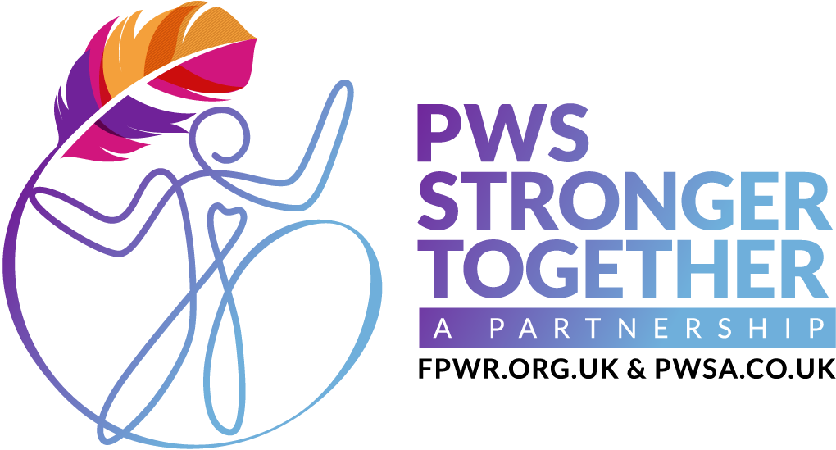
www.pwsstrongertogether.co.uk
E: info@pwsstrongertogether.co.uk

PWS Awareness Day: Time to get ready!

On May 15th, Schools, families and the whole PWS community will be coming together to celebrate Prader-Willi syndrome Awareness Day. We really hope you're going to be able to join us!
By Going Orange for PWS, you'll be supporting your pupils with PWS and our whole community - thank you.

Step 1: Get Ready!
Download all the resources to make the day a success here including assembly presentations, bunting and information for parents
Don't forget to fill in our contact form so we know you're participating

Step 2: Go Orange!
Wear orange or bright colours on May 15th to spread awareness and raise funds for PWS
Collection donations through your school's payment system or with cash

Step 3: Pay in donations
Pay in any donations you have raised via our givestar page

We want to make it as easy as possible for you to participate and to help you make the day a success, so please let us know if you have any questions. If there's anything we can do to support you just send us a message to info@pwsstrongertogether.co.uk

Thanks for your support, it means the world!

Thankyou

PWS Stronger Together team

