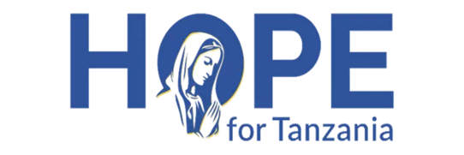
Healing Bodies to Help Save Souls
By Fr. Nestor Mtweve
Dear Friend,
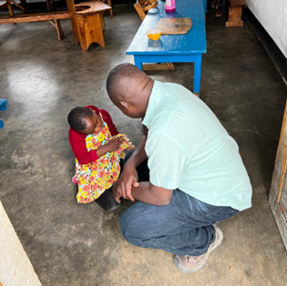
My name is Fr. Nestor Mtweve, a Roman Catholic Priest of the Diocese of Njombe – Tanzania. After my four hectic years of undergraduate and graduate school at Benedictine University, I came back to my diocese and was assigned to work as managing director of the INUKA rehabilitation hospital. While I am managing the hospital, I am still a priest and my mission to bring Christ to the people in my region is still my priority. However, when people lack the essentials of life, including adequate water, food, shelter, and health care, they are not as receptive to the gospel. Thus, I have asked Hope for Tanzania (“HFT”) to aid in Healing Bodies to Help Save Souls.
The day I received the appointment to work in the rehabilitation hospital, I couldn’t help but remember an event I witnessed when I was a parochial vicar in one of the parishes here in the diocese. We had a neighbor who was a teacher and although he wasn’t Catholic, we knew him and his family well as village teachers are the most educated of all the people in the village. One day, we were told that one of his sons had died, but we were confused as we thought that he had only one son. To our surprise the son we knew about was very much alive, but we sadly learned that it was his brother who had died. He was fourteen years old and was disabled. Although he was our neighbor, we never saw him around or even outside their house. Was he living with a relative or in a special school? No, he was locked away in the family house for his entire life.
This experience explains how people in rural communities treat people with disabilities. They consider children with disabilities as a burden, a disgrace, and a curse which is why the teacher hid the child in his house for fourteen years. It is important to also highlight that the house didn’t have indoor plumbing with a toilet like developed countries do. In the villages, bathrooms are always outside a couple of meters from the house. The fourteen years must have been very difficult for this young boy who was unable to even go outside to the bathroom. Unfortunately, the belief that children with disabilities are a disgrace or curse has led some families in rural communities to kill children born with a disability at birth.
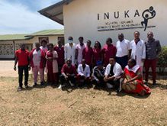
In 2010, the late Bishop Alfred Maluma started the INUKA rehabilitation center to provide a place where children with disabilities could be treated with dignity and respect and their God-given rights guaranteed. It is a hope-filled place where parents and caregivers can be counseled and taught that children with disabilities are a blessed child of God just like we are. My assignment here at the center, now hospital, is to build on this legacy of hope. Our mission is to provide essential rehabilitation and health care services to people with disabilities, while educating their families and neighbors that their children can receive treatments that will help them lead a joy filled life. Our hope is to reduce and eventually eliminate the occurrences of families killing the babies with disabilities or locking them in the house for long periods of time.
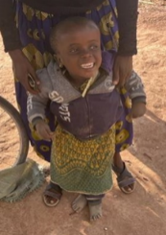
There are many success stories that give us the strength to continue our mission. While we work to bring them to Christ, we are also bringing smiles to children and families. Aggrey, Lupiana, and Gloria are part of the team at the hospital, and they work in the income generating activities department. Several years ago, they were the first children to benefit from the rehabilitation services offered here. They too were always locked in their houses and considered a burden and a curse. When the hospital started, there were home visits to families with special needs children and Aggrey, Lupiana, and Gloria were identified and brought to the hospital. They had cognitive issues, rickets (weak bones), and were unable to walk. As young adults, they are now able to function on their own and perform basic and needed tasks at the hospital.
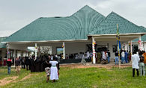
In the process of providing rehabilitation services, it was also discovered that our special needs children also suffer from other diseases like malaria, typhoid fever, urinary tract infections, and many others. Therefore, the rehabilitation center was turned into a hospital so that other medical issues could be addressed at one location. The support we received in 2021 and 2022 from HFT in its Healing Bodies to Help Save Souls campaign was crucial to our ability to improve general medical services. The outpatient clinic is located next to the rehab hospital and it has improved the health of the children with disabilities. It has also helped us attract a medical doctor to work with us onsite. In Tanzania, a medical doctor is required to determine if a child needs therapy or not so the outpatient clinic helps us provide quality rehabilitation services.
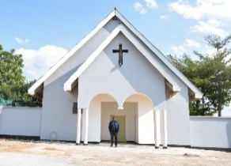
As our patient growth accelerated and word spread of the hope offered at INUKA, our expansion needs have grown. During late 2022 and early 2023, we worked with HFT on several new projects at our facility. First, we constructed a new therapy building next to the main rehabilitation building and outpatient clinic. It includes a new physiotherapy hall for children, an occupational therapy hall, and treatment rooms for autism and other special needs. There are also individual treatment rooms to provide privacy for adults and children as required by law. Secondly, electrical power is an ongoing focus as grid outages continued to be a problem for the facility, and the solar backup system originally installed was not functioning properly. With HFT’s support, we fixed our solar power inverters and purchased new battery capacity to ensure the availability of day and night electricity. In late 2023 and 2024, we discerned the need to build an operating room and surgical ward and construct some apartment housing for MDs that travel from far away to serve our patients. We have also taken an existing building at INUKA and converted into a chapel as prayer is an important part of our work here. These projects were completed by June 2024.
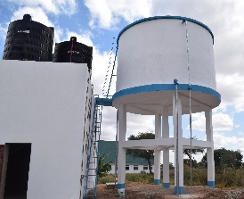
As we continued to build an oasis of hope at INUKA, we next added staff housing to support our operations, built a 75,000-liter water tower to support the growth of INUKA’s operations, and improved our farm operations at the hospital so that more patients can be treated, housed, and fed. These HFT supported projects were all completed by July 2025. We have since built and furnished a new full service orthopedic workshop, a new hydrotherapy facility with a small treatment pool, and a new rehabilitation hostel with twelve private rooms and two executive suites. In addition, we were able to use incremental funds raised to fully fund scholarships for three new seminarians within the Diocese of Njombe and to add to our endowment fund to provide for the future maintenance and operations at INUKA. These efforts were completed by July 2026.
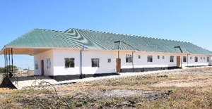
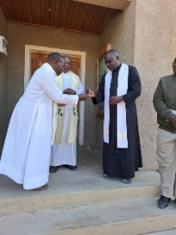
You have been so very generous in the past I am hesitant to ask for more financial help, but I am driven to ask by the people in need that I see each day. As we continue to create an oasis of hope at INUKA and support our diocese, we are looking to build short-term (12 to 18 month) rehab housing for disabled older priests, invest in additional rehab equipment, increase our inventory of medications and diagnostic tests, fund additional seminarian scholarships and add to our endowment fund.
In July 2025, I was given another challenge as the bishop entrusted me with pastoral care as the Pastor of St. Augustine Parish in Wanging’ombe, near the hospital. Our parish also includes 19 outstation churches that are visited at least monthly for sacramental purposes. For the past year, it has been a very rewarding challenge to meet the needs of the people in this parish.
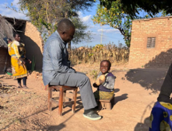
As a priest, it is almost impossible to bring people to Christ and save souls without first bringing the hope of healing to these families. The INUKA hospital complex is one of the most important tools to help me save these souls. Therefore, on behalf of Aggrey, Lupiana, Gloria and many other clients, I am asking you to help support this mission and our ongoing projects. The need is real and critical as we never want to see another child killed during birth, locked in their house, or considered to be a curse. We want to reach as many parents as possible and let everybody know that children with disabilities are created in the image and likeness of God. Please give generously because I promise your contribution will indeed make a difference in many lives. Thank you and God bless.

