THE GRAVESEND AND ROCHESTER
AGRICULTURAL ASSOCIATION

Established 1834

PRESIDENT: Mr B Stone BTF

CHAIRMAN: Mr T Filmer CLOCKHOUSE BARN

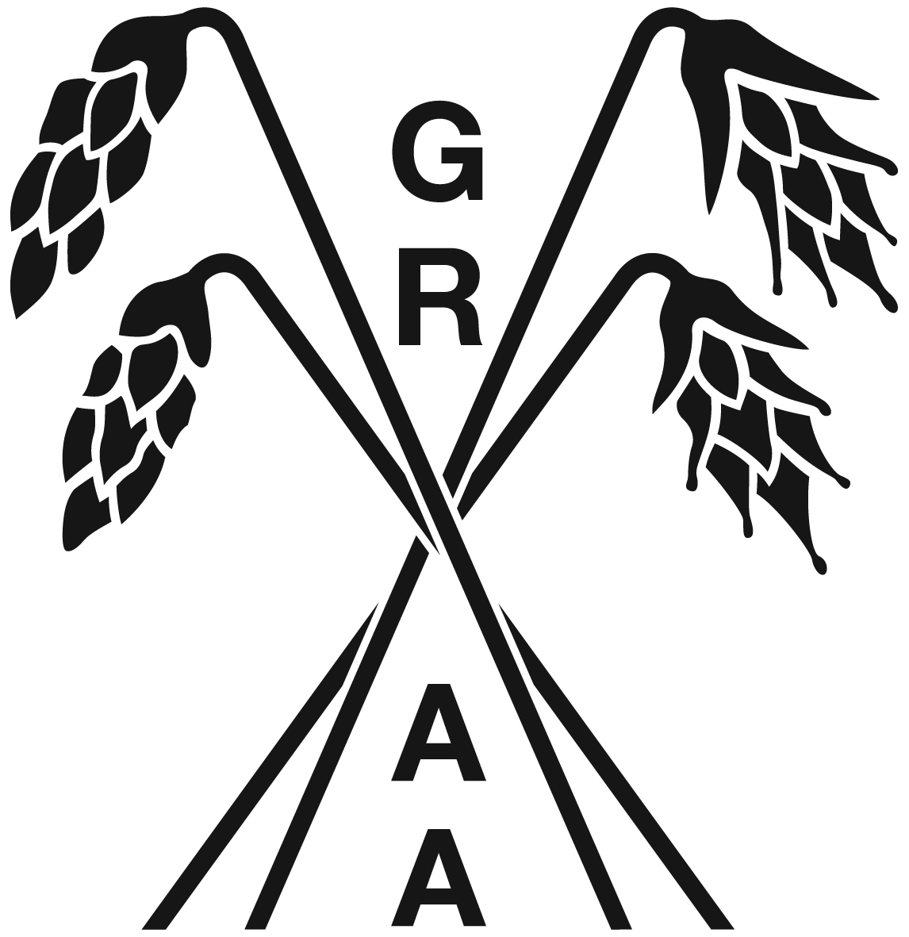
VICE CHAIRMAN: Mr M Batchelor CANTERBURY ROAD

SECRETARY: Mr J Hearnden CHALLOCK, ASHFORD

KENT TN25 4BJ
TEL: 01233 740077
E: ashley.kenyon@btfpartnership.co.uk

VINTAGE PLOUGHING ENTRY FORM – 19 SEPTEMBER 2026
NEWLANDS FARM, CLIFFE, ROCHESTER ME3 7RU
By kind permission OF PETER TICKLE

CLASS NO | MAKE OF TRACTOR | PLOUGH | NO OF  FURROWS | ENTRANT

NAME

ADDRESS

TEL NO
EMAIL:
ELIGIBLE FOR TURNOUT |  | PLEASE TICK

ENTRIES CLOSE: 1 SEPTEMBER 2026
ENTRY FEE: £15.00
Please make payment to: Account Name: GRAA
Sort Code: 20-54-11
Account No: 20440507
Or by cheque to: G.R.A.A

RETURN TO: ASHLEY KENYON, BTF, CLOCKHOUSE BARN, CANTERBURY ROAD, CHALLOCK, ASHFORD, KENT TN25 4BJ
E: ashley.kenyon@btfpartnership.co.uk

IN BOTH TRAILING & MOUNTED PLOUGHS CLASSES, ALL MODELS OF TRACTOR MUST HAVE BEEN IN PRODUCTION BEFORE 31ST DECEMBER 1959 AND AS MANUFACTURED.

TRAILING PLOUGHS - ANY TRAILING PLOUGH IS ELIGIBLE.
MOUNTED PLOUGHS - IN PRODUCTION BEFORE 31.12.1959 AND AS MANUFACTURED.

THE COMMITTEE RESERVES THE RIGHT TO REFUSE ENTRY TO ANY PERSON WITHOUT REASON.

I AGREE TO THE GRAA ENTRY RULES

SIGNED ____________________________________

Class A | VINTAGE TRAILED KENT  (open to all Kent Ploughmen) | Class D | VINTAGE MOUNTED OPEN  (Open to all Ploughmen outside Kent)
Tractor | Model to have been in production before 31 December 1959 and to be as manufactured | Tractor | Model to have been in production before 31 December 1959 and to be as manufactured
Plough | Any make of trailing plough and as manufactured. | Plough | Any make of mounted plough before 31 December 1959
Class B | VINTAGE TRAILED OPEN  (Open to all Ploughmen outside Kent) | Class E | SINGLE FURROW (If numbers warrant)
Tractor | Model to have been in production before 31 December 1959 and to be as manufactured | Class F | SHOW/CLASSIC CLASS (If numbers warrant)  Models from 1959 – 1971 pre Q Cab tractors only
Plough | Any make of trailing plough and as manufactured. | Class G | Static Display of Working Tractors. Also eligible for turn out prize.
Class C | VINTAGE MOUNTED KENT  (Open to all Kent Ploughmen) | Class H | EXHIBITION CLASS For any non-competing vintage or classic tractors and Vintage Commercial Farm Vehicles.
Tractor | Model to have been in production before 31 December 1959 and to be as manufactured |  | TURN OUT COMPETITION  PRIZE £10.00
Plough | Any make of mounted plough before 31 December 1959

