THE GRAVESEND AND ROCHESTER
AGRICULTURAL ASSOCIATION

Established 1834  PRESIDENT: Mr B Stone  CHAIRMAN: Mr T Filmer  VICE CHAIRMAN: Mr M Batchelor  SECRETARY: Mr J Hearnden  THF/AK  10 March 2026 | 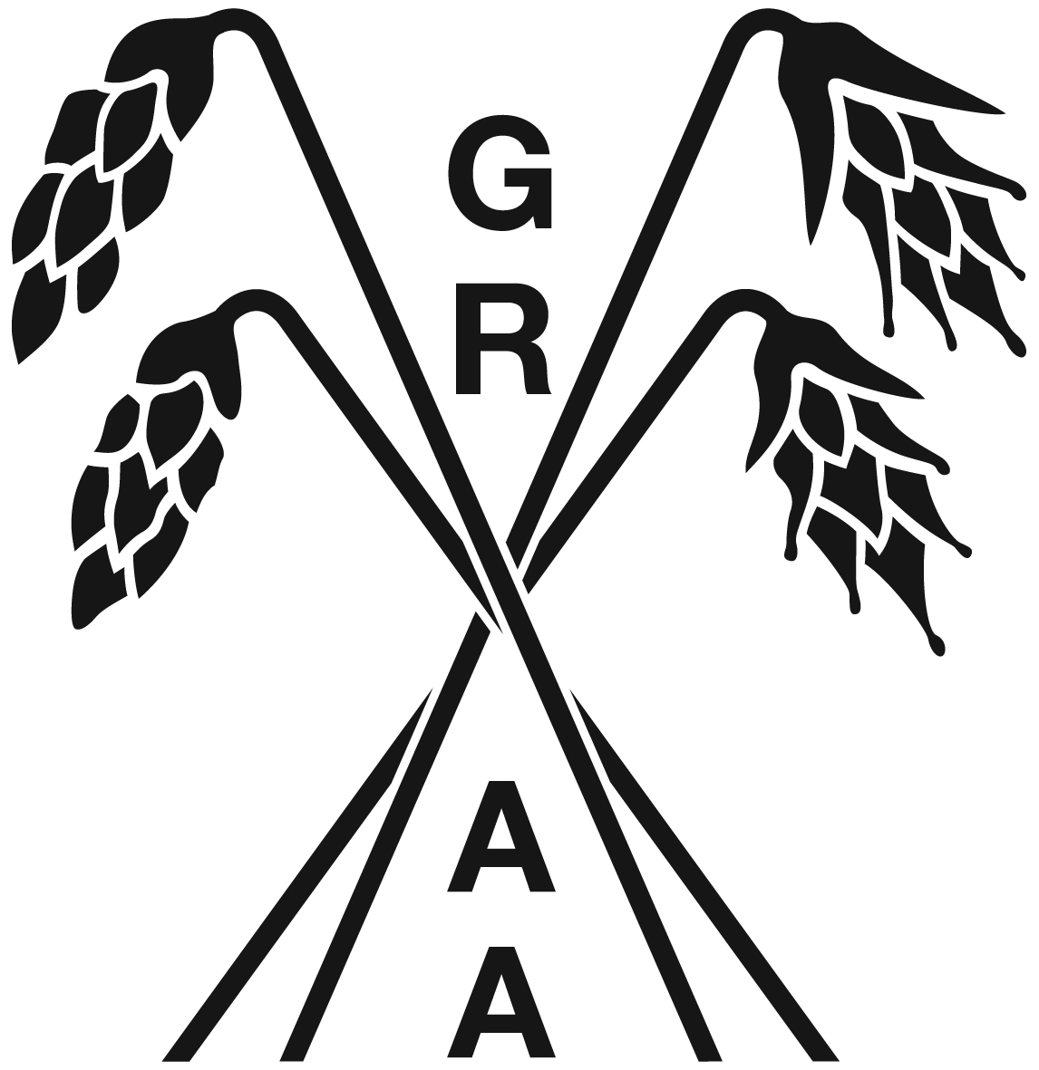 | BTF  CLOCKHOUSE BARN  CANTERBURY ROAD  CHALLOCK, ASHFORD  KENT TN25 4BJ  TEL: 01233 740077  E: ashley.kenyon@btfpartnership.co.uk

CONVENTIONAL PLOUGHING ENTRY FORM – 19 SEPTEMBER 2026
NEWLANDS FARM, CLIFFE, ROCHESTER ME3 7RU
By kind permission OF PETER TICKLE

Class 1 | Two furrow power lift plough and Three furrow or more power lift run round plough
Class 3 | Two or three furrow reversible plough
Class 4 | Four furrow reversible plough (to be sub divided if numbers warrant)
Class 5 | Five furrow or more reversible plough (to be sub divided if numbers warrant)

TO BE ELIGIBLE TO PLOUGH IN THE CONVENTIONAL PLOUGHING COMPETITION YOU MUST BE EITHER A MEMBER OF THE ASSOCIATION, AN EMPLOYEE OF A MEMBER OR LIVE OR WORK IN KENT.

ENTRY FEE: £15.00
Please make payment to: Account Name: GRAA
Sort Code: 20-54-11
Account No: 20440507
Or by cheque to: G.R.A.A

THE COMMITTEE RESERVES THE RIGHT TO REFUSE ENTRY TO ANY PERSON WITHOUT REASON.

PLEASE COMPLETE TEAR OFF SLIP BELOW

CLASS NO | MAKE OF TRACTOR | PLOUGH | NO OF  FURROWS | ENTRANT

NAME

HOME ADDRESS OR EMPLOYER

TEL NO
E:MAIL

ENTRIES CLOSE: 1 September 2026

RETURN TO ASHLEY KENYON

BTF, CLOCKHOUSE BARN, CANTERBURY ROAD, CHALLOCK, ASHFORD TN245 4BJ
OR EMAIL TO: ashley.kenyon@btfpartnership.co.uk

