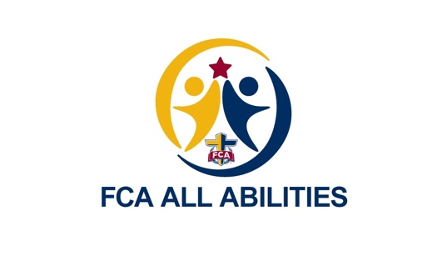

Oconee County Saturday Schedule

10:00 - Camp Intro’s
10:10 - Stretch and Message
10:10 - 11:55 Stations
12:00 - 12:30 Huddle time
12:30 - 1:30 Lunch, Awards, and Large Group
1:30 - 2:00 Stations
2:00 - 2:30 Huddle time
2:30 - 3:00 Kickball Game

