
______________________________________________________________________________________
WHITTLESEA JUNIOR FOOTBALL CLUB
INJURY MANAGEMENT POLICY 2026
______________________________________________________________________________________
PURPOSE
To develop a Whittlesea Junior Football Club (WJFC) Injury Management Policy for:
- Key Audience
- Aims & Objectives
- Medical Officer Definitions & Requirements
- Role & Responsibilities
- Injury / Concussion Reporting & Record Keeping
- Medical Notification
- Return To Play & Medical Clearances
- Strapping
- Injury Management And Ice Packs
- Risk
- Privacy
- Policy Review

KEY AUDIENCE
WJFC Committee, WJFC Medic/trainers, coaches, assistant coaches, team managers, player, parents/guardians

AIMS AND OBJECTIVES
- ALL Whittlesea Junior Football Club (WJFC) medic / trainers, coaching team have a role to play in identifying and managing injuries
- ALL WJFC sports trainers and first aid will be trained in the first aid needs as per Play AFL Injury Management Guidelines (https://play.afl/clubhelp/resources/injury-guidelines#article-1)
- WJFC AFL First Aiders and sports trainers, coaches will understand how to recognise and manage injuries and concussion in Australian Football.
- WJFC will ensure a culture that promotes honesty and integrity of reporting and safety to optimise the management of concussion.
- WJFC will provide record keeping and governance of all WJFC players’ sustained injuries & concussions via HURT – Sports Buddy incident reporting platform.
- WJFC will follow Play AFL NATIONAL COMMUNITY FOOTBALL POLICY HANDBOOK - MARCH 2023 > PART D – HEALTH & SAFETY and THE MANAGEMENT OF SPORT-RELATED CONCUSSION IN AUSTRALIAN FOOTBALL
- WJFC will ensure that at each match or training session at least one Sports Trainer or First Aid Provider with Appropriate Minimum Qualifications for the relevant level of Australian Football is in attendance as outlined below:

Minimum & Recommended Qualification | Renew | Age Group  U9 - U12  Title = Medic  (unless completed STL1 course) | Age Group  U13 & U18  Title = Trainer | Coaches | Qualified Medical Professional (QMP)
HTLAID009 Provide CPR | Yearly | Yes | Yes | Yes | No
HTLAID011 Provide First Aid | Every 3 years | Yes | Yes | Yes | No
AFL First Aider: Concussion & Injury Management in Community Football | Every 2 years | Yes | Yes | No | Yes
AFL Sports Trainer Level 1 Course (STL1) | Every 3 years | Not required but recommended | Yes | No | No
Working with children’s check (wwcc) | When expired | Yes | Yes | Yes | Yes

1. MEDICAL OFFICER DEFINITIONS & REQUIREMENTS
1.1 The requirements of each Medical Officer role are outlined below:

AFL First Aider means a person who has:
- obtained a nationally accredited first aid and CPR qualification which is current and up-to-date and includes assessed competencies HLTAID011 (Provide First Aid) and HLTAID009 (Provide Cardiopulmonary Resuscitation); and
- has completed the AFL First Aid and Concussion Management online module within the previous 24 months.
- Note: HLTAID011 (Provide First Aid) remains valid for 3 years after completion. HLTAID009 Provide Cardiopulmonary Resuscitation remains valid for 1 year (and must be renewed annually).

Level 1 Sports Trainer means a person who has:
completed a AFL approved Level 1 Sports Trainer Course which is current and up to date; and
- has completed the AFL First Aid and Concussion Management online module within the previous 24 months.
- Note: HLTAID011 (Provide First Aid) and HLTAID009 Provide Cardiopulmonary Resuscitation are both prerequisites for a Level 1 Sports Trainer Course. HLTAID011 (Provide First Aid) remains valid for 3 years after completion. HLTAID009 Provide Cardiopulmonary Resuscitation remains valid for 1 year (and must be renewed annually).

Qualified Medical Professional (QMP) means a person who:
- is a qualified and AHPRA registered medical practitioner, paramedic, physiotherapist, or nurse with appropriate first aid competencies (including or equivalent to HLTAID011 (Provide First Aid) and HLTAID009 (Provide Cardiopulmonary Resuscitation)); and
- has completed the AFL First Aid and Concussion Management online module within the previous 24 months.

1.2 ALL Trainers and Medics MUST have a current working with children’s check (WWCC) or equivalent (Registered teachers with the Victorian Institute of Teaching (VIT) and sworn Victoria Police/AFP officers are generally exempt from needing a Working with Children Check (WWCC) in Victoria, as they undergo similar screening).

  - ALL Trainers and Medics will register as a ‘Medical Officer’ with PlayHQ and add their WWCC number at start of each season.

  - All medics and trainers will provide WJFC Medic Coordinator evidence of their current HTLAID009 Provide CPR and HTLAID011 Provide First Aid if obtained via employment.

  - WJFC will pay for the cost of all AFL approved trainer / medic / coaches training.

2. ROLE & RESPONSIBILITIES
2.1 Medic / Trainer role and responsibility
- Medics/trainers are trained to provide immediate injury management and first aid for players, and if required, team officials and spectators.
- It is extremely important that all medics/trainers act within the scope of their qualification.
- Medics / trainer will following the Children and Young People policies, ensuring Child Safety
- Medics / trainer will gain consent from player before providing first aid, unless life threatening injury
- If Medics/trainers are assessing or treating player off the field away from play, they may request another Medic/trainer or opposition Medic/trainer to oversee that game. If this is not possible, match must be postponed until appropriately qualified Medic/trainer is available for game.
- If injured player is being treated on the field (i.e; spinal injury, significant suspected fracture), medic/trainer will request umpire to pause or postpone game until player safely removed from field.
- Medic/trainer will notify coach & team manager asap if player is unable to return to play due to injury.
- If ambulance is called for player injury, medic/trainer will notify emergency contact asap. This is available on HURT.
- If ambulance is called for player injury, medic/trainer must stay with player until player injury is stabilised and player parent / guardian is present.
- If an individual medic/trainer has a higher qualification e.g. registered nurse, medical doctor, paramedic, physiotherapist, osteopath, etc. they may then act within the scope of their AHPRA qualification, but this is not the expectation of WJFC.
- Injury report forms must be completed for any injury that requires treatment via HURT and notify team manager.
- Except in the case of an emergency (ie: provision of salbutamol (Ventolin) in case of known asthma; EpiPen in case of anaphylaxis), no medications or substances/sprays etc. are to be provided by the medic/trainer to a player without the consent of the player’s parents/guardian.
- Trainer / medic will ensure player confidentiality and privacy is respected
- It is the team medic / trainer responsibility to have a fully stocked team medic bag, ensure the spinal board is available and visible and defibrillator is accessible at each game.
- It is the team medic / trainer responsibility to understand the contents of their team medic bag and restock the medic bag when required. Medic bag supplies will be available at WJFC Merchandise Store.
- It is the responsibility of all WJFC Medics and Trainers to read and understand the NATIONAL COMMUNITY FOOTBALL POLICY HANDBOOK - MARCH 2023 > PART D – HEALTH & SAFETY and THE MANAGEMENT OF SPORT-RELATED CONCUSSION IN AUSTRALIAN FOOTBALL
- If required, medic / trainer will notify parent about WJFC Player Insurance claim and direct to WJFC Secretary

2.2 Parents/Players:
• Player (or parent / guardian) must notify their coach and or medic/trainer if player unable to train or play or of any changes in circumstances (injury / health problem etc) that could place the player or team at greater risk.
• During games the decision for a player’s capacity to play is made by the medic/trainer. Medics/trainers are advised to take a conservative management plan in their decision making. Parents / guardian and players are required to abide by this decision.
• Parents / guardians will not be permitted to sit on the player bench with their child as per NFNL By-Law rule 8.13.8.
• The cost of transportation and/or medical treatment is the responsibility of the parent/guardian or player.
• In event of injury, if medical clearance is requested, it is required to be provided to the medic/trainer/team manager prior to player return to training / match day.

2.3 Coach:
• During games, in the event of an injury or injury/health concern, coaches and assistant coaches are to be guided and will respect and accept the decision by the Medic/trainer concerning the player’s capacity to play the game.
• All WJFC coaches are required to complete the HTLAID009 Provide CPR and HTLAID011 Provide First Aid. As per Play AFL Injury Management Guidelines, “Club must ensure that at each match or training session at least one Sports Trainer or First Aid Provider with Appropriate Minimum Qualifications for the relevant level of Australian Football is in attendance.

2.4 Team Manager:
• Provide notification of medic/trainer name and contact details to WJFC medic coordinator as soon as possible (preferably during pre-season).
• Team managers will ensure their team has a minimum of one qualified medic / trainer at every practice match and game.
• Serious injuries (i.e. those that may require medical treatment) must be reported to the Team medic/trainer who must create in incident report via HURT.

2.5 Whittlesea Junior Football Club:
• Overall responsibility to provide safe training environment
• Provision of WJFC insurance details to club members

2.6 Whittlesea Junior Football Club Medic Coordinator Responsibilities
- WJFC Medic Coordinator will organise NFNL approved training for the team medics and trainers as per Play AFL Injury Management Guidelines in February / March each season.
- WJFC Medic coordinator together with WJFC Team manager coordinator will ensure ALL WJFC teams have a qualified Medic or Trainer and maintain a register at the commencement of the season.
- WJFC Medic coordinator will ensure there is a functioning defibrillator, medic bag and stretcher available at Whittlesea Showgrounds and Walker Reserve at start of season.
- WJFC Medic coordinator is responsible for the ordering supplies and stocking all medic bags prior to the commencement of the season.
- WJFC Medic coordinator, at the commencement of the season, will be responsible for uploading registered WJFC players from PlayHQ to HURT, and add all WJFC team Medics and Trainers to relevant team on HURT.
- WJFC Medic coordinator will maintain a record of ALL player injuries and concussions via HURT portal and ensure medical clearances have been submitted by team medic / trainers.
- WJFC Medic coordinator is responsible for notifying NFNL of all suspected concussions and submitting medical clearances by Tuesday each week.
- WJFC Medic coordinator will provide support, feedback and debriefing for team medic / trainers and player and parents/guardians.

3. INJURY / CONCUSSION REPORTING & RECORD KEEPING
3.1 Whittlesea Junior Football Club will use HURT injury management portal as record keeping and governance for all concussions and injuries.
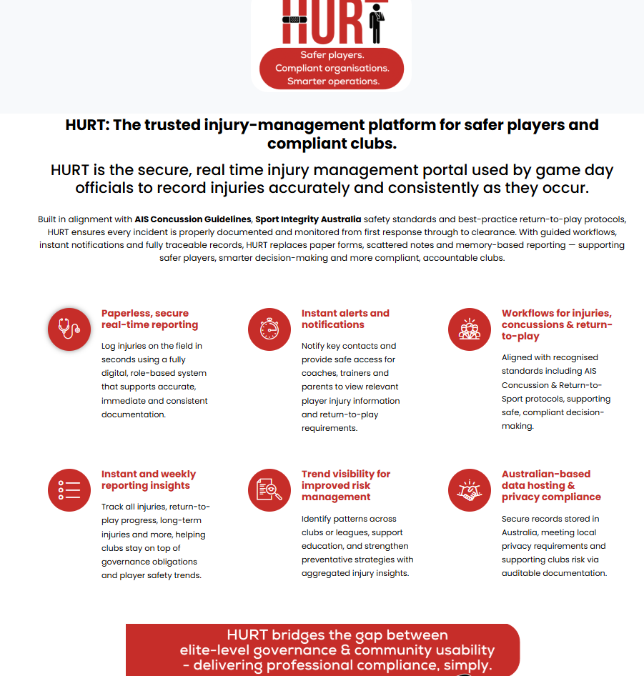

3.2 Medic / trainer will document ALL injuries and head knocks via HURT. They must bring mobile phone to games and log into HURT portal

  - Medic / trainer will educate player and parent / guardian about injury management and any recommended referral to healthcare provider. Medic / trainer will inform parent / guardian they will receive email from HURT Sports Buddy about injury, and concussion management protocol.

- MEDICAL NOTIFICATION
4.1 At the start of the season, Medic Coordinator will send out club medical form, via team manager, for each player to submit. The player (or parents) must advise of any conditions that would place the player at risk or could impede his/her ability to participate.
4.2 The player medical forms are retained by team trainer/medic will be destroyed at the end of the season.
4.3 All injuries are to be reported to the trainer/medic in the first instance.
4.4 If the Coach or trainer/medic is concerned about a player’s medical status they may require the player to provide a medical certificate stating that they are fit to play, prior to resuming training / playing.

5. RETURN TO PLAY & MEDICAL CLEARANCES
5.1 The requirement for medical clearances is about ensuring that players seek medical attention for conditions that may cause them further serious health problems in the long term. For certain injuries and illnesses, a player will not be permitted to return to training or participate in any further games until a medical clearance is made by a Doctor, Physiotherapist, Chiropractor, Osteopath, Dentist or Psychologist (As AHPRA guidelines) and the paperwork has been provided to the Team Medic / Trainer.
5.2 Conditions where a medical clearance is required are:
- Any form of cardiac (heart condition)
- Hypertension (history of high blood pressure)
- Broken bones of any sort
- Significant soft tissue injuries (where a player has not recovered to a playing capacity one-week post injury)
- Any form of concussion
- Any form of unconsciousness, no matter how brief
- Any form of potential cervical (neck) injury
- Repeated episodes of illness of and already diagnosed medical conditions such as asthma, diabetes and epilepsy
- Any injury involving the eye itself
- Any player recovering from a significant illness, such as:- Chicken pox, Measles, Whooping cough, Glandular fever, Pneumonia, any form of influenza where it has caused the player to miss games and training greater than one week, any immune depressed conditions.
5.3 The medical clearance/certificate should state that “The player is fit to return to Football”
5.4 The above list is not exhaustive, and a common-sense approach will be used when requesting a medical clearance. Many of the above conditions can be made worse by physical activity and cause the player/s further illness or discomfort. Some medical conditions can also be contagious and pose a risk to other players and coaching staff.
5.5 The medical clearance may also be subject to conditions attached by the doctor/physio for example restricting the player to only light training and no games or player is only permitted to play x amount of minutes etc. Coaches will be guided by these recommendations.
5.6 The return to play will be at the discretion of the Coach and Trainers. Once a medical clearance has been provided, the Coach/Club and Trainer may be required to confirm the player’s fitness to resume training or participation in game play.
5.7 Medic / trainer will upload Medical Clearance forms into HURT portal asap. Player will not be able to return to play without medical clearance. This includes any injury, not limited to concussion, referred to healthcare provider.

6. STRAPPING
6.1 The tape provided in medic kits is for injury treatment or management not for routine pre-game or existing injury taping/strapping. If any player wants to be strapped pre-game, they must provide their own tape.
6.2 Medics/trainers are not expected to provide strapping, massage, or other treatment outside of the scope of their qualifications, i.e.; (Sports Trainer Level 1 = ankle / fingers / thumb taping). If taping is required as part of injury rehabilitation, either a parent tapes the player, or clear instruction is provided to the medic/trainer by the medical practitioner. The medic/trainer has the right to decline if not comfortable.

7. INJURY MANAGEMENT AND ICE PACKS
7.1 Medic / trainer may apply instant ice pack to player’s injury. Ensure instant ice pack is covered to protect skin.
7.2 If a player receives an injury, WJFC medic / trainer will assess player injury via TOTAPS (Talk. Observe. Touch. Active Movement. Passive Movement. Skills Test), as per Sports Trainer Level 1 course. If player passes the TOTAPS test, they may return to play. If player is unable to pass TOTAPS test, they must sit out the rest of the game and be referred to healthcare provider.
7.3 If a player has instant ice pack applied to injury for a short time and passes TOTAPS test, they may return to play (excluding suspected concussion).
RISKS
• Returning to training or matches without medical clearance increases the player risk of further or chronic injury.
• Trainers/medics must seek player consent prior to providing first aid or medications administration, noting that consent is included in player medical forms.

PRIVACY
All medical information is confidential. Access to any WJFC Medical form is limited to Team Trainer/Medic, Team Manager, Coach and Medic Coordinator. This information will be treated in accordance with the Privacy Statement below.
Victorians are protected by three pieces of privacy legislation – The Victorian Information Privacy Act 2000, the Victorian Health Records Act 2001 and the Federal Privacy Act 1988 (extended in 2001)

POLICY REVIEW
This Policy will be reviewed annually to ensure it remains relevant, practical and that it reflects Community AFL Concussion Management guidelines/expectations and legal requirements. The Policy will be reviewed in the first instance by WJFC Medic Coordinator and Executive Committee.

This document was tabled to the Executive Committee, and the above stated Policy was voted upon and endorsed/accepted by majority vote.
Whittlesea Junior Football Club Executive & General Committee March 2026.

