AMERICA'S FIRST BLACK EPISCOPAL PRIEST
By the Reverend Canon Richard L. Marquess-Barry, 1986

ABSALOM JONES was born a slave in Sussex County, Delaware in 1746. He taught himself to read and write. In 1762, he was sent to Philadelphia, Pennsylvania to work in his master's store. In the evenings he attended school. In 1786, Jones met Richard Allen. They became lay preachers for the Black members of Saint George's Methodist Episcopal Church. As result of their active evangelistic and pastoral efforts, the Black membership increased more than tenfold. The Church officials became alarmed. One Sunday morning, the White leaders of the Church decided that the Black members must sit in the gallery. Jones and Allen, along with others Blacks, disagreed and walked out of the Church. Blacks saw the request for them to sit in the gallery as degrading to them. Most of them were free. The gallery was always reserved for slaves throughout the states.
On -April 12, 1787, Jones and Allen organized the Free African Society, the first know publicly organized society among Afro-Americans. It was both religious and benevolent. Members met monthly and paid dues which were applied to burial expenses, sick relief, and for help to orphans and widows. Members who drank or disregarded marriage vows were rigorously disciplined and finally, they were put out of the society.
On January 1, 1791, Jones and Allen started having church services on Sunday. The African Church was organized on July 7, 1791. Jones and Allen thought the African Church should become a Methodist Church. They thought the Methodist religion was better for Black people. Most of the members of the Church disagreed with Jones and Allen. They did not want to be Methodist because the White Methodists had "so violently persecuted" the Black members. Allen withdrew from the African Society. Jones reluctantly remained as sole leader. Richard Allen, along with those who followed him, went on to found the African Methodist Episcopal Church.
Absalom Jones, with the aid of Quakers and Episcopalians, erected the African Church that was dedicated on July 17, 1794 by two Episcopal pastors. The African Church applied for membership in the Episcopal Diocese of Pennsylvania on the following conditions: (1) that they be received as an organized body; (2) that they have control over their local affairs; (3) that Absalom Jones be licensed as Lay Reader, and if qualified, be ordained as minister. In October, 1794, it was admitted as Saint Thomas African Episcopal Church. Bishop White ordained Jones as deacon in 1795 and as priest on September 21, 1802. Neither Jones nor his members were permitted to participate in Diocesan life. Thus Jones and his followers once again faced exclusion.
For Absalom Jones, the Church was not only for worship, religious instruction and education but for mutual aid and for protest. The founders of Saint Thomas' stated that they had organized "For the purpose of advancing our friends in a true knowledge of God, of true religion, and the ways and means to restore our long lost race to the dignity of men.”
Since Blacks were excluded from the Public Schools of Pennsylvania, education was a major need of the Black community. Absalom Jones founded a Day School at the Church. At Saint Thomas' he founded the Female Benevolent Society.
During the severe yellow fever epidemic of 1793, Absalom Jones and Richard Allen mobilized the Black community to care for the afflicted. In 1797 and 1799 Absalom Jones, with other free Africans, presented tenable petitions to Congress and to the President of the United States opposing slavery. Two schools and supportive services for the Black community developed under his leadership.
Absalom Jones and Richard Allen continued in closed friendship as co-workers for uplifting of Afro-Americans. In 1794, Allen purchased an old building and dedicated it as Bethel African Methodist Episcopal Church. In 1798, a branch of the African Masonic Lodge was founded in Philadelphia. Jones was elected as the Worshipful Master and Allen as the Treasurer. Although both protested against Slavery, Allen was much more direct and vocal in his opposition. Jones preached a Thanksgiving sermon on the Abolition of the Slave Trade in 1808. During the war of 1812; they jointly recruited 3,000 Blacks to form a "Black Legion". They also founded an insurance company and a society for the suppression of vice and immorality.
In 1816, Jones united with four Methodist Ministers to consecrate Allen as Bishop over the newly formed African Methodist Episcopal Church. Thus Jones helped to ordain the First Black Bishop of any Church in the United States. Allen became Bishop over Churches with nearly 7,000 members. Saint Thomas' Church, which attracted more prosperous Blacks, remained small.
Absalom Jones was known as "the Black Bishop of the Episcopal Church." His constant visiting of his flock and his mild manner endeared him not only to his people but to the larger community as well. Absalom Jones died on February 13, 1818. He was buried in the cemetery of Saint Thomas' Church. He is significant not only because he was the first person of African descent ordained to the priesthood in the American Church, but because he was a leader in the establishment of religious, educational and social institutions for the uplifting of Afro-Americans and under their leadership and control.
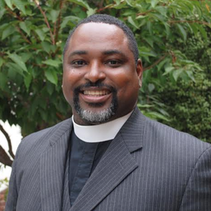

The Rev. Dr. Mauricio Wilson

The Reverend Mauricio Wilson, who also answers to Fr. Wilson or Fr. Mauricio, is the recently elected National Board President of the Union of Black Episcopalians and has been the Rector of St. Paul’s Episcopal Church in Oakland, California, since October 2009. As the Rector of St. Paul’s, he holds ex-officio seats on the Board of Clausen House in Oakland and St. Paul’s Episcopal School. Since arriving in the Bay Area to serve at St. Paul’s, he is also active in ministries around Oakland and the Diocese of California.

The Rev. Wilson served on the Standing Committee and Executive Council of the Diocese of California, the Program and Budget Committee and chaired the Assessment Relief Committee, as well as the Diocesan Committee on Nominations. He is a former member of the Governing Board of the National Association of Episcopal Schools and of the Board of Trustees of the Church Divinity School of the Pacific. Fr. Wilson was a Mayoral appointee to the City of Oakland’s Citizens Police Review Board and served as a commissioner for 2016 and 2017.

A lifelong Episcopalian, he is the child of deeply committed church leaders. His mother serves as a multidimensional lay leader of her parish and his father (R.I.P.) was Bishop of Costa Rica. Fr. Mauricio started preaching at age 17 and was Youth Director of the Diocese of Costa Rica for 15 years. A business and accounting major at the University of Costa Rica, he was a registered CPA in his home country, eventually working as a corporate auditor.) “My first calling was always to the priesthood,” said Fr. Wilson, who is bilingual in English and Spanish. “Accounting was my backup plan.”

He attained the Doctor of Ministry degree in Ministry Development from Virginia Theological Seminary in 2013, as well as Master’s degrees in Divinity and Sacred Theology (Liturgy) from General Theological Seminary in 2000 and 2001, respectively. His wife, Karla, is a Doctor of Mechanical Engineering and they have two children who attend San Francisco State University.

Fr. Mauricio’s hobbies include cooking, collecting wines, and driving different kinds of vehicles. His favorite book is Dan Brown’s Angels & Demons, and he believes he’s seen his favorite movie, The Matrix, 150 times.

The Holy Eucharist
HymnSing

Greetings

At the entrance of the altar party, please stand as you are able.
African Percussion Voluntary and Processional

Opening Hymn “We’ve Come This Far by Faith” Albert A. Goodson All sing.
Jevon Clarke, tenor soloist
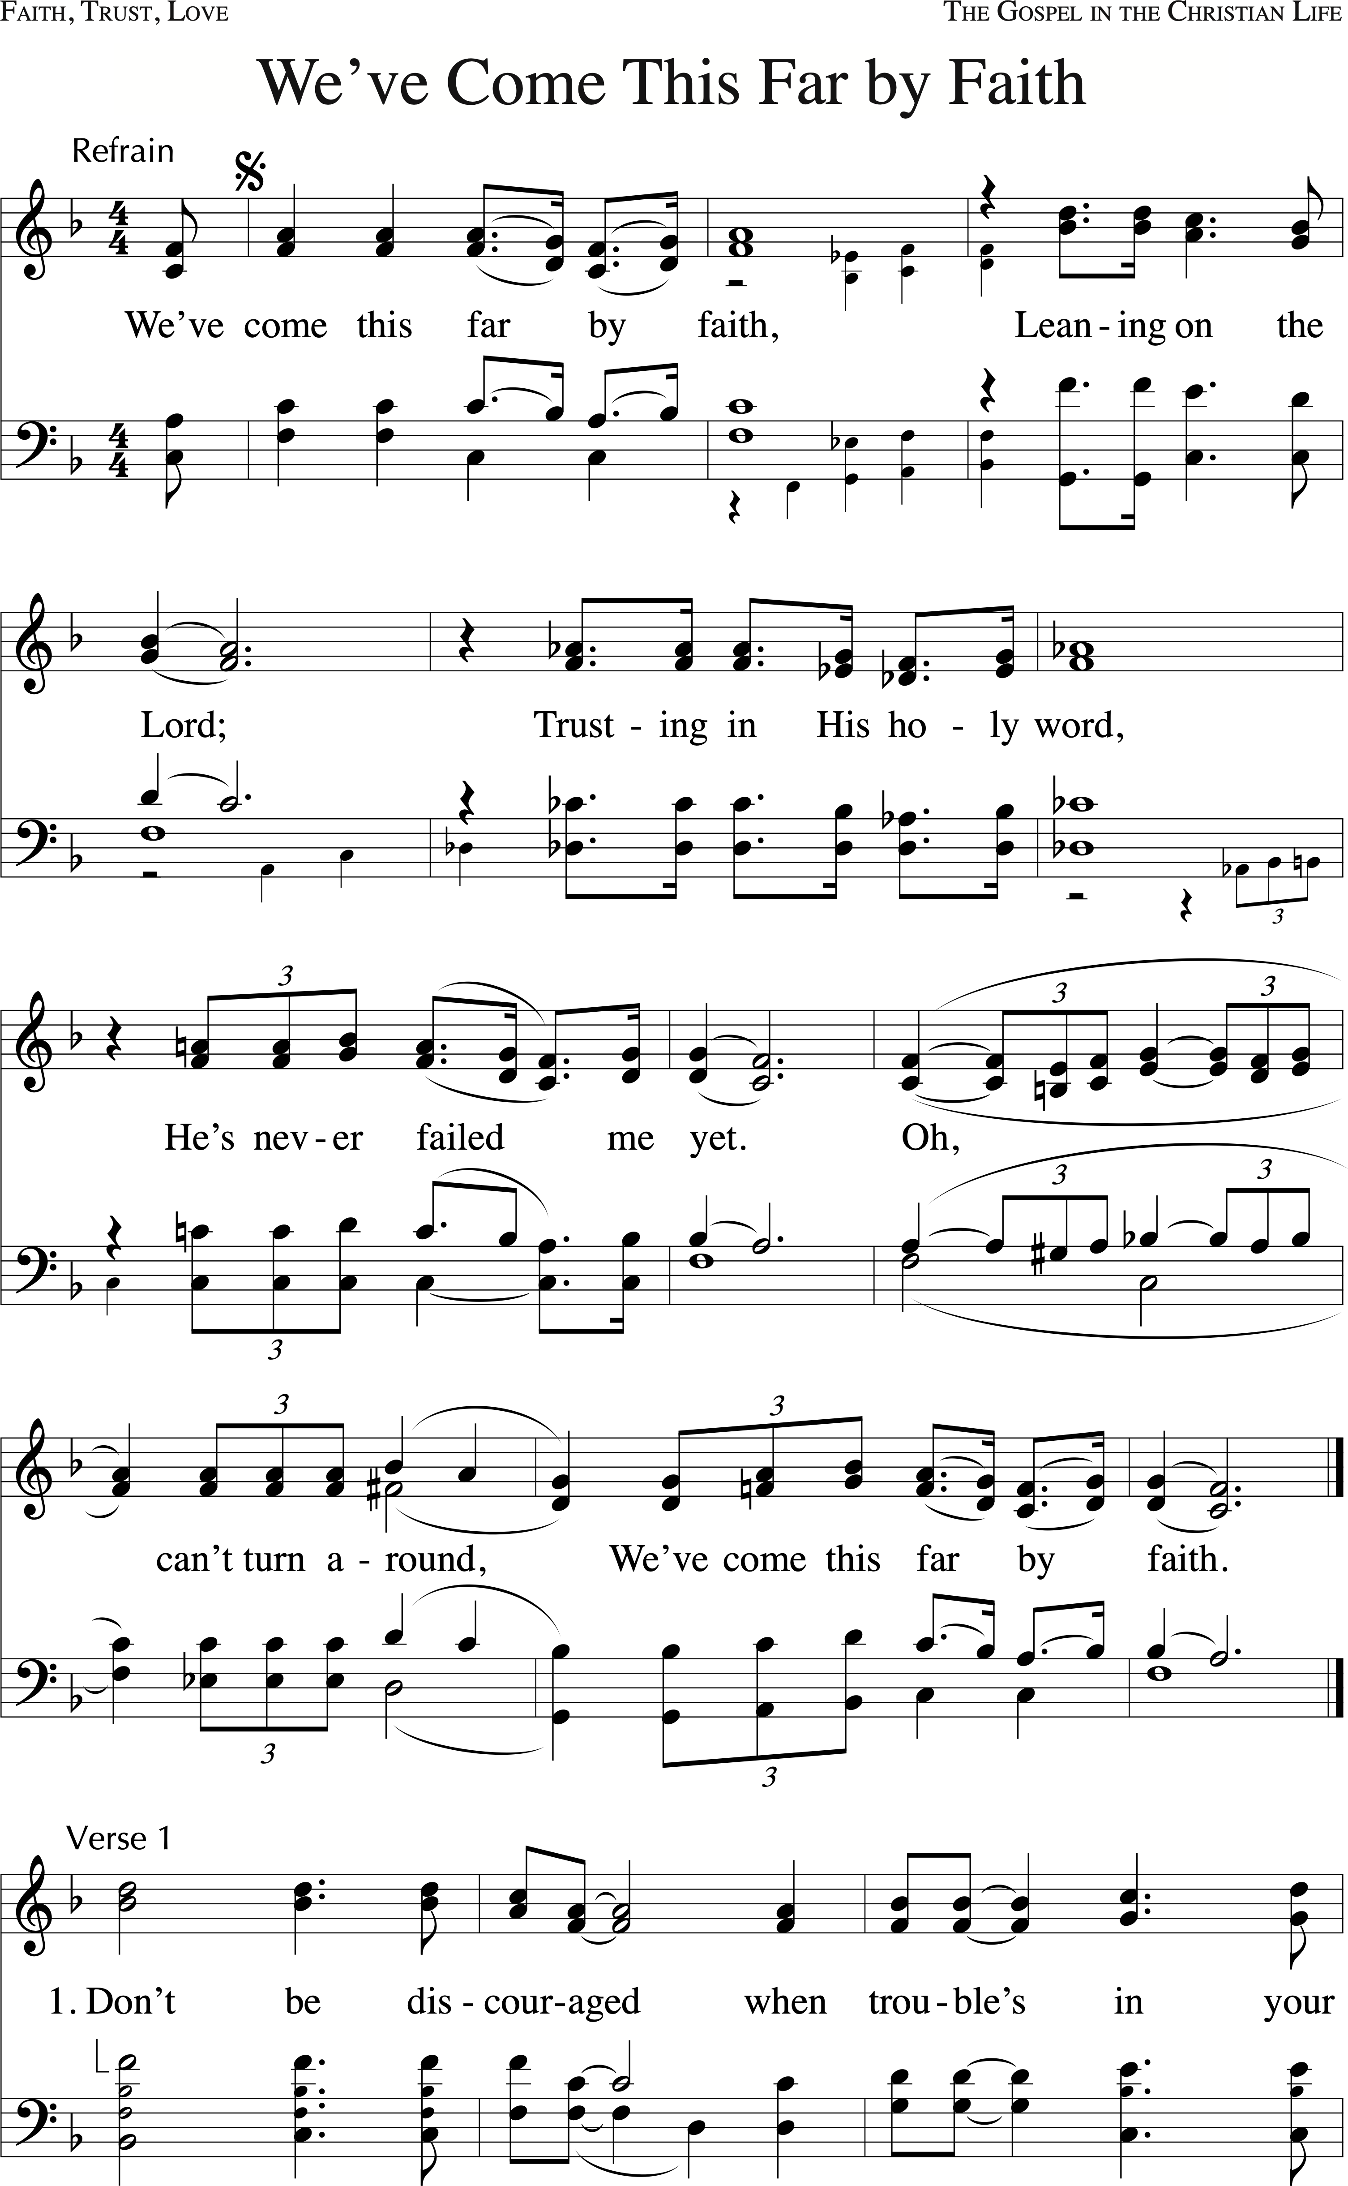
The hymn continues on page 4.
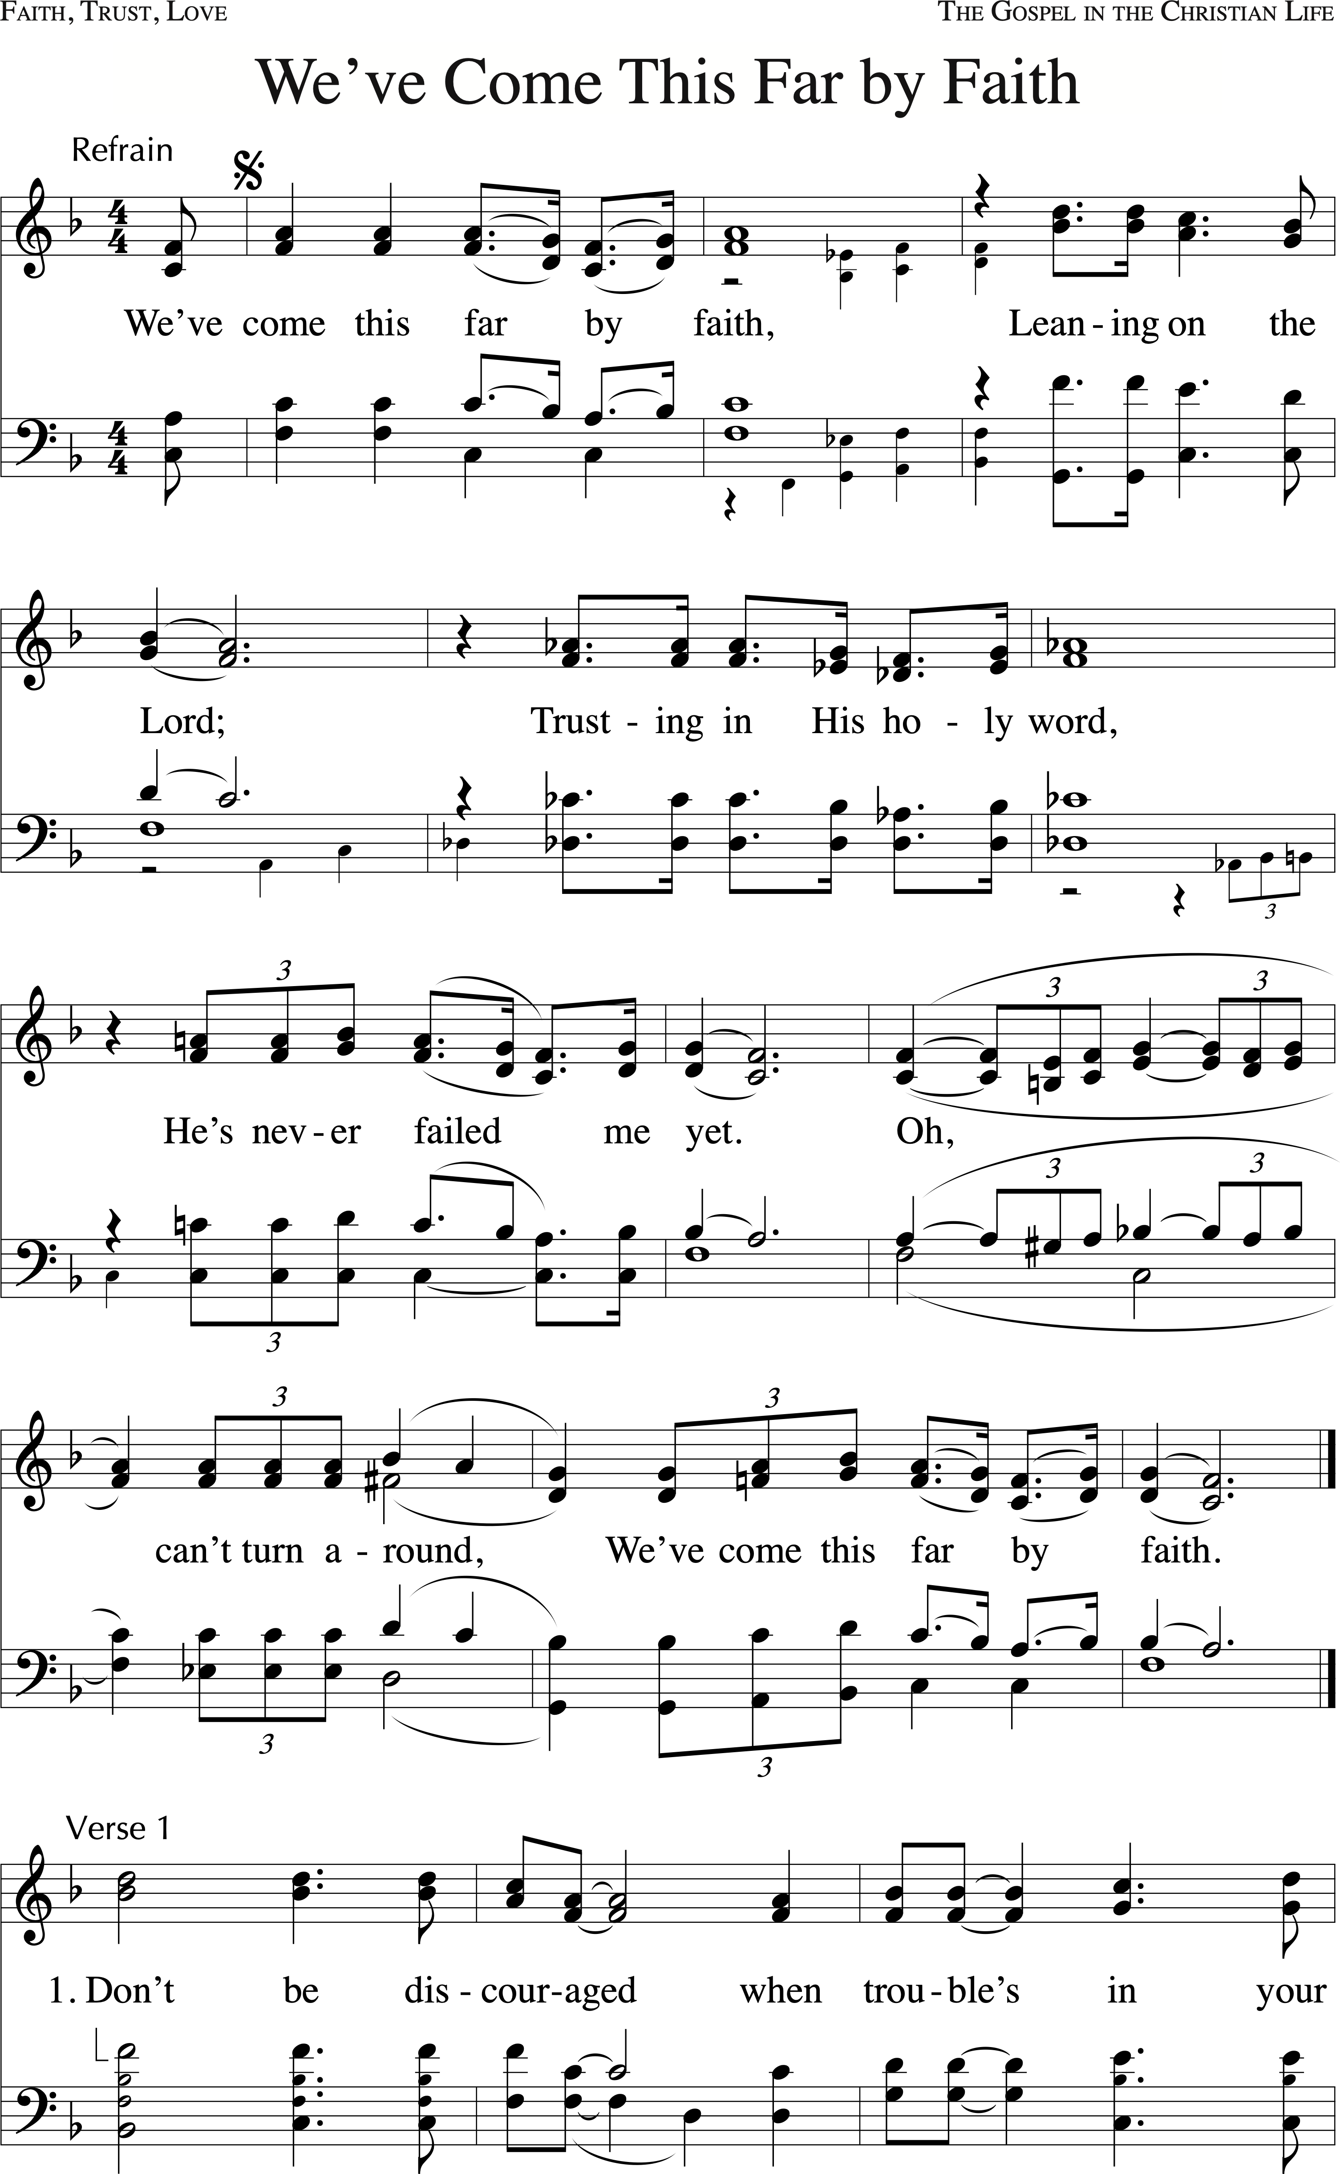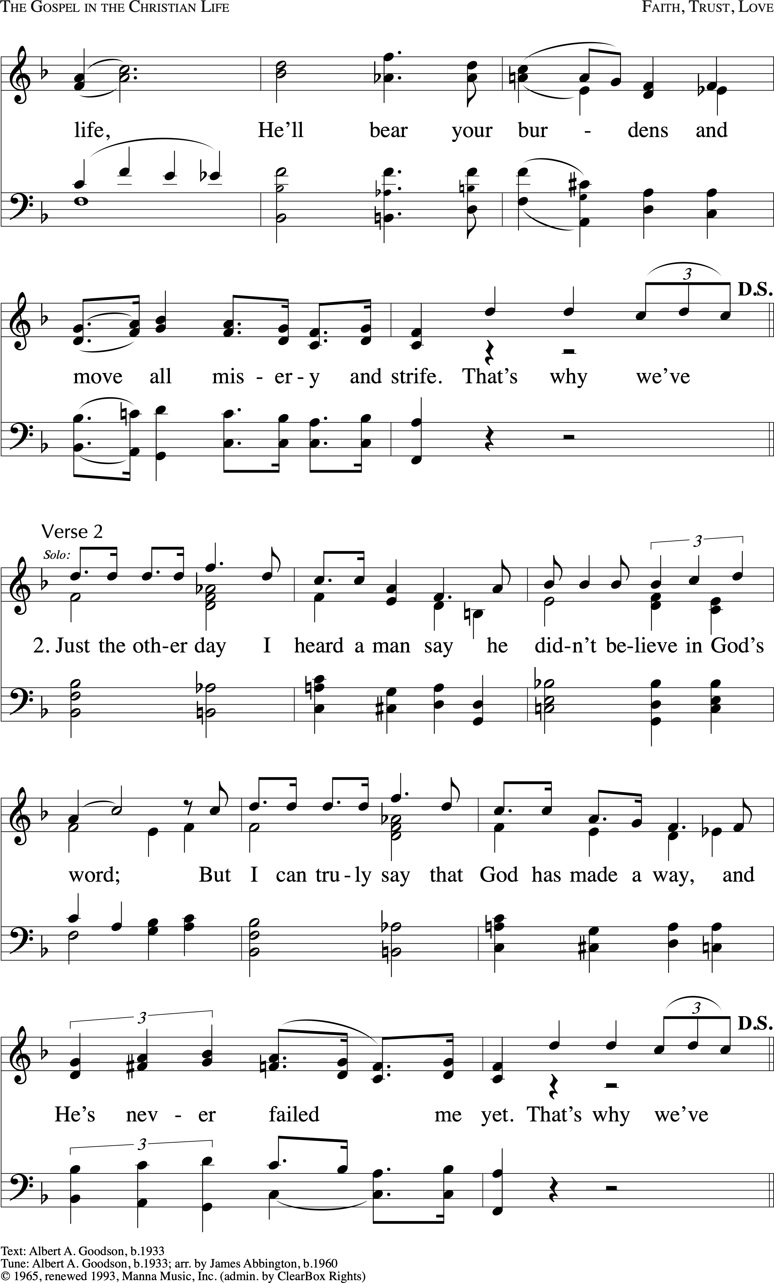
Sing the Refrain & Ride Out.

Ride Out
We’ve come this far by faith, we’ve come this far by faith,
we’ve come this far by faith.
Liturgy of the Word
Acclamation
Bishop God is here.
People And we are God’s People

Bishop Blessed be God: Father, Son, and Holy Spirit.
People And Blessed be his kingdom, now and forever. Amen.

Collect for Purity
Bishop Almighty God, to you all hearts are open, all desires known, and from you no secrets are hid: Cleanse the thoughts of our hearts by the inspiration of your Holy Spirit, that we may perfectly love you, and worthily magnify your holy Name; through Christ our Lord.
People Amen.

Kyrie “Lord, Have Mercy” (Eucharist of the Soul) Lena McLin All sing.

Collect for the Feast of Absalom Jones
Bishop The Lord be with you.
People And also with you.
Bishop Let us pray.

Almighty and everliving God, who raised up your servant Absalom Jones to proclaim liberty to the captives and grace to the weary: Grant that we, empowered by your Holy Spirit, may rise with courage in the face of injustice and walk with humility in the path of your peace. Stir up in us the faith that casts out fear, the love that conquers hate, and the grace that leads us boldly into your kingdom. Through Jesus Christ our Lord, who lives and reigns with you and the Holy Spirit, one God, now and for ever.
People Amen.

All sit.
First Reading Isaiah 61:1-4, 8-11
Reader A reading from Isaiah
The spirit of the Lord God is upon me because the Lord has anointed me;
he has sent me to bring good news to the oppressed, to bind up the brokenhearted, to proclaim liberty to the captives and release to the prisoners, to proclaim the year of the Lord’s favor and the day of vengeance of our God, to comfort all who mourn, to provide for those who mourn in Zion—to give them a garland instead of ashes, the oil of gladness instead of mourning, the mantle of praise instead of a faint spirit. They will be called oaks of righteousness, the planting of the Lord, to display his glory. They shall build up the ancient ruins; they shall raise up the former devastations;
they shall repair the ruined cities, the devastations of many generations.

For I, the Lord, love justice, I hate robbery and wrongdoing; I will faithfully give them their recompense, and I will make an everlasting covenant with them. Their descendants shall be known among the nations and their offspring among the peoples; all who see them shall acknowledge that they are a people whom the Lord has blessed. I will greatly rejoice in the Lord; my whole being shall exult in my God, for he has clothed me with the garments of salvation; he has covered me with the robe of righteousness, as a bridegroom decks himself with a garland and as a bride adorns herself with her jewels.
For as the earth brings forth its shoots and as a garden causes what is sown in it to spring up, so the Lord God will cause righteousness and praise to spring up before all the nations.

(Silence)

Reader Here what the Spirit is saying to God’s people.
People Thanks be to God.

Psalm 27:1-7 Dominus illuminato “The Lord is My Light and My Salvation”
Music: Refrain–Carl MaultsBy; Verses–Carl Haywood
The cantor sings the Refrain. All repeat the Refrain and chant the Verses as indicated.
Stephen O’Connell, cantor
Refrain
Verses
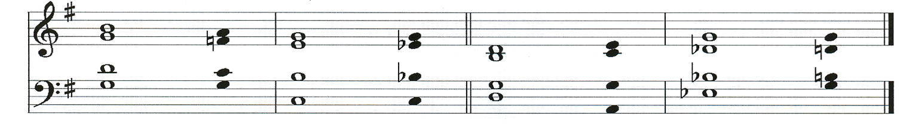
1 The Lord is my light and my salvation;
whom then shall I fear? *
the Lord is the strength of my life;
of whom then shall I be a-fraid?
2 When evildoers came upon me to eat up my flesh, *
it was they, my foes and my adversaries, who stumbled and fell. (Refrain)

3 Though an army should encamp a-gainst me, *
yet my heart shall not be a-fraid;

4 And though war should rise up a-gainst me, *
yet will I put my trust in him. (Refrain)

Second half
5 One thing have I asked of the Lord;
one thing I seek; *
that I may dwell in the house of the Lord all the days of my life;
The psalm continues on page 7.

6 To behold the fair beauty of the Lord *
and to seek him in his temple.
7 For in the day of trouble he shall keep me safe in his shelter; *
he shall hide me in the secrecy of his dwelling
and set me high upon a rock. (Refrain, 2x)

Second Reading Ephesians 4:1-6
Reader A reading from Ephesians

I, therefore, the prisoner in the Lord, beg you to walk in a manner worthy of the calling to which you have been called, with all humility and gentleness, with patience, bearing with one another in love, making every effort to maintain the unity of the Spirit in the bond of peace: there is one body and one Spirit, just as you were called to the one hope of your calling, one Lord, one faith, one baptism, one God and Father of all, who is above all and through all and in all.

Reader Here what the Spirit is saying to God’s people.
People Thanks be to God.

A Brief History of the Canon Nelson Pinder UBE Chapter
The Union of Black Episcopalians (UBE) stands in the continuing tradition of more than 200 years of Black leadership advocating for civil, social and economic justice within The Episcopal Church. Building upon the labor of earlier organizations dedicated to “the betterment of Colored People,” the Union of Black Clergy and Laity was founded in 1968. In 1971 the name was changed to the Union of Black Episcopalians.
Initiated in 1995 by the efforts of the late Rev. Canon Nelson Wardell Pinder, Ms. Una Harrison and the late Ms. Krisita A. Jackson, the Central Florida Chapter was established following the 27th Annual Meeting and Conference of the National UBE held in Orlando. Ms. Harrison was the Chapter’s first president. Subsequent Chapter presidents were Dr. Brenda Y. Person, Mr. Greg Person, the late Ms. Grace Burgess, Dr. Carl MaultsBy, the Rev. Deacon Brenda Taylor, John F. Robertson, Ph.D., and current president, Ms. Carrie Brown.
In 2021 the Chapter’s name was officially changed to the Canon Nelson Pinder UBE (CNP-UBE) to honor the life and legacy of Canon Pinder, a fierce champion of the Civil Rights Movement who kept the city of Orlando peaceful during the height of protest and civil disobedience of the 1960s.
CNP-UBE many activities include the annual commemoration of the Feast of Absalom Jones, the first Black Episcopal priest. The commemoration is a consciousness raising, educational and informational event with the goal of financially supporting the Episcopal affiliated Historically Black Colleges and Universities of Vorhees College and St. Augustine’s University.
In 2025, the Chapter initiated its Justice, Faith and Legacy Luncheon to commemorate the Feast Day of Thurgood Marshall. The event honors Marshall’s trailblazing legacy as a civil rights attorney, Supreme Court Justice, and devoted Episcopalian whose faith guided his fight for Justice and equality. On this occasion, CNP-UBE presents its Community Impact Award to an individual who has demonstrated a commitment to advancing social justice in Florida.
Sequence Hymn “Sweet, Sweet Spirit” Doris Akers All sing.

The Holy Gospel John 15:12-17
Deacon The Holy gospel of our Lord Jesus Christ according to John.
People Glory to you, Lord Christ.

Deacon This is my commandment, that you love one another as I have loved you. No one has greater love than this, to lay down one’s life for one’s friends. You are my friends if you do what I command you. I do not call you servants[a] any longer, because the servant[b] does not know what the master is doing, but I have called you friends, because I have made known to you everything that I have heard from my Father. You did not choose me, but I chose you. And I appointed you to go and bear fruit, fruit that will last, so that the Father will give you whatever you ask him in my name. I am giving you these commands so that you may love one another

Deacon The Gospel of the Lord.
People Praise to you, Lord Christ.

The people sit.
Sermon

Please stand as you are able.
Nicene Creed
All | We believe in one God, the Father, the Almighty, maker of heaven and earth, of all that is, seen and unseen.  We believe in one Lord, Jesus Christ, the only Son of God, eternally begotten of the Father, God from God, Light from Light, true God from true God, begotten, not made, of one Being with the Father. Through him all things were made. For us and for our salvation he came down from heaven: by the power of the Holy Spirit he became incarnate from the Virgin Mary, and was made man.  For our sake he was crucified under Pontius Pilate; he suffered death and was buried. On the third day he rose again in accordance with the Scriptures; he ascended into heaven and is seated at the right hand of the Father. He will come again in glory to judge the living and the dead, and his kingdom will have no end.  We believe in the Holy Spirit, the Lord, the giver of life, who proceeds from the Father and the Son. With the Father and the Son he is worshiped and glorified. He has spoken through the Prophets. We believe in one holy catholic and apostolic Church. We acknowledge one baptism for the forgiveness of sins. We look for the resurrection of the dead, and the life of the world to come. Amen.

Prayers of the People (for the Feast of Absalom Jones)
Deacon God of our weary years, God of our silent tears,
You have walked with your people through bondage and through blessing.
As we gather to remember your servant Absalom Jones,
we come before you with hearts open to rise, and feet ready to walk; we pray

Leader For the Church, your Body on earth:
May she rise with boldness to proclaim good news to the poor,
liberty to the oppressed, and healing to the brokenhearted.
Bless bishops, clergy, lay leaders, and all who serve in your Name.
People Empower us, O God, to rise in the power of the Spirit, and walk in grace.

Leader For this nation and all in authority:
Let justice roll down like waters,
and righteousness like an ever-flowing stream.
Guide our leaders to govern with equity, mercy, and humility.
People Empower us, O God, to rise in the power of the Spirit, and walk in grace.

Leader For all who suffer in body, mind, or spirit:
The sick, the grieving, the poor, the displaced, and the lonely;
especially those harmed by racism, violence, or exclusion.
Wrap them in your healing love and lift them into new life.
People Empower us, O God, to rise in the power of the Spirit, and walk in grace.

Leader For all people, especially for all Black Episcopalians,
and all historically Black congregations:
Grant us strength to tell our stories, claim our place,
and continue the work of those who came before us.
People We have known this road before.
We have moved forward with faith.
And by your Spirit, O God, we press on with power and grace.

Leader For the faithful departed who have gone before us,
especially Absalom Jones and the saints who built the Church with their prayers, their labor, and their hope.
May we honor them not just in memory, but in action/
People We have known this road before.
We have moved forward with faith.
And by your Spirit, O God, we press on with power and grace.

Leader And for ourselves, O Lord,
Grant us the courage to rise where there is fear,
and the grace to walk where there is pain.
Make us instruments of your Spirit, witnesses of your truth, and vessels of our peace.
People Empower us, O God, to rise in the power of the Spirit, and walk in grace.

Bishop Holy and gracious God,
You have been our dwelling place in every generation.
Uplift us now by your Holy Spirit.
Strengthen us to rise, embolden us to speak,
and teach us to talk always in your grace;
through Jesus Christ our Savior.
All Amen.

Confession of Sin
Deacon Let us confess our sins against God and one another,
trusting in the Spirit’s power to renew us and grace to restore us.

Please stand or kneel as you are able.
Silence
All God of justice and mercy,
we confess that we have not always responded
when your Spirit called us to rise.
At times we have chosen comfort over courage,
routine over renewal,
and hesitation over hope.
We confess that we have not always walked in grace.
We have missed chances to forgive,
to extend kindness,
or to accompany those in need with compassion.
Forgive us, O God,
for the times we have settled for less than your calling,
for the ways we have held back love,
and for the moments we have forgotten who and whose we are.
By the same Spirit that raised Jesus from the dead,
lift us again into new life.
Empower us to rise with joy and purpose,
and to walk in grace with humility and love.
In the name of Jesus Christ, our Savior and guide.
Amen.

Absolution
Bishop Almighty God have mercy on you, forgive you all your sins through our Lord Jesus Christ, strengthen you in all goodness, and by the power of the Holy Spirit keep you in eternal life.
All Amen.

Peace
Bishop The peace of the Lord be always with you.
People And also with you.

The Ministers and People great one another in the name of the Lord.



The Holy Communion
Offertory Sentence
Bishop | Walk in love, as Christ loved us and gave himself for us, an offering and sacrifice to God. Ephesians 5:2
The Offertory proceeds will be donated towards Historically Black Colleges & Universities scholarships. Make checks payable to Canon Nelson Pinder UBE or use the QR code to donate online.

Offertory Hymn “The Lord Is My Light and My Salvation” Lillian Bouknight All sing.

Please stand as you are able. All sing.
Presentation Hymn “Blessed Absalom” Words: Harold Lewis; Music: Lauda Anima, John Goss

Eucharistic Prayer A
Sursum Corda
Bishop | The Lord be with you.
People | And also with you.
Bishop | Lift up your hearts.
People | We lift them to the Lord.
Bishop | Let us give thanks to the Lord our God.
People | It is right to give him thanks and praise.
Bishop | It is right, and a good and joyful thing, always and everywhere to give thanks to you, Father Almighty, Creator of heaven and earth.  For the wonderful grace and virtue declared in all your saints, who have been the chosen vessels of your grace, and the lights of the world in their generations.  Therefore we praise you, joining our voices with Angels and Archangels and with all the company of heaven, who for ever sing this hymn to proclaim the glory of your Name:

Sanctus AND Benedictus “Holy, holy, holy” (Eucharist of the Soul) Lena McLin All sing.

Then the Bishop continues
Holy and gracious Father: In your infinite love you made us for yourself, and, when we had fallen into sin and become subject to evil and death, you, in your mercy, sent Jesus Christ, your only and eternal Son, to share our human nature, to live and die as one of us, to reconcile us to you, the God and Father of all.

He stretched out his arms upon the cross, and offered himself, in obedience to your will, a perfect sacrifice for the whole world.

On the night he was handed over to suffering and death, our Lord Jesus Christ took bread; and when he had given thanks to you, he broke it, and gave it to his disciples, and said, “Take, eat: this is my Body, which is given for you. Do this for the remembrance of me.”

After supper he took the cup of wine; and when he had given thanks, he gave it to them, and said, “Drink this, all of you: This is my Blood of the new Covenant, which is shed for you and for many for the forgiveness of sins. Whenever you drink it, do this for the remembrance of me.”

Therefore we proclaim the mystery of faith:

Memorial Acclamation “Jesus Christ Has Died” All sing. (Tune of “We Shall Overcome”)
Music: UBE Mass, Adapt. Curtis Cisco, arr. Carl MaultsBy
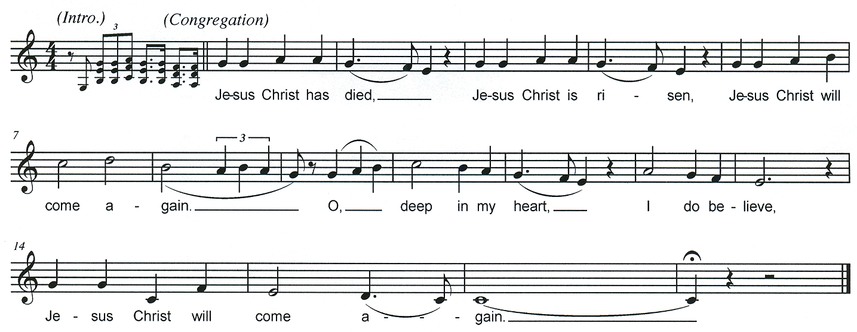
© 2004 Malted Milk Music

Bishop | We celebrate the memorial of our redemption, O Father, in this sacrifice of praise and thanksgiving. Recalling his death, resurrection, and ascension, we offer you these gifts.  Sanctify them by your Holy Spirit to be for your people the Body and Blood of your Son, the holy food and drink of new and unending life in him. Sanctify us also that we may faithfully receive this holy Sacrament, and serve you in unity, constancy, and peace; and at the last day bring us with all your saints into the joy of your eternal kingdom.  All this we ask through your Son Jesus Christ: By him, and with him, and in him, in the unity of the Holy Spirit all honor and glory is yours, Almighty Father, now and for ever.

GREAT AMEN (UBE Mass) All sing. African American Spiritual, arr. Carl MaultsBy
© 2006 Malted Milk Music

Bishop | As our Savior Christ has taught us, we now pray,

The Lord’s Prayer All sing.

Words: Book of Common Prayer;
Music: Traditional Scottish Chant, harm. Carl MaultsBy ©2006 Malted Milk Music

Breaking of the Bread
Bishop | Christ our Passover is sacrificed for us;
People | Therefore let us keep the feast.

AGNUS DEI “Fraction Anthem: Lamb of God” (Eucharist of the Soul) Lena McLin All sing.

INVITATION TO COMMUNION
Bishop | The Gifts of God for the People of God. Take them in remembrance that Christ died for you, and feed on him in your hearts by faith, with thanksgiving.

CO
MMUNION HYMNS
“Jesus is here right now” Leon Roberts
All sing the Refrain twice. The cantor sings each verse. All sing the Refrain where designated and following Verse 2, as the Spirit leads.

Refrain
Verses
- Do not let your old hearts be troubled. Have faith in God and have faith in me.
In my Father’s house there are many mansions; otherwise, how could I told you so? Refrain

- I am indeed going to prepare a place for you, and then I shall come back to take you with me, that where I am you also may be,
For you know the way that leads to where I go. Refrain

“Let us talents and tongues employ” Doreen Potter All sing.
© 1975 Hope Publishing Company.

Post Communion Prayer
Bishop | Let us pray.
All | Eternal God, heavenly Father, you have graciously accepted us as living members of your Son our Savior Jesus Christ, and you have fed us with spiritual food in the Sacrament of his Body and Blood. Send us now into the world in peace, and grant us strength and courage to love and serve you with gladness and singleness of heart; through Christ our Lord. Amen.

Please stand as you are able. All sing. The beginning of stanza 3 is sung quietly by All.
ORISON “Lift Ev’ry Voice and Sing” Words: James W. Johnson; Music: J. Rosamond Johnson
Blessing
Bishop  All  Bishop  All  Bishop  All  Bishop | May the God who calls us to rise, lift you with the strength of the Spirit.  Amen.  May Christ who walks beside us, guide your steps in grace and peace.  Amen.  May the Spirit who stirred Absalom Jones, stir your heart with courage, compassion, and holy boldness.  Amen.  And the blessing of God Almighty, the Father, the Son, and the Holy Spirit, be among you and remain with you always.
All | Amen.

Closing Hymn “Don’t You Let Nobody Turn You Aroun’” African-American Spiritual, arr. Carl MaultsBy
All sing.

©2026 Malted Milk Music

Dismissal
Deacon | Let us go forth into the world, rejoicing in the power of the Spirit and walking always in grace.
People | Thanks be to God.

PERCUSSION VOLUNTARY
On the sounding of the drums, please follow the percussionist to the Parish Hall.
The Luncheon Symposium begins in 10 minutes.

Permissions
Streaming and reprinted under OneLicense.Net#A722955
“Lord, Have Mercy,” “Holy, holy, Holy Lord” and “Lamb of God” from Eucharist of the Spirit, Lena McLin © 1972 Neil A. Kjos Music Company. All Rights Reserved.

“The Lord is my light and my salvation,” Music: Carl MaultsBy ©2019 Carl MaultsBy & Malted Milk Music.
All rights reserved.

Modified Anglican Chant in G Major from Mass for Grace, Carl Haywood © 1992 Carl Haywood.
“The Lord is my light and my salvation,” Lillian Bouknight ©1980 Savgos Music, Inc. All Rights Reserved.
“Don’t You Let Nobody Turn You Around,” African American Spiritual, arr. Carl MaultsBy. ©2026 Malted Milk Music. All rights reserved. Used by permission.

“Jesus Christ Has Died,” UBE Mass, Adapt. Curtis Cisco, arr. Carl MaultsBy, ©2004 Malted Milk Music

“Great Amen,” UBE Mass, African American Spiritual, arr. Carl MaultsBy, ©2006 Malted Milk Music

“The Lord’s Prayer,” Words: Book of Common Prayer;
Music: Traditional Scottish Chant, harm. Carl MaultsBy
© 2006 Malted Milke Music

“Jesus Is Here Right Now,” Leon Roberts, © 1986 GIA Publications, Inc.

“Let us talents and tongues employ,” Doreen Potter, © 1975 Hope Publishing Company.

“Don’t You Let Nobody Turn You Aroun’” African-American Spiritual, arr. Carl MaultsBy © 2026 Malted Milk Music

Streaming and reprinted under CCLI
“Sweet, Sweet Spirit,” Doris Akers, Copyright © 1962. Renewed 1990 Manna Music, Inc. All rights reserved.

Reprinted under RiteSong

“Blessed Absalom,” Words: Harold T. Lewis ©1992 Harold T. Lewis; Music: Lauda Anima, PD.
“Lift Ev’ry Voice and Sing” Words: James W. Johnson; Music: J. Rosamond Johnson

Service Participants

Celebrant
The Rt. Rev. Dr. Justin S. Holcomb
Bishop, Episcopal Diocese of Central Florida

Preacher
The Rev. Dr. Mauricio J. Wilson
National President, Union of Black Episcopalians

Deacon
The Rev. Dr. Ernest Ogbozor
St. Mary’s, Daytona Beach

Assisting Clergy & Greeter
The Rev. Dr. A. Dale Truscott
St. Richard’s, Winter Park

Readers
Stephen Perry, St. Timothy’s, Daytona Beach
Brenda Perry, St. Timothy’s, Daytona Beach

Litanist
The Rev. Soner Alexandre, Messiah, Winter Garden

Crucifer
Warren Carlson, St. Richard’s, Winter Park

Lay Eucharistic Minister
Dr. Deobrah Hensen-Governor
St. Timothy’s, Daytona Beach

Liturgist
Roger Johnson, Esq., St. John the Baptist, Orlando

Flowers
Kin Xuxa, St. Richard’s, Winter Park

The St. Richard’s Altar Guild

Ushers
Steven McConnell, Head Usher
St. Richard’s, Winter Park
Shirley Caballero, St. Richard’s, Winter Park
Adea Prime, St. John the Baptist, Orlando
May Prime, St. John the Baptist, Orlando
Lee Sands, St. John the Baptist, Orlando

Musicians
Cantors
Stephen O’Connell, St. Richard’s, Winter Park
Jevon Clarke, St. Richard’s, Winter Park
Celia Benton, St. John the Baptist, Orlando
Bill Smith, St. John the Baptist, Orlando

All Saints Choir
Soprano Christy Woodruff
Tenor Peter Rodrigues, Jimmy Walker

The Ascension Chorale
Soprano Mercy Bruce-Amanquah
Dr. Karen Adderly Clark, Teresa Fynn

St. John the Baptist Choir
Soprano Celia Benton, Ama Brown-Fenton, Una Harrison, Sonja Johnson Alto ShirleyBradley, Faye Henderson
Bass Pete Boyd, Bill Smith

Schola St. Richard’s
Soprano Susan McConnell
Alto Fernando Arnay, Kim Wheeler
Tenor Jevon Clarke, Bass Stephen O’Connell

African Percussion
Frederick Blanchard

Organ & Piano
Dr. Carl MaultsBy

Luncheon Symposium
Lunch 12:00 P.M.

Table Talk - Moderated by Faye Henderson and Roger Johnson: 12:45 - 1:45

Summaries of Table Talks

Acknowledgements

Closing Prayer

