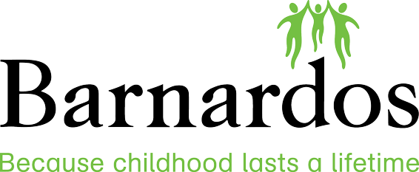

Barnardos National Parent Support Service
Response to Covid-19 Pandemic
Barnardos provides practical and emotional supports to children and parents in its 41 centres, in families’ own homes, through the school environment, and within communities across Ireland. Last year we worked with over 20,000 children, young people and their families.
Given our expertise in providing a wide variety of supports to families and children, Barnardos have launched a national telephone and email support service for parents in response to the challenges they are facing during the Covid-19 pandemic. This service will be staffed by Barnardos project workers who are trained professionals in the areas family support and social care.
The government’s response to Covid-19 has meant that normal routines and sources of support are currently unavailable to many families. Through our dedicated telephone and email support service Barnardos staff can provide support and advice to parents on the following issues:
- How to talk to your children about the corona virus
- Setting a good routine
- Managing children’s behaviours and sibling dynamics
- Managing aggression and family discord
- Home schooling/managing school expectations.
- Fostering natural learning opportunities in the home
- Healthy eating
- Accessing fun and educational activities for families and individual children
- Managing your child’s worries
- Self-care for parents
- Helping parents manage their own worries and anxieties
- Managing children’s online activity
Barnardos also provides specialist services and support in relation to bereavement, adoption and fostering.
You can make contact with this service by phoning 1800 910 123 between 10.00am and 2.00pm Monday to Friday or by emailing parentsupport@barnardos.ie.

