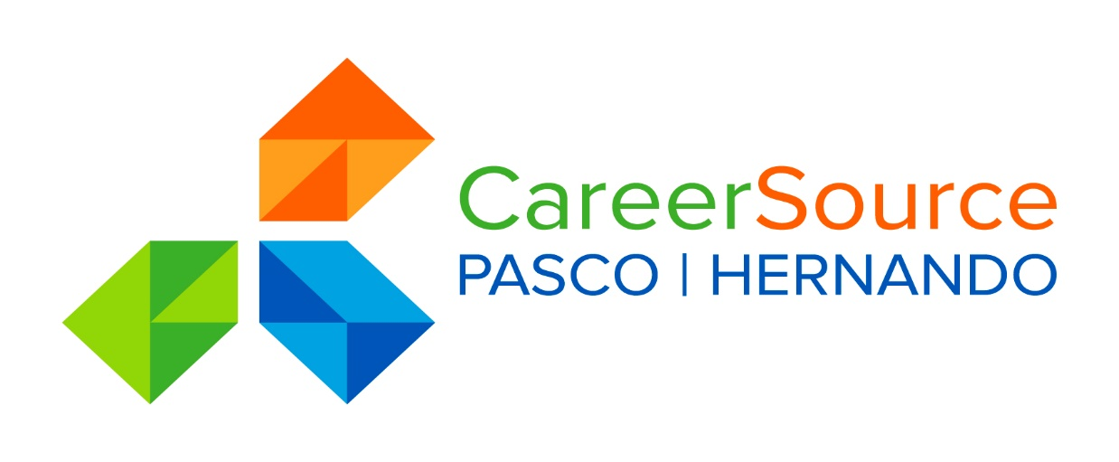

CareerSource Pasco Hernando
One Stop Operator Report
PY19-20

Background

WIOA and its implementing regulations require Local Workforce Development Boards (LWDBs) to use a competitive process for the selection of a one-stop operator for the system, and to support continuous improvement through the evaluation of one-stop operator performance and the re-competition of operators every four years. CSPH used the competitive to promote the efficiency and effectiveness of one-stop operators by providing a mechanism to examine performance and costs against original expectations.
CSPH staff issued a One Stop Operator (OSO) RFP and Gulf Coast Jewish Family & Community Services (GCJFCS) was selected. The initial term of the contract was October 1, 2019 through June 30, 2020 with an option to renew for two (2) additional one-year terms.
OSO oversight includes reports for Partner Program Performance, sharing information between CSPH and partner agencies through Quarterly Partner Meetings and in-person or telephonic one on one meetings. The OSO may also assist with tracking within the One Stop including traffic flow, tracking in-house recruitments, placements and services as needed by CSPH. The monthly program report and Talking Points have information pulled from the management system and is provided to the OSO to share with partner agencies and for tracking purposes, if needed. In addition, GCJFCS established and maintained linkages between partners for communication and tracking purposes. GCJFCS will continue to manage, track and oversee CSPH customer satisfaction initiatives. There were no issues to report in the past program year.



Performance reporting

The total population for Pasco County averaged 553,947 in the 18-19 program year with 242,110 in workforce. Hernando’s population was lower - 193,920 with 73,135 in workforce. The US Census is in the process of surveying for the current year and will release that data later in the year. Below you will find a brief overview of the services provided to these customers.

Employer Services
- Pasco Hernando employers directly listed 2,380 new jobs, which is a 9% increase over last year.
- The CSPH One Stops hosted 17 employer recruitments (a 41% decrease) with 174 applicants in attendance.
- A total of $318,195.87 was spent on 275 customers being trained (227% increase) through the Employed Worker Training (EWT) and On the Job Training (OJT) programs.

Sector Strategy
- Since July 1, 2019, CSPH enrolled 67 candidates in one of the three sector strategy fields - Healthcare, Manufacturing, and Construction.

- Through June 30, 2020, a total of 143 candidates have gained employed in one of the three sector fields.

Job Seekers
- 3,710 people (a 21% decrease) were assisted in finding employment (decrease in the last several months could be linked to COVID-19).
- 26,465 people visited a One-Stop career center in Pasco and Hernando Counties. This is a 15% decrease from last year based on the availability of services online.
- 307 Pasco Hernando Veterans found employment. This is a 25% increase over last year.
- The Mobile One Stop brought services to 303 job seekers in remote locations throughout Pasco and Hernando.
- 459 members attended (13% decrease) a monthly Professional Placement Network (PPN) meeting in Pasco and Hernando counties.

Workforce Training
- CSPH provided Individual Training Accounts for 98 low-income adults and dislocated workers (70% increase) in Pasco and Hernando counties.
- Through June 30, 2020 CSPH, assisted 312 customers (14% increase) referred from Department of Children and Family Services for the Welfare Transition Program find employment.

Youth
- 92 youth participating in the Youth program in Pasco and Hernando counties found employment or enrolled in post-secondary education. 269 youth earned a credential and 45 youth completed their internship opportunities.

Unemployment-Reemployment Assistance

CareerSource Pasco Hernando staff provides individualized career services to individuals who have filed a claim for Re-Employment Assistance.
The Unemployment (UC) Rate has shown a large increase this year vs. last year based on the impact of COVID-19. A snap shot of the UC rate increases as well as the amount of new RA claims can be seen below.

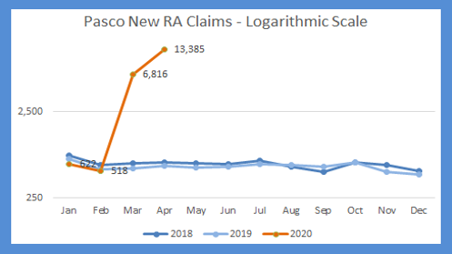

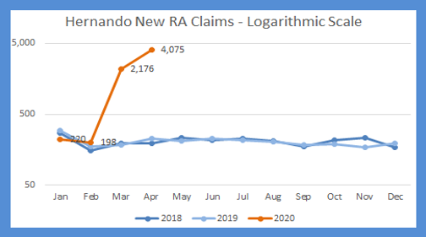

sector strategies

CSPH continues to place a strong emphasis on our targeted sector strategies. Those sectors include Healthcare, Manufacturing and Construction. In-house and pilot programs focus on those sectors. CSPH Youth oversees the Phoenix Rising program with a focus on construction and has been well received by East Pasco County leadership and Habitat For Humanity. The newest program within Pasco County (and funded by Pennies for Pasco) targets Pasco County residents and focuses on training, direct placements and On the Job Training in the targeted occupations and sectors. The following is an example of Program Sector Reports.

TANF Sector Strategy | 18/19 | 19/20
Total Cases | 75 | 8
Total Cases in Health / Manufacturing/Construction | 35 | 5
Tuition Paid | 28 | 2
Gained Employment | 57 | 4
Employed in Health / Manufacturing/Construction | 11 | 4
WIOA Sector Strategy AD/DW | 18/19 | 19/20
Total Cases | 358 | 90
Total Cases in Health / Manufacturing/Construction | 131 | 29
Tuition Paid | 13 | 0
Gained Employment | 157 | 251
Employed in Health / Manufacturing/Construction | 85 | 124

WIOA Sector Strategy Youth | 18/19 | 19/20
Total Cases | 280 | 254
Total Cases in Health / Manufacturing/Construction | 80 | 33
Tuition Paid | 50 | 19
Gained Employment | 91 | 76
Employed in Health / Manufacturing/Construction | 33 | 15

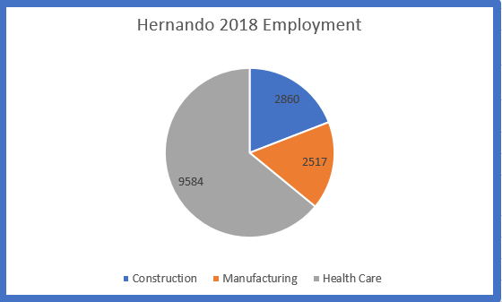

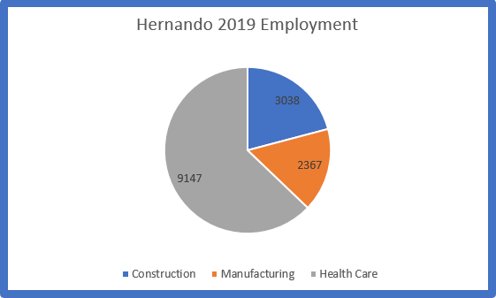

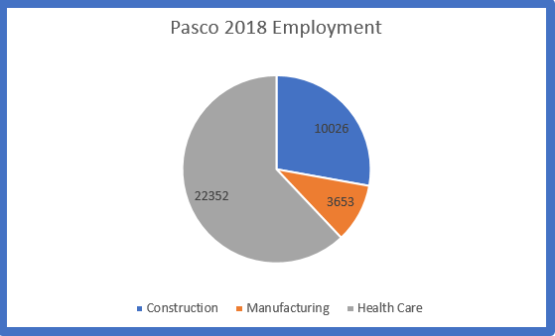

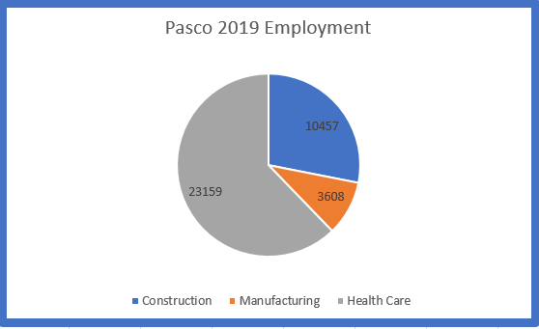

Employer Services

The chart below is representative of those services pulled by Business Services and does not include all program information as that is pulled as a whole and is shown in the performance section.

Top 10 Industry Sectors for Pasco|Hernando

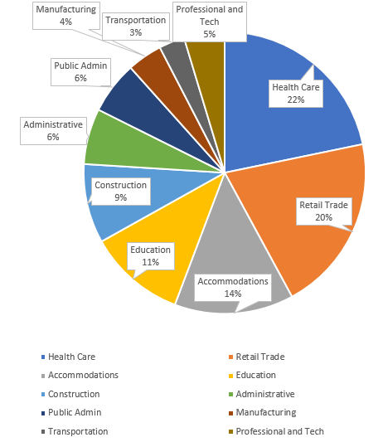

Labor market

FASTEST-GROWING OCCUPATIONS
WORKFORCE DEVELOPMENT AREA 16 - HERNANDO AND PASCO COUNTIES
 |  |  | Employment
Rank | SOC Code | SOC Title | 2019 | 2027 | Growth | Percent Growth | Total Job Openings | 2018 Median Hourly Wage ($)*
1 | 29-1071 | Physician Assistants | 189 | 256 | 67 | 35.4 | 161 | 48.99
2 | 31-2011 | Occupational Therapy Assistants | 84 | 108 | 24 | 28.6 | 118 | 29.22
3 | 29-1171 | Nurse Practitioners | 315 | 402 | 87 | 27.6 | 225 | 45.19
4 | 29-1126 | Respiratory Therapists | 212 | 269 | 57 | 26.9 | 146 | 28.52
5 | 31-2022 | Physical Therapist Aides | 87 | 110 | 23 | 26.4 | 116 | 13.12
6 | 15-2031 | Operations Research Analysts | 141 | 178 | 37 | 26.2 | 111 | 30.57
7 | 31-9092 | Medical Assistants | 1,384 | 1,718 | 334 | 24.1 | 1,641 | 15.36
8 | 31-2021 | Physical Therapist Assistants | 126 | 156 | 30 | 23.8 | 162 | 31.49
9 | 29-2032 | Diagnostic Medical Sonographers | 125 | 154 | 29 | 23.2 | 86 | 33.52
10 | 39-2021 | Nonfarm Animal Caretakers | 194 | 239 | 45 | 23.2 | 303 | 10.80

OCCUPATIONS GAINING THE MOST NEW JOBS
WORKFORCE DEVELOPMENT AREA 16 - HERNANDO AND PASCO COUNTIES
 |  |  | Employment
Rank | SOC Code | SOC Title | 2019 | 2027 | Growth | Percent Growth | Total Job Openings | 2018 Median Hourly Wage ($)*
1 | 35-3021 | Combined Food Preparation and Serving Workers, Including Fast Food | 5,908 | 7,256 | 1,348 | 22.8 | 10,887 | 9.44
2 | 41-2031 | Retail Salespersons | 7,905 | 8,806 | 901 | 11.4 | 10,438 | 11.14
3 | 35-3031 | Waiters and Waitresses | 4,970 | 5,779 | 809 | 16.3 | 8,868 | 9.39
4 | 29-1141 | Registered Nurses | 4,268 | 4,927 | 659 | 15.4 | 2,512 | 31.97
5 | 35-2014 | Cooks, Restaurant | 2,083 | 2,516 | 433 | 20.8 | 2,983 | 12.41
6 | 43-5081 | Stock Clerks and Order Fillers | 3,575 | 3,928 | 353 | 9.9 | 4,130 | 11.74
7 | 37-2011 | Janitors and Cleaners, Except Maids and Housekeeping Cleaners | 2,533 | 2,881 | 348 | 13.7 | 3,120 | 11.80
8 | 31-9092 | Medical Assistants | 1,384 | 1,718 | 334 | 24.1 | 1,641 | 15.36
9 | 37-3011 | Landscaping and Grounds keeping Workers | 2,072 | 2,399 | 327 | 15.8 | 2,439 | 12.68
10 | 41-1011 | First-Line Supervisors of Retail Sales Workers | 3,094 | 3,406 | 312 | 10.1 | 3,022 | 20.65

Veterans

CareerSource Pasco Hernando is dedicated to the delivery of services to veterans. Veterans are identified at the point of entry to each center and are given priority over non-veterans with respect to all Department of Labor funded programs and services.



Veterans 2018-2019 | Totals |  | Veterans 2019-2020 | Totals
Vets Hired | 329 |  | Vets Hired | 162
Vets Attended Work Studies | 0 |  | Vets Attended Work Studies | 10
Vet Staff Employer Visits | 30 |  | Vet Staff Employer Visits | 98
Veteran Job Fairs Held | 0 |  | Veteran Job Fairs Held | 4

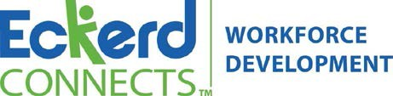

CareerSource Pasco Hernando Youth Program

The CareerSource Pasco Hernando Youth Program is designed to serve at-risk young adults between the ages of 18-24 overcome obstacles and barriers on their way to self-sufficiency.

Currently the youth program serves 165 enrolled participants.
- Since July 1, participants have earned 269 nationally recognized credentials that will assist them in their pursuit of employment.
- Since July 1, 81 participants have gained sustainable employment with an average wage rate of $10.00/hr and 11 have entered into Post-Secondary Education.
- Since July 1, 91 participants have completed the program successfully and transitioned into follow-up services.

Over 6,800 paid work experience hours have been completed by WIOA Youth program participants since July 1st!



Phoenix Rising

Phoenix Rising is an alternative education and construction trade program which seeks to revitalize economically challenged areas in Pasco and Hernando Counties, making a positive difference in the lives of young adults between the ages of 18-24.
Phoenix Rising was originally spearheaded by the Ocala Police Chief Sam Williams and the Ocala Police Department, construction began on the first home in 2011. The program has assisted in the building of 13 Habitat homes in Marion and Citrus counties, with 157 young adults contributing to its success. This success has led to expansion to the Pasco and Hernando County area to launch the first cycle in October 2018.
Through Phoenix Rising, income-eligible participants receive hands-on and classroom training designed to develop workforce skills that lead to employment. A key feature of the program involves construction of Habitat for Humanity homes for deserving families in Pasco and Hernando County. Additionally, participants may earn their high school diploma, as well as industry-recognized certifications while receiving weekly participation payments.

- As of the end of April, all Phoenix participants in need of a diploma (9 out of 10 enrollees) have completed Penn Foster and have earned their High School Diplomas!
- Over 1,000 hours of paid work experience has benefited both participants and our community via this cohort of Phoenix Rising!

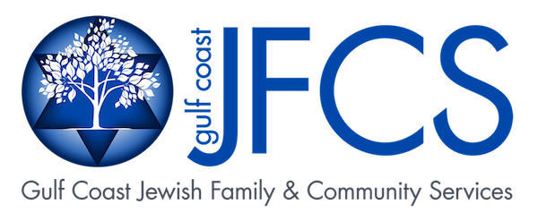

Gulf Coast Jewish Family &Community Services
Non-Custodial Parent Employment Program (NCPEP) assists unemployed or underemployed noncustodial parents in establishing a pattern of regular child support payments by obtaining and maintaining unsubsidized, competitive employment. Below is a snapshot of services provided during our current program year.

NCPEP | PY 18-19 | PY 19-20
Enrollments | 217 | 185
Placements | 103 | 102
Made 3 months of child support payments | 87 | 75
Maintained employment for 90 days | 80 | 68
Maintained employment for 180 days | 55 | 47
Obtained position increase | 19 | 15
Obtained a wage increase | 37 | 26
Received a Skills Training | 58 | 62

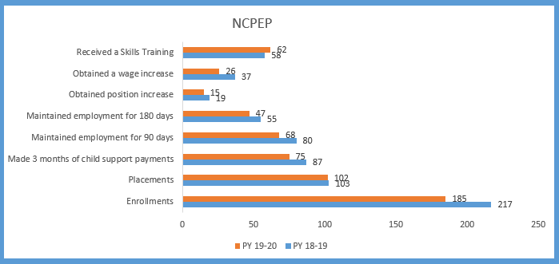

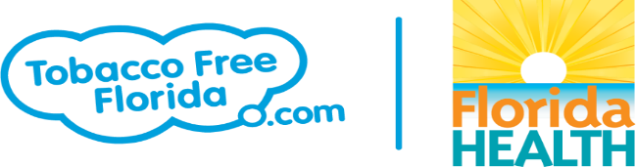

Tobacco Free Florida

CareerSource Pasco Hernando partners with Tobacco Free Florida in assisting individuals locally that wish to quit using all types of tobacco. Tobacco Free Florida provides free services, tools and tips to assist our customers and their loved ones with quitting tobacco use.
CareerSource Pasco Hernando (CSPH) has been awarded the Dr. Rosebud Foster Excellence Award for the most customers referred out of all 24 Regions in the State of Florida 3 years in a row.

Tobacco Free Florida | 18/19 | 19/20
Pasco | 789 | 542
Hernando | 276 | 139
Totals | 1065 | 681

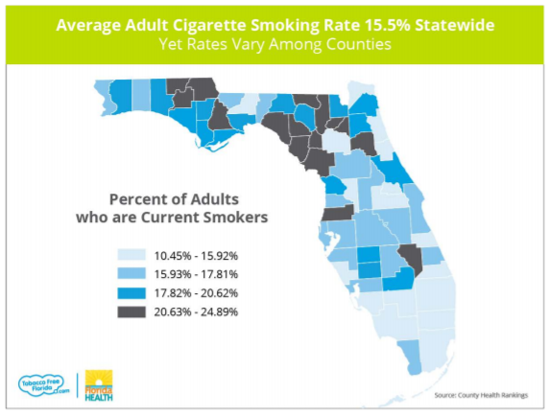

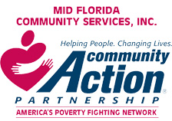

Mid Florida Community Services

These are the numbers reported to our board quarterly. Projected numbers will increase due to increase in funding for COVID-19.

Community Action Plan (Data Source: 1st QTR FOCAS Report)
Services |  | Yearly Planned |  | 1st QTR |  | YTD
Employment |  | 57 |  | 31 |  | 54%
Education |  | 25 |  | 6 |  | 24%
Housing |  | 2200 |  | 1181 |  | 54%
Income & Asset Building |  | 160 |  | 66 |  | 41%
Outcomes Across Multiple Domains |  | 2560 |  | 1969 |  | 77%

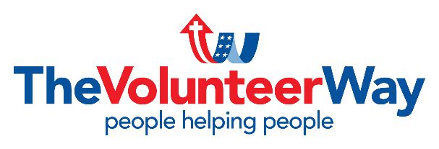

Hope Resource Center/Volunteer Way

The Volunteer Way’s Hope Resource Center provides information and various resources for the Moon Lake community. The Center is an ACCESS site providing assistance with SNAP applications, Medicare/Medicaid, ID verification, job search and other resources. Below you will find a snapshot of the services they have provided this program year.
Services Provided 2019-2020 | Total
# of People Seen/helped | 1800
# of Services Performed | 1952
Volunteer Hours (does not include agencies time) | 5383.5
# of volunteers included in above hours | 94
Access applied or recertified food stamps | 304
Medicaid applied or recertified | 41
CareerSource vet Rep Assisted | 29
Boxes of food | 114
Gov. Assurance Phones: applied or received free phones | 130
Shoes | 58
Mailboxes: checking on, requested a box for collecting their mail | 899
Visitors and information on the Center | 93
Resumes | 13
Job Searches | 58
Notary Services | 7
Use of phone , fax or copies | 106
Blankets | 23
Gave a Ride for medical or court | 7

