Name: __________________
Date: __________________
LOVESPOONS
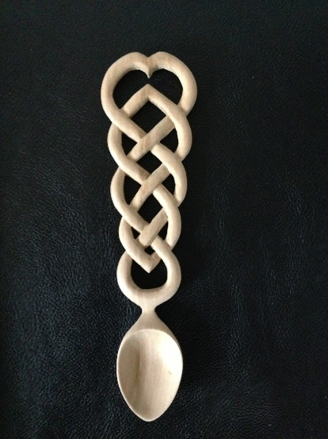
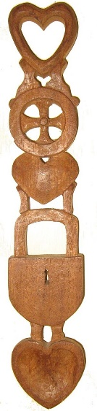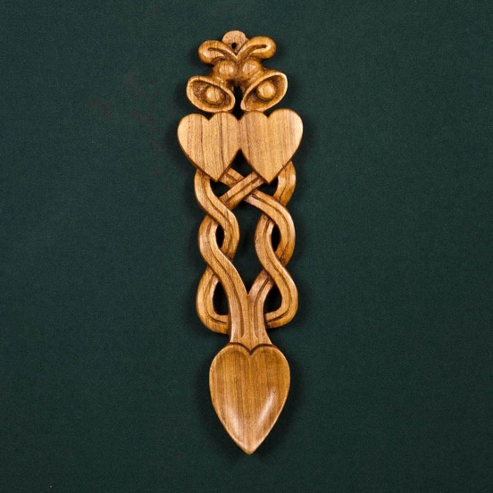
A lovespoon is a decoratively carved wooden spoon that was traditionally given as a gift to someone you love. The spoon was traditionally decorated with symbols of love, and was intended to reflect your woodworking skills.
History
The lovespoon is a traditional Welsh craft that dates back to the seventeenth century. Over generations, decorative carvings were added to the spoon and it lost its original practical use and became a treasured decorative item to be hung on a wall.
The earliest known Welsh lovespoon is from 1667, although the tradition is believed to date back long before that. While the Welsh lovespoons might be the most famous now, lovespoons were popular in other European countires as well.

Symbols
The lovespoon was originally given to a young woman by her boyfriend, to prove to her father that he was a good woodworker and that he could provide for his future wife and their family.
Sailors would often carve lovespoons during their long journeys, which is why anchors would often be incorporated into the carvings.
Certain symbols came to have specific meanings: a horseshoe for luck, a cross for faith, bells for marriage, hearts for love, a wheel supporting a loved one and a lock for security, among others.
Lovespoons today
Today lovespoons are given as wedding and anniversary presents, birthday presents, baby presents, Christmas or Valentine's Day presents.
Your lovespoon is going to be a present for a very important woman in your life. This could be your girlfriend, your mother, grandmother, sister, aunt, or any other relative or friend. Choose symbols that represent either this person or your relationship with this person.
- Who am I making this spoon for? Why?

- Which type of wood am I using? Why?

- Sketch:

- Which symbols did I include in the design? Why?

- The process of making my spoon:
(procedure, tools)

- Did I have any difficulties making my lovespoon? How did I fix my mistakes?

- How do I feel about making my spoon? Am I happy with it? Would I do something similar again?

- Picture of my lovespoon:

