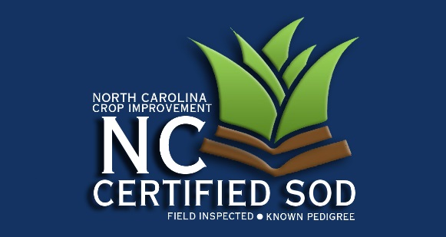
PO Box 33008
Raleigh, NC 27636-3008
Office: 919-515-2851
NC_CIA@ncsu.edu
www.nccrop.com

WARM SEASON FORAGE GRASS

NAME: Certification #:
COMPANY:
ADDRESS: Email:
Telephone: Fax:

Applications for certification are due April 1. Please verify your address (if your address has changed). Check your telephone area code and number and include your fax number and email address if you have one.

Please indicate below the Varieties, class and acreage that you want inspected this year.

Variety | Class | Acreage

If you have are adding new acreage during the past year, please complete the application below.

Variety | Field No. | Previous Crop | Source of Planting Seed |  |  | To Be Inspected
Variety | Field No. | Previous Crop | Producer | Class | Amt. Planted | Class | Acres

To complete the application process, sign, date and return this form to our office.

Signature Date

