Tips for using the new Communication Diary
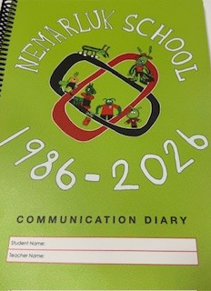
In our new diary there is a home schedule and visuals that can be cut out of the diary to be used at home.
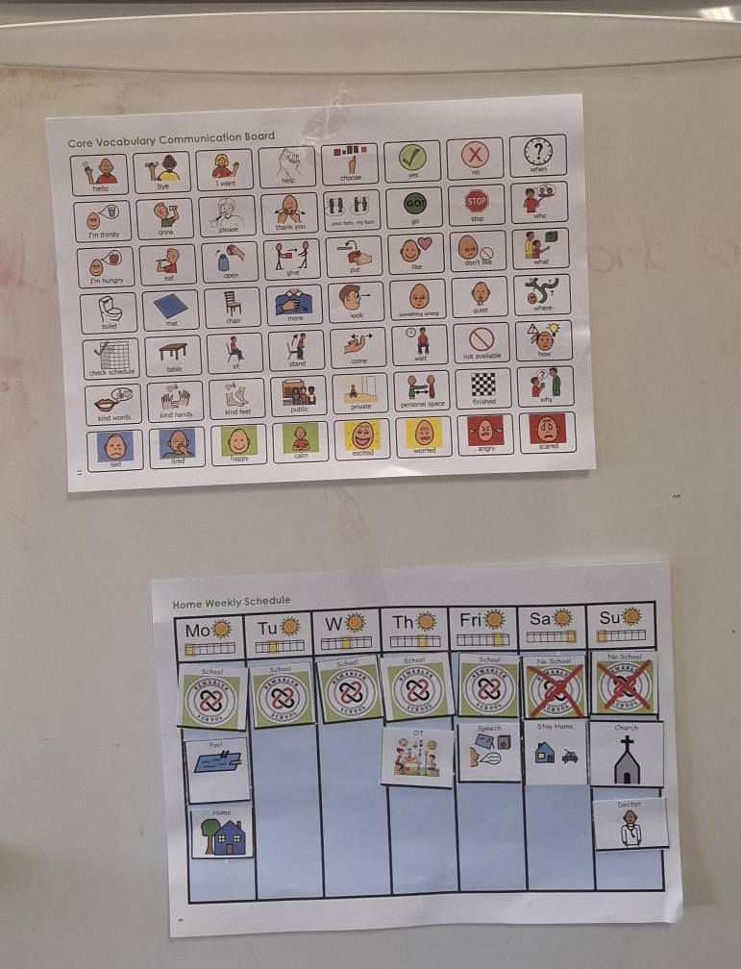
You could have the core communication board and the schedule on the fridge

You can also use the visuals in the community see example below
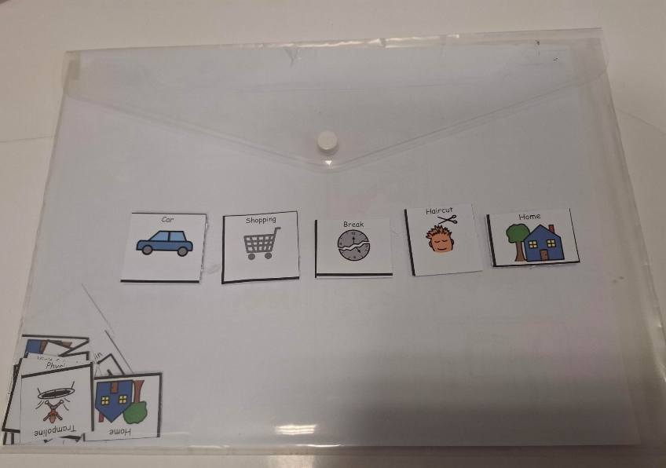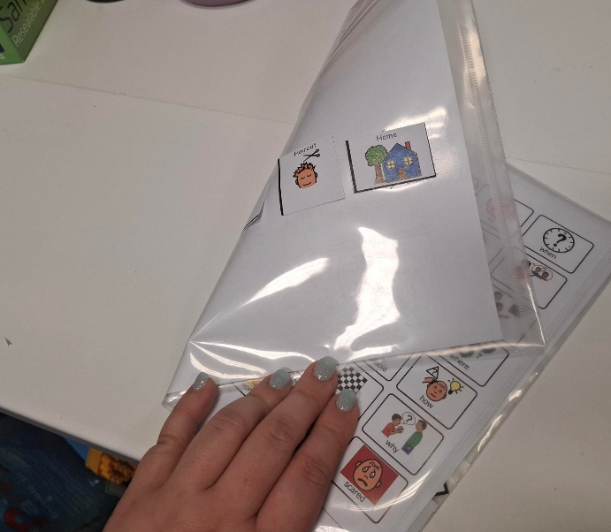

How to complete the diary entry to share information see the below examples that include questions you or the teacher could ask

Parent/ carer diary completed
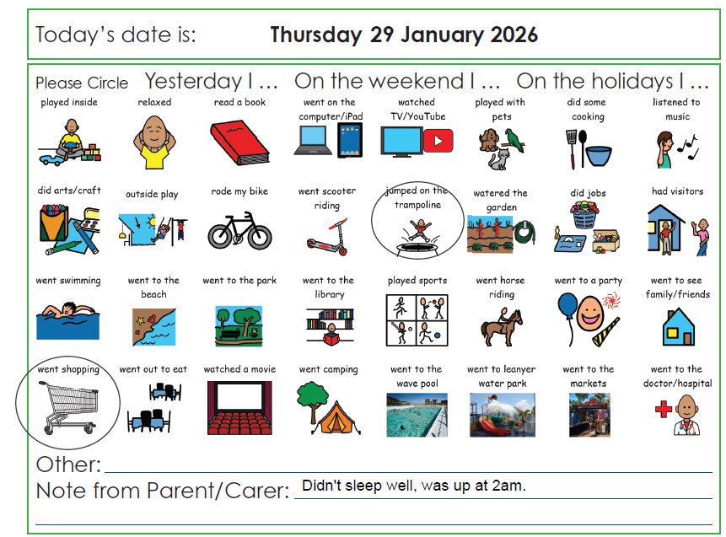

Parents and carers could share information about or ask questions:
- Your child’s sleep- e.g. did they wake up early
- Eating/food- if they don’t like something, if they have tried something new, if they refused to eat breakfast
- What activities they did after school/weekend/holidays (if there is an activity they did but no visual to circle write it into the ‘other’ line above the note from parent
- Ask what did they enjoy at school, were they regulated? what can I do at home to support their communication/toileting/eating etc

Teacher diary completed
