While the monthly park clean ups are on pause until Spring, the Downing Park Committee is actively gathering information and working on different aspects that will support the QR code tour project that will begin in January.

We are meeting with the Boys and Girls Club of Newburgh later this month to see if a partnership is a good fit for spring/summer.

The Downing Park Conservancy invited our committee to their holiday party at the Silk Factory in Newburgh as a thank you for all of our efforts.

Pam Breeman attended the Olmsted Network Annual Conference in Washington, DC with the president and another member of the Downing Park Conservancy. It was a very informative few days. Please see Pams notes below.

The next committee meeting is January 26th @ 1PM.

Respectfully submitted,
Martine Najork & Carolyn Newman
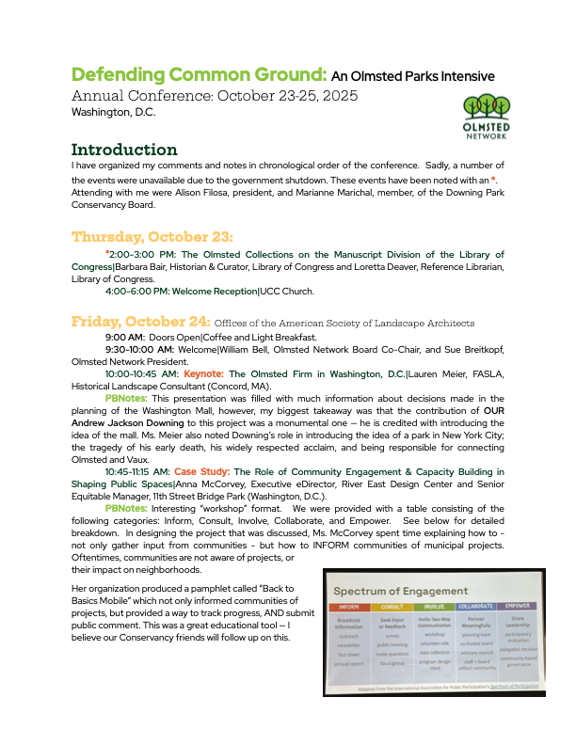
Donning Park Committee Co-Chairs

