Leadership Guide: From Drama to Empowerment, Shifting Mindsets for Self and Team Leadership

Introduction: The Human Side of Conflict
When conflict happens, especially in high pressure, purpose driven environments, it can leave people feeling hurt, dismissed or disconnected. Maybe a conversation went wrong, someone felt unheard or a decision landed without context. In those moments, emotions like frustration, sadness or even abandonment can surface. This is part of being human and it’s also the starting point for stronger leadership and collaboration.
The ability to move through those emotions, rather than avoid them, is what turns conflict into growth. Recognising your feelings doesn’t make you weak, they make you aware of the deeper beliefs and values you hold. And this awareness opens the door to compassion for yourself and others and creates the space to rebuild trust and understanding.
🖼️ Suggested Image: Two colleagues having a calm conversation after a disagreement, showing empathy and reconnection.

The Hidden Cost of Workplace Drama
Conflict itself isn’t the issue it’s how we respond to it that determines whether teams grow stronger or spiral into frustration. In government and other high stakes workplaces, interpersonal tension, reactive communication and hidden drama quietly drain productivity. Studies show that professionals spend an average of 2.5 hours a day managing interpersonal conflict, costing millions of dollars in lost productivity each year for larger organisations.
For individuals, that looks like frustration, fatigue or feeling unheard. For leaders, it can show up as disengaged teams, micromanagement and burnout. Drama limits trust and stifles progress, but awareness of it is the first step toward empowerment.
“Every drama moment is an invitation to step into blame or to step into ownership.”
🖼️ Suggested Image: Team in active discussion, overlay text: “Drama drains energy. Empowerment restores it.”

Focus on What You Can Control
Leadership of yourself or others starts with focus. Stephen Covey’s Circle of Influence model offers a simple but powerful insight:
- Circle of Control: What you can directly influence your thoughts, choices, language and behaviour.
- Circle of Influence: What you can shape indirectly relationships, team culture, collaboration.
- Circle of Concern: What you can’t control policies, politics or others’ reactions.
When we focus on what’s outside our control, frustration builds and energy leaks. When we focus on what we can control, we reclaim power and clarity.
Actionable Reflection: Ask yourself “Am I acting within my circle of control or stuck in my circle of concern?” If it’s the latter, redirect your energy toward what you can actually influence.
🖼️ Suggested Diagram: Three concentric circles Control → Influence → Concern showing growth of empowerment from the centre.
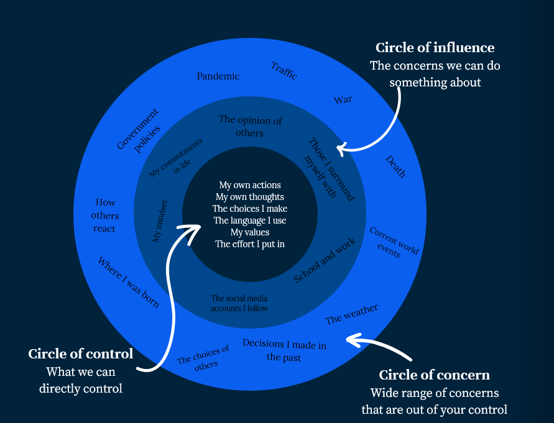

Above and Below the Line: A Leadership Compass
Every person operates either above or below the line a concept from The Conscious Leadership Group that explains how mindset shapes performance.
- Above the Line: Open, accountable, curious, learning focused.
- Below the Line: Blaming, defensive, reactive or avoiding responsibility.
We all fall below the line at times, that’s human. What matters is how quickly we notice and shift.
Action for Self-Leadership: When things go wrong, pause and ask yourself: “Am I above or below the line right now?” This quick check creates space to respond instead of react.
Action for Team Leadership: When your team falls below the line (blame, excuses, finger pointing), call it in not out. Say: “I think we might be slipping below the line here. What would it take to move above it?”

Common Language Shifts
Below the Line | Above the Line
“It’s not my fault.” | “Here’s what I can do differently.”
“They keep changing things on us.” | “How can we adapt effectively?”
“I’ll just fix it myself.” | “What support do you need to take ownership?”
When we slip below the line, we often get caught in a reactive cycle of blame, avoidance or rescuing others what psychologists call the Drama Triangle.
🖼️ Suggested Diagram: A horizontal line with two sides labelled “Below” (Blame, Defend, Avoid) and “Above” (Own, Learn, Empower).
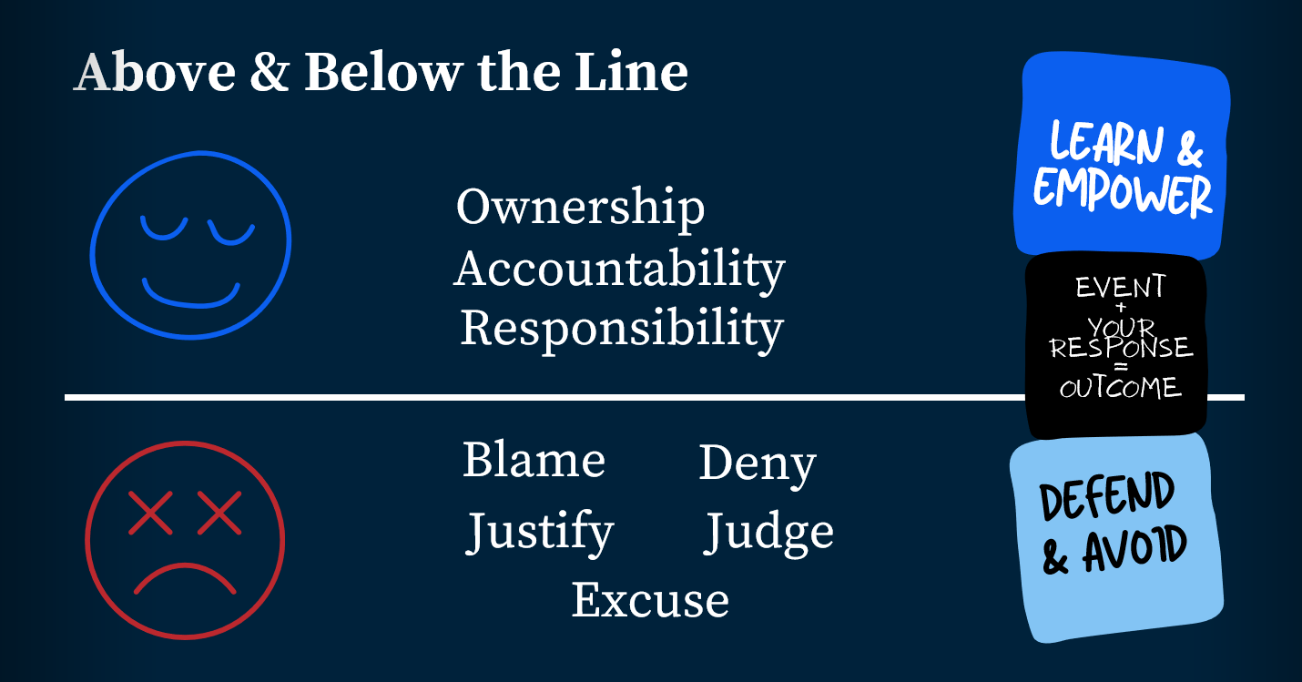

Understanding the Drama Triangle
Dr Stephen Karpman’s Drama Triangle describes three roles that people unconsciously fall into when reacting from fear or ego:
Role | Common Thinking | Impact on Self | Impact on Team
Victim | “This is unfair.” | Feels powerless and stuck. | Others overcompensate or disengage.
Persecutor | “It’s all your fault.” | Feels right but isolated. | Creates fear and defensiveness.
Rescuer | “Let me fix it.” | Feels needed but exhausted. | Creates dependency, limits growth.
We all play these roles at times. They’re not bad just unproductive. The power lies in recognising when we’ve stepped into one and deciding to shift.
Actionable Reflection: Think of a recent conflict. Which role did you play Victim, Persecutor or Rescuer? How did it serve you in the moment and what did it cost you or your team?
Recognising these patterns is powerful, because every drama role has an empowered counterpart a way to lead and respond with accountability and curiosity instead of fear.
🖼️ Suggested Diagram: Classic Drama Triangle showing how roles switch and feed each other (Victim ↔ Rescuer ↔ Persecutor).
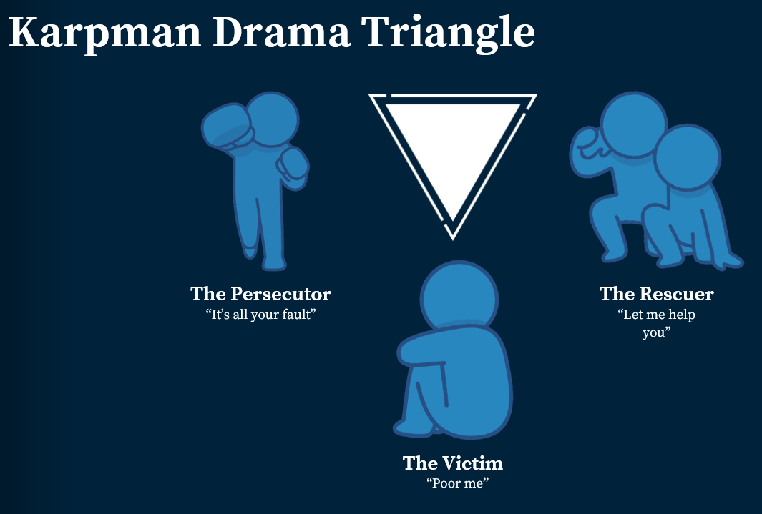

Moving into the Empowerment Triangle
To step out of drama, we can choose empowerment. David Emerald’s Empowerment Dynamic (TED) transforms those same roles into strengths based alternatives:
Drama Role | Empowered Role | Shift in Thinking
Victim -> | Creator | “What outcome do I want?”
Persecutor-> | Challenger | “What can be learned or improved?”
Rescuer-> | Coach | “How can I support others to take ownership?”
- Creators focus on outcomes, not problems.
- Challengers hold high standards with empathy.
- Coaches guide others without taking over.
When we consciously shift into these roles, we stop managing drama and start building empowerment. This transition is what helps individuals and teams move from emotional reactivity to clarity, collaboration and growth.
🖼️ Suggested Diagram: Two triangles side by side Drama vs Empowerment with arrows showing transformation.
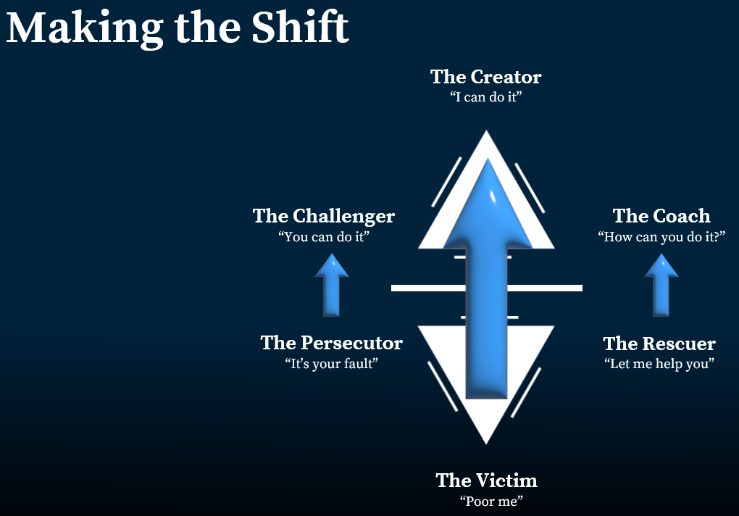

How to Shift Using the AAA Formula
Even with awareness, shifting out of drama takes deliberate effort. The AAA Formula gives us a simple way to move from below the line (reactivity) to above the line (responsivity):
1. Awareness – Ask: “Am I above or below the line right now?”
Notice your emotions, tone and mindset without judgment. Awareness brings unconscious patterns into view.
2. Acceptance – Without blame or guilt, acknowledge where you are. Falling below the line is part of being human. Acceptance builds psychological safety and prevents shame driven reactions.
3. Action – Choose your next step consciously. Ask: “What outcome do I want?” or “What would being above the line look like right now?” Then act accordingly.
When we practice the AAA Formula consistently, we strengthen the neural and cultural habit of empowerment, creating the foundation for practical change and better communication.
🖼️ Suggested Diagram: A circular flow Awareness → Acceptance → Action → Empowerment representing continuous growth.

Building a Culture of Empowerment
Empowerment becomes sustainable when it’s woven into everyday habits. Each moment of awareness, honesty or accountability contributes to a stronger culture.
For Individuals: Use empowerment language (“I can”, “We could”, “Let’s try”).
Take ownership for your contribution. Ask for coaching, not rescuing.
For Leaders: Model vulnerability and admit when you fall below the line.
Replace blame with curiosity. Celebrate accountability and initiative publicly.
When people consistently model this mindset, accountability feels safe and that’s when empowerment becomes the cultural default.
🖼️ Suggested Diagram: Flowchart showing ripple effect Self awareness → Shared Language → Model Ownership → Team Empowerment.

Empowerment in Action
Remember, empowerment isn’t about control it’s about clarity, capability and choice. Every time you pause before reacting, ask a better question or invite others into ownership, you build stronger teams and a more resilient mindset.
Leadership isn’t about hierarchy it’s about choice. Every time you choose to rise above the line, you create space for others to do the same.
Empower yourself. Empower your team. Empower your culture.
🖼️ Suggested Image: Sunrise over a city skyline symbolising perspective and renewal; overlay text: “Empower yourself. Empower your team.”

Let’s Talk About How We Can Support Your Workforce Goals
Whether it’s leadership development, recruitment, or cultural transformation, Kingston Human Capital helps you hire and lead with impact.
Ready to strengthen your leaders and lift performance?
👉 Book one of our training workshops today at www.kingstonhumancapital.com.au/training
📞 (07) 3211 7719
📩 Talent@kingstonhumancapital.com.au
🌐 www.kingstonhumancapital.com.au
Queensland owned. People focused. Results driven.
Approved supplier on the GGS0060 Labour Hire, A3737 HR Services, and GGS0111 Professional Services panels.

Additional information/value add with guidance on real examples and possible situations they’ll face

From Rescuer to Coach: A Case Study
When we apply the AAA Formula and empowerment mindset to real workplace challenges, the transformation becomes visible.
Let’s call our team leader Jane. Jane is a manager in a Queensland Government agency and she cared deeply for her team. When deadlines approached, Jane often redid her teams’ work to protect them from her manager’s often ‘direct’ feedback. Her intentions were kind but over time, she grew resentful and exhausted and her team stopped stepping up.
After learning about the Drama and Empowerment Triangles, Jane recognised how she was stepping into the Rescuer role. She decided to act as a Coach instead. So, instead of fixing, she asked, “How do you think we should tackle this?” and “What support do you need?”
At first, her team resisted, but over time, they grew more capable, accountable and confident. Jane’s workload decreased and her team’s ownership soared.
When we shift from rescuing to coaching, we model empowerment and teams respond with trust and initiative.
🖼️ Suggested Image: Manager facilitating a team workshop with open discussion and shared ownership.

Practical Guide: When Conflict Leaves Someone Stuck
Conflict Coaching Quick Guide – “I Don’t Know What to Do” Moments
When conflict has happened and emotions are high, people can feel abandoned, confused or simply stuck. If a team member says, “I don’t know,” follow this quick guide to move from shutdown to empowerment.
Stage | Leader or Coach Action | Example Language | Purpose
1. Pause and Normalise | Acknowledge emotion and uncertainty. | “That’s okay not knowing is part of the process.” | Builds safety and reduces shame.
2. Validate Feelings | Recognise the human impact. | “It sounds like this has been really hard. It’s normal to feel unsure after conflict.” | Creates connection and trust.
3. Reconnect to Agency | Invite a small, possible next step. | “If you can’t see the big answer right now, what’s one small thing that might make today easier?” | Moves from Victim to Creator mindset.
4. Use Gentle Curiosity | Encourage reflection without pressure. | “What’s feeling hardest about this right now?” / “What do you wish others understood?” | Activates self awareness (Awareness in AAA).
5. Reassure and Regroup | End with empathy and space. | “You don’t have to know today we’ll work through it together.” | Reinforces belonging and emotional safety.
🧠 Tip: If they still say “I don’t know,” use imaginative distance: “If someone else were in your shoes, what might help them take a step forward?”
🖼️ Suggested Diagram: Flowchart illustrating “Stuck → Acknowledge → Reconnect → Empower” with a curved upward arrow from emotional shutdown to engagement.

