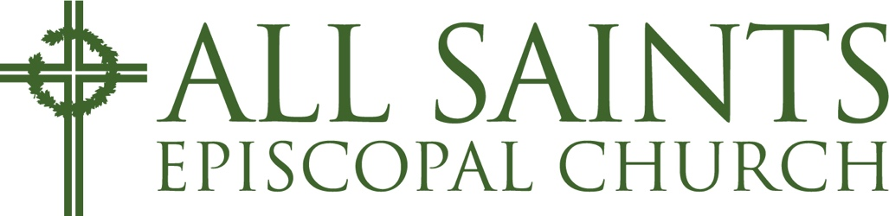

Social Media Community Guidelines
We are glad you are here. Our social media pages are a place to share updates, connect with one another, and engage in respectful conversation.

Purpose of This Page
This space is intended for encouragement, information, and meaningful dialogue within our wider community.

Community Standards
We ask that everyone interacting here do so with respect. To keep this space healthy and welcoming, we do not allow:
- Personal attacks, harassment, or bullying
- Hate speech, discriminatory language, or demeaning remarks toward any person or group
- Profanity or abusive language directed at others
- Spam, repeated posting, or off-topic disruption
Healthy disagreement is welcome when it is expressed respectfully.

Moderation
We reserve the right to remove comments that violate these guidelines and to restrict or block accounts that repeatedly disregard them. Moderation is not about limiting conversation, but about maintaining a space where conversation can happen with dignity and respect.

Thank You
Thank you for helping us keep this a space where people can engage thoughtfully and treat one another with care.

