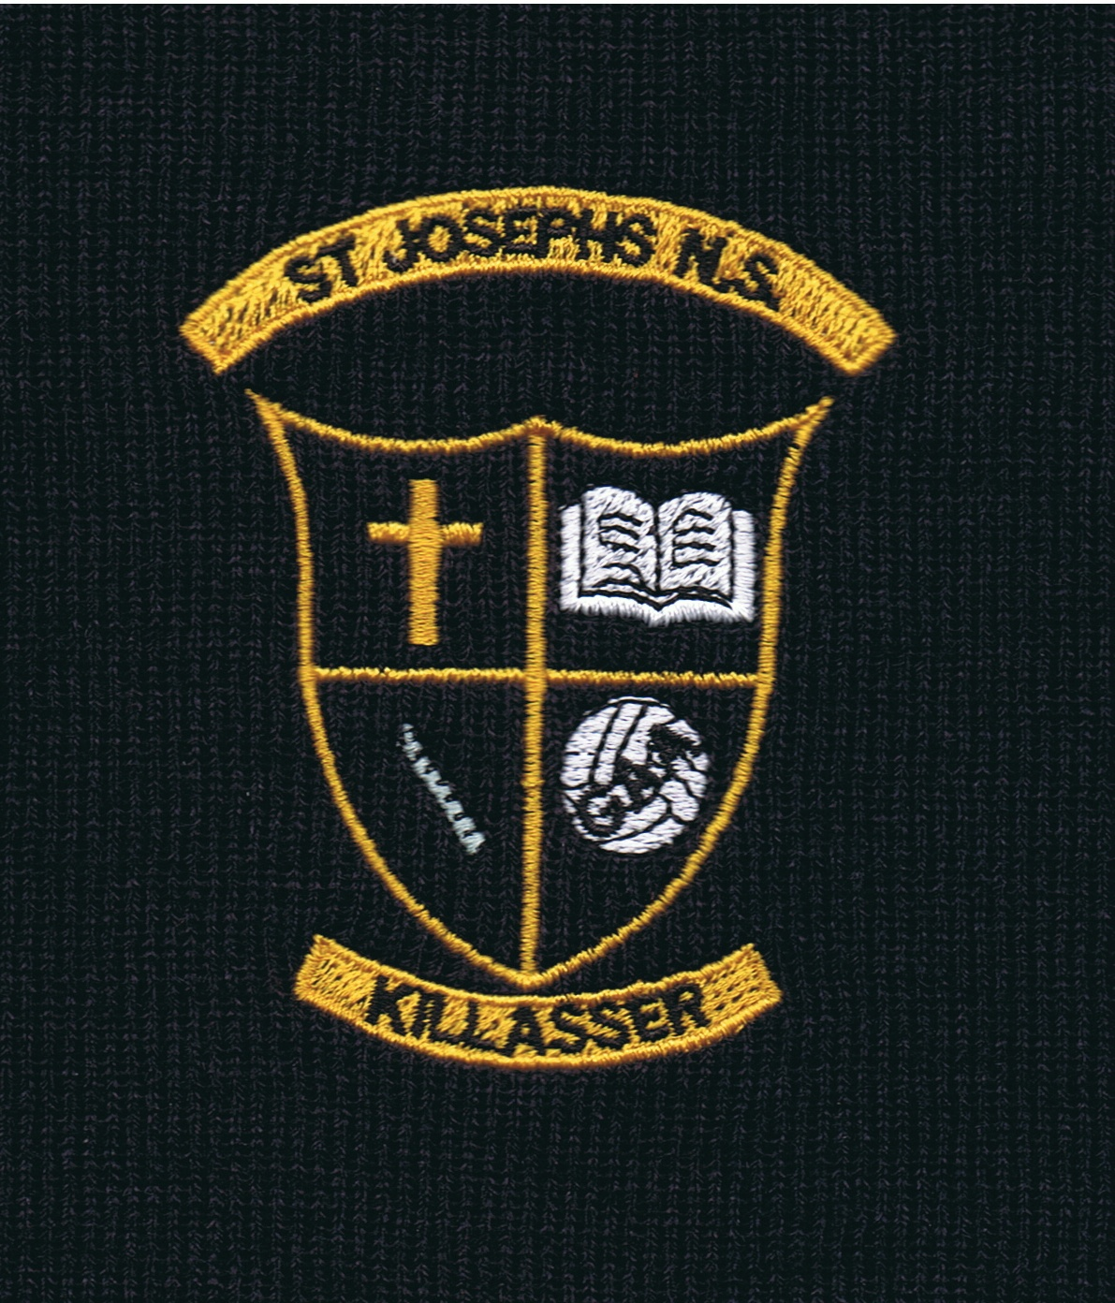

As per the Free Primary School Book scheme the school will provide textbooks and copies for pupils’ next term.
Pupils will be required to supply their own stationery and they will be expected to have sufficient stationery every day. The school will not provide any stationery. Any used items should be replaced promptly. Please note that some of the items listed below may be collected from the children in September & stored in the classroom, for use throughout the school year.

Pupils will require the items below:

- Twistables 12 packet
- Set of markers
- 3 Glue Sticks (preferably not the coloured type)
- Triangular Pencil for Senior Infants
- HB pencil for 1st & 3rd
- Scissors
- Sharpener
- Rubber
- 1 pencil case
- 30 cm ruler (1st & 3rd Class only)
- Tin Whistle (1st & 3rd Class only)
- Highlighters – 3 different colours (3rd only)
- Red pen (3rd only)

Pupils will be provided with folders for their reading and a homework journal in September. Pupils are expected to treat these with care as they remain school property.
Please ensure that children have an appropriately sized school bag that can accommodate A4 sized folders.
Insurance
Pupil Personal Insurance due in September for the next school year, €8 per pupil, (school + leisure activities 24hr)
Contribution
A contribution is payable in September. This is to cover photocopying costs; art & crafts supplies and testing costs. An etransfer link will be emailed for those who require it.
1 pupil = €30
2 pupils = €40
3 pupils = €55

Please note: Shared reading books and library books are part of the book rental scheme and are reused annually. Pupils are asked to take particular care with these books and to return them in good condition. Books returned in poor condition will not be accepted and must be replaced or the cost of the book returned to school.

