Swim Team Issues with Corpus Christi Natatorium Aquatics

Mayor’s Meeting

April 19, 2023
2023

HIGH PERFORMANCE AQUATIC CLUB
Head Coach: Dean ‘Kondo’ Kondziolka

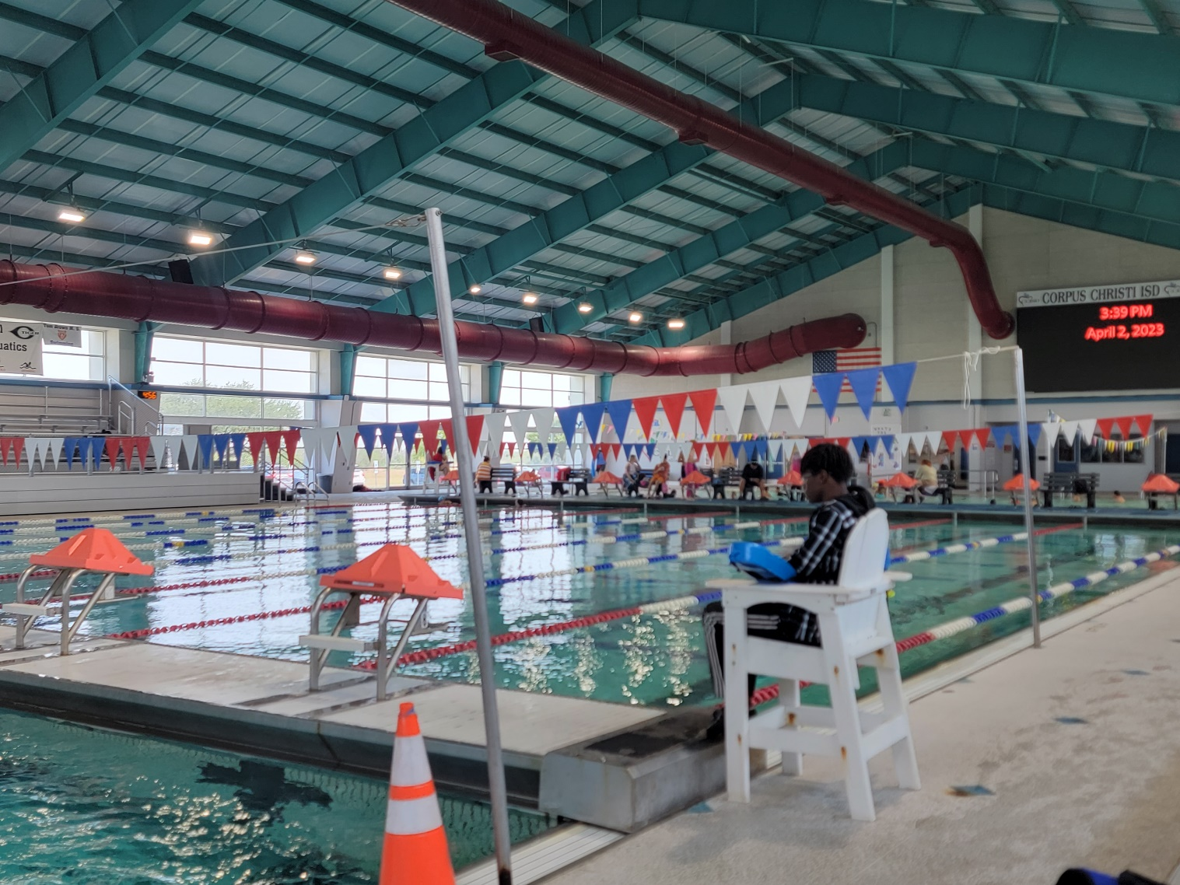

Hosting Competitions

Since the end of covid restrictions I have been in pursuit of running competitions at the natatorium. This is to include local competitions to state encompassing championships.

Main issue:
Pool Rental: $150.00 per hour: no issues
Timing system rental: $500.00 PER DAY
This timing system rental is where I keep running into issues. Since 2020, I have been asking to rent the pool for a half day meet and have the timing system rental fee WAVED since I am not confident it how the system runs with my computers. Competitions and their respected attendance relies heavily on your reputation on how efficient a team can administer the event; it becomes our reputation. I have been to far to many meets where we have all waited up to an hour while the system is being checked to find why something is preventing the meet to start on time. Since this has happened many times, at our own natatorium, with the other team in town hosting, I am very concerned about my first official meet being a disaster because I haven’t had any practice on how the system runs with my computers hooked up to the timing console.

In the past when I have tried to explain this to the various pool managers/supervisors in person, they seem understand what I am saying and then never get back to me. On follow up, they seem to have become completely oblivious to my request and don’t understand what I had asked in person.

I don’t feel that this request is out of line, to establish a future to continue to host competitions here in Corpus. As a result of these frustrations, I have been running very successful meets out of Calallen and recently the Alice natatorium. When asked why do we never do any meets at our own home pool? (The very pool we train out of DAILY and the pool I pay to rent [the natatorium’s primary user])??? My only response after almost 3 years is a shoulder shrug with a few of my own conclusion based on what I have delt with.

Why would the city not want to have money being brought in for usage? Is the lap swimming of 2 or 4 swimmers on a Saturday or Sunday afternoon more important that a competition pool being used for…competition. Why would the city not want to generate visitation form surrounding and out of town families?

All this will generate income to:
Restaurants
Hotels
Tourist stops
Beaches
Aquatics!
Staff income for extra work
Airport Traffic for far teams travelling in

I do not feel that my request is out of line for what could be a major growth to swimming in Corpus. Once I am confident with how the system is set up and runs with my equipment, then I can move forward with hosting meets for USA year round and Summer league level competitions. Alice and Calallen are always very excited to have their facilities being used for its purpose, I would like to think that Corpus would like that as well.


Daily Natatorium Issues

About 4 years ago, a decision was made to put swim teams in the far deep end of the natatorium, leaving the ‘competition’ pool available exclusively for ‘public’. No explanation was given, which is a standard when dealing with head of beaches and aquatics.

The main competition pool has all 8 starting blocks installed (that the public is not even allowed to use). There are wider lane lines (9’ wide) for capacity and safety, and include backstroke flags that cover the entire width of the pool. This is where the general public lap swimmers swim, for free.

The far deep end of the pool is where the swim teams are sent.
- Narrower lanes (6.5 feet wide)
- Only 5 blocks available
- Backstroke flags that cover only 6 lanes of the pool, which has resulted in kids hitting their heads. One resulted in a concussion serious enough for the swimmer to have to go home. When reporting the facility did not even have incident reports. Instead a sticky note was placed on my usage log.

In summary this would be like building a new football stadium and telling the teams to use the back field at a premium rental fee while the main field is reserved for public scrimmage at no charge.
Much like the competition issue above, when I am asked by parents why this is, I have no reasonable answer other than the ones I have been provided. In a meeting in Feb of 2022 with Kevin and Darren (both from city parks and rec), this is what some of the questions and explanations that were provided to me look like:

1)
Q) Why are swim teams restricted to the deep end and not the competition end?
A) this was changed and there have been no complaints (even though my team and my families have had plenty).
2)
Q) Why do the backstroke flags not cover all lanes for the competitive swimmers?
A) we will look into that. (over a year has gone by and nothing has changed)

3)
Q) Why do the ‘public’ get priority when we pay and the public does not? These kids are public too
A) Darren’s response after his hand was raised and rudely put in my face with the statement “DON”T GO THERE! Coaches before you have all asked the same thing”. After this extremely rude and unprofessional act, I was taken a back while thinking [yes, obviously, why wouldn’t a coach want to utilize the main training pool with all available amenities]

4)
Q) My team is growing and this layout is making it hard to continue that growth, is the option to use lanes in the competition pool available if some are not being used?
A) Absolutely not, and if we happen to start getting more lap swimmers, we may have to take lanes away from you

Sometime later, after this meeting that went nowhere (with Kevin and Darren) some of these issues were brought up to Jennifer Flores who had been moved up to pool supervisor. When asked about the request to used lanes in the competition pool again, one of her answers was “that if we have some ‘disabled swimmers’ that need that ladder, they have access.”
To me this makes no sense. Not only are there ladders in the deep end of the pool, if something happens to a swimmer and they need help getting out, the water level is even with the deck. In the competition pool, there is a very high bulkhead that makes getting out, or access to a disabled swimmer extremely difficult.

Last fall, after speaking with newly appointed supervisor Chuck, who came to one of my practices and observed the deck activity and crowding of lanes. He mentioned who this seemed rather dangerous and asked if there have been any incidents. To which as we both looked at the pool 3 kids hit their heads on the wall because there were no backstroke flags covering the width of the pool.

Sadly, in summary, it has become very clear how aquatics views their main primary patrons. That being worthless. For over 40 years I have been a swimmer or coach and never have I seen a facility to where main users were so disrespected and deprioritized, leaving the question what exactly are we paying for? I’m not in any way making this a team vs public issue. I want all swimming to be busy in this area, I just have no idea why there is such resistance and lack of support for swim teams.

If this exact problem was happening, and the sport of swimming was changed to football, what kind of scenario would we have? In my opinion, this meeting would never even be required.

I have provided some random pictures taken on various days and times. As you see, the main competition pool is generally far under utilized; where 8 competition lanes are being reserved for 1 maybe 2 or on a busy night 5 or 6 people, who aren’t even permitted to use the starting blocks, while swim teams are jammed to narrow lanes where 6 to sometimes 12 bodies are trying to train in 1 lane. This takes the safety to a whole new level of dangerous. Being unable to even use starting blocks because there aren’t even enough for each lane when 8 are sitting unused across the pool.

It seems ludicrous that Corpus Christi swimmers are resorting to using a pool for competition that is an hour away because of a few employees that would rather not do their job. The school district does their job hosting high school and other district meets but what has the city done to promote swimming competition locally? I would argue they only try to hinder it, and this is why I feel obligated to present you, the mayor, with this information.
If you feel the way it’s being executed is sufficient, that will ultimately be your decision, but in order for me to be at peace with myself about this issue, I wanted to do everything in my power to make these concerns apparent and known, and know I’ve done everything I could have possibly done.

