Child Support: What You Need to Know

Information Provided by Brian Demidovich
Managing Attorney at The Law Corner
211 East Six Forks Rd, Building C, Suite 106, Raleigh, NC 27609 T (919) 424-8319

Child Support: What You Need To Know
In a nutshell, Child Support refers to either voluntary contractual payments or court-ordered payments, typically made by a noncustodial divorced or separated parent, to support one's minor child or children. However, it is not always as easily agreed upon and determined. Let’s explore some of the intricacies of the child support issue.

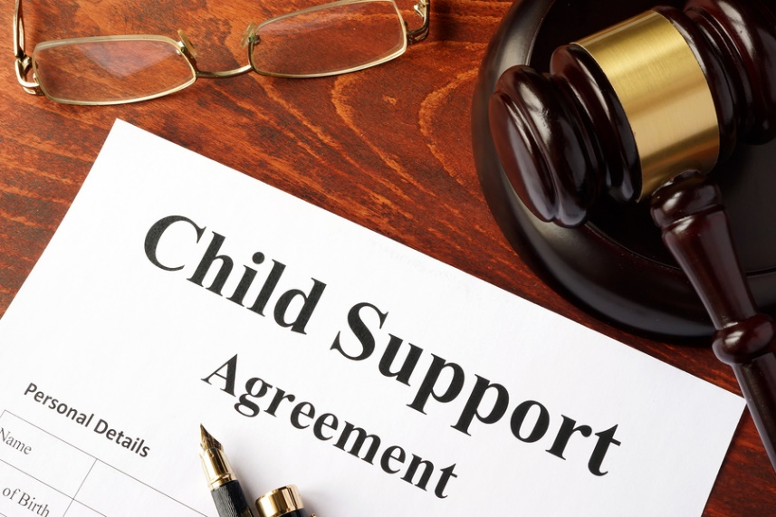
How is Child Support Determined?
In North Carolina, the court uses established Child Support Guidelines to determine the presumptive amount of child support. The guidelines generally are set to meet the reasonable needs of the child for health, education, and maintenance, taking into consideration the custodial schedule of the children, the gross income of the parties, the cost for work related child care costs, the support of other children, other biological children residing with a parent and the cost for the child’s portion of health insurance. The court will always consider extraordinary needs and expenses. Individual bills and living expenses are not typically considered by the court.

Is Court Necessary for Receiving Child Support?
Parents can contract provisions of child support as part of their Separation Agreement. If a parent believes he or she will have trouble receiving regular child support, it may be necessary to ask the Court to order payments. A claim for child support can be filed at any time however, the court will review what was agreed to contractually and compare it to the presumptive amount while considering the reasonable needs of the child(ren). If the amount in the contract is not grossly disproportionate to the court’s determination, the court will uphold the contract amount. The amount of child support is typically reviewed every three years or upon a significant change in circumstances such as loss of employment or a temporary or permanent disability.

In North Carolina, does the noncustodial parent have to pay child support?
Both parents are legally responsible for the support of their minor child. Payment of child support is generally based on the amount of time spent with the child and a percentage of the income of each parent. In effect, the parent who earns more money pays child support to the parent earning less.

What if the North Carolina child support payments are more than one’s ability to pay?
Either parent may request the court to deviate either upward or downward from the presumptive amount. A judge may vary from the child support guidelines. The party ordered to pay child support must show by the greater weight of the evidence that the application of the guidelines would be unjust or inappropriate. Often, the Judges follow the guidelines.

What if a spouse refuses to pay Court ordered child support?

There are several remedies available a judge may use to enforce child support payments. A judge may secure payments by means of a bond, seizure of property, arrest, garnishment of wages, entering a judgment or place a specific lien against real property. In extreme cases, one’s professional license such as to practice law or medicine may be jeopardized.

Can Visitation be Refused if Child Support is Not Paid?

Absolutely Not. The remedies set out above are the only actions available to force child support payments and are separate from a parent’s right to visit a child. Children do not understand the complicated issues that adults create and it is in their best interest to have consistent contact with both parents. Never tell a Judge that you refused visits because he was not paying child support.

How long will child support payments last?
Child support payments last until a child reaches 18 unless the child is still in high school or fails to make satisfactory academic progress towards graduation, or reaches age 20, whichever comes first. In addition, payments will cease if the child becomes emancipated.

Can I appeal Court ordered child support?
Yes, a party may appeal Court ordered child support, however, the party will continue child support payments throughout the appeal process unless the Appellate Court decides otherwise.
The Law Corner



Brian S. Demidovich – Managing Attorney
Brian Demidovich is the Managing Attorney at The Law Corner. Brian formed The Law Corner in 2006 on this basic principle: the legal profession is and always will be a service profession. Consequently, attorneys should value their clients, promptly return their phone calls and emails, meet with them as often as requested and treat them with common decency and respect.

Brian has lived in Raleigh, North Carolina since January 2001 when he started his legal career in corporate contract, merger, and acquisition law. In 2004, Brian became a partner at Russell, Pressley & Demidovich, PC where he focused his practice on matters involving family law and contract litigation. From 2004 through 2010, Brian was a “court house attorney,” spending much of his time inside the courthouse. In 2013, Brian became a DRC Certified Family Financial Mediator and shortly thereafter became trained in the Collaborative Divorce process.

Brian thoroughly enjoys Managing the law firm by overseeing and strategizing with the associate attorneys. While Brian is still very comfortable in the courtroom, he recognizes the benefits of utilizing mediation and the collaborative process. Brian often serves as a mediator where neither party is represented by an attorney during the mediation. Brian says “concluding a mediation in this manner is as satisfying as winning a trial but only takes a fraction of the client’s time and cost”.

For A Confidential Consultation Call 919-424-8319
The Law Corner
211 E. Six Forks Rd.
Building C, Suite 106
Raleigh, NC 27609
Information contained in this E-book is the exclusive property of Brian Demidovich and The Demidovich Law Firm, PLLC and may not be reproduced without written permission.

Legal Disclaimer
The information in this ebook is not legal advice, nor is it intended to be. You should consult an attorney for advice regarding your individual situation.

