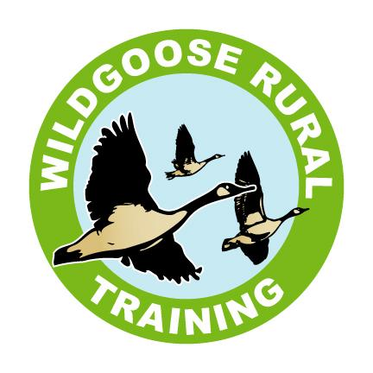

**TERMS AND CONDITIONS**

**Please read the following Terms and Conditions that apply to your placement with Wildgoose Rural Training, then sign and return a copy by 30th September 2025.**

**Financial Terms**

1. Invoices will be issued at the end of each month. Prompt payment is appreciated.
2. Fees apply even in the event of short-term illness, unauthorised holidays, or other non-agreed reasons.
3. The contract for a student placement may be terminated by giving notice to Wildgoose. 4 weeks written notice is required, and fees are payable for the notice period.

**General Terms**

1. Please do not arrive at the centre before **9.00 am** as there may not be staff available to look after you. Students can arrive between 9am – 9.30am and should be collected for 2.30pm.
2. Please notify the Centre in the event of illness/absence on 01905 620840 or email absences@wgrt.org
3. Holidays and other ad hoc absences – Please use our holiday request form to book holidays. If you can give us 4 weeks’ notice, then we will not charge if you are away on holiday. If you do not give us 4 weeks’ notice, we will charge your usual daily fee.
4. Please make staff aware of any medication that you may bring to the Centre either to self-medicate or for staff to administer, please note staff will only administer medication if they have the appropriate training and written authorisation from parents/carers.
5. **Nut free environment. Please do not send students with any nut products as we have some students who are highly allergic to nuts.**
6. Energy drinks - we do not allow the consumption of energy drinks on our site and would ask that students do not bring them.
7. Please do not bring valuable items with you i.e. mobile phones, tablets, laptops or expensive jewellery. If the student decides to bring in expensive items, we cannot take responsibility for the item’s safe keeping. Mobile phones that are brought in can only be used during breaks.
8. Please wear sensible and weather appropriate clothing whilst attending the Centre, including a waterproof coat and a sun hat (depending on the weather). We require all students who work woodwork, horticulture, animal care, conservation and mechanics or more active/outdoor groups to wear steel toe capped boots or work shoes.
9. Please remember to notify us immediately if **any** contact details or home address changes.

**Transport**

1. Please make sure you are ready for collection the bus will wait for no longer than 5 minutes to keep us on time and make sure other students aren’t disadvantaged.
2. The bus leaves Wildgoose at 07:30, please let us know as soon as possible if you don’t require collection on any of the days.

**Additional Terms**

1. If a student has any cold/flu or sickness symptoms (no matter how mild) they should not attend Wildgoose to avoid passing on viruses to their peers.
2. In addition, we are required to hold your National Insurance Number. This is essential for enrolment on any courses available at Wildgoose, but in no way affects any benefits received by individuals.

**Personal Care Plans**

1. We are required by Worcestershire Country Council to hold on file some additional information about each person, this includes a copy of your personal care plan. If you have not already done so, please enclose a copy of it with your signed contract.

**Wildgoose Whistleblowing Policy**

1. At Wildgoose we want your experience to be the best. If you wish to discuss a problem or make a complaint, in the first instance please contact Hollie (Provision Manager) if you feel your issue has not been resolved please contact Jim (Chief Executive). If a resolution cannot be found by Jim, then a member of our Board of Trustees will be available to assist in resolving any issues.

**Important contact details**

Absences – Please call us on 01905 620840 or email absences@wgrt.org to inform us of absences due to sickness, medical appointments or other general reasons.

Holidays – Please complete a holiday form that can be found on our website, or the student can request one from our main office. (See T&C’s)

Jim Hidderley CEO – [jim@wgrt.org](mailto:jim@wgrt.org)

Hollie Burfitt – Provision Manager and Designated Safeguarding Lead - [hollie@wgrt.org](mailto:hollie@wgrt.org)

Jon Wightman – Pastoral Manager - [jon@wgrt.org](mailto:jon@wgrt.org)

Bev Cooper & Vicky Bayliss – Finance controllers - [accounts@wgrt.org](mailto:accounts@wgrt.org)

**We run a “Parents & Carers” WhatsApp group to enable to contact you quickly and collectively. If you would like to be added to this group, please email Ben on** [**ben@wgrt.org**](mailto:ben@wgrt.org)

**PLEASE INFORM YOUR TRANSPORT OF THE FOLLOWING CLOSURE DATES**

**Christmas Break**

Last day for students will be Monday 22nd December 2025

Students return on Monday 5th January 2026

**Bank Holiday Closure Dates**

Friday 3rd April 2026 (Good Friday) **– Closed**

Monday 6th April 2026 (Easter Monday) **- Closed**

Monday 4th May 2026 **- Closed**

Monday 25th May 2026 **– Closed**

Monday 31st August 2026 **– Closed**

**Staff Training Day Closure**

**Wildgoose will be closed to students on this date to allow staff to complete essential training.**

Tuesday 23rd December 2025

Friday 5th June 2026

I agree with the terms and conditions contained in this document and understand all the term dates as stated.

Signed …………………………………………………………………. Student/Carer Date ……………………………

Signed A picture containing object

Description generated with high confidence On behalf of Wildgoose Rural Training Date – 1st September 2025