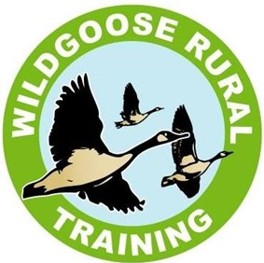
WILDGOOSE RURAL TRAINING Smoke Free Policy
This policy has been developed to protect all employees, service users, customers and visitors from exposure to second hand smoke and to assist compliance with the Health Act 2006. Exposure to second-hand smoke increases the risk of lung cancer, heart disease and other serious illnesses. Ventilation or separating smokers and non-smokers within the same airspace does not completely stop potentially dangerous exposure.

Premises Address:
Wildgoose Rural Training
Old Quarry Drive
Main Road
Hallow
WR2 6LS
Contact Number: 01905 620840
Plan Date: December 2023
Review Date: December 2026
Designated Staff Hollie Burfitt
Jim Hidderley

POLICY
It is the policy of Wildgoose Rural Training that our workplace is smoke free including Vaping, and all employees have a right to work in a smoke free environment. The policy came into effect on Monday 11th January 2006. Smoking is prohibited in or near all enclosed or substantially enclosed premises in the workplace. This includes company vehicles. This policy applies to all employees, service users, contractors and visitors. A smoking shelter is provided for staff and students (of legal age) who are smokers and this is the only place that smoking is permitted at any time and only during normal break times. Staff must set a good example and not smoke in front of school students at any time.
N.B. A smoking shelter has been provided as staff are unable to leave the site during working hours and this is located opposite the main hub.
IMPLEMENTATION
Overall responsibility for policy implementation and review rests with Jim Hidderley. However, all staff are obliged to adhere to and support the implementation of the policy. The person named above shall inform all existing employees, consultants and contractors of the policy and their role in the implementation and monitoring of the policy. They will also give all new personnel a copy of the policy on recruitment/induction. Appropriate ‘no-smoking’ signs will be clearly displayed at the entrances to and within the premises, and in all smoke free vehicles.
NON-COMPLIANCE
Local disciplinary procedures will be followed if a member of staff does not comply with this policy. Those who do not comply with the smoke free law may also be liable to a fixed penalty fine and possible criminal prosecution. Students who fail to follow these guidelines will receive a verbal warning which could be followed by temporary suspension.
HELP TO STOP SMOKING
The NHS offers a range of free services to help smokers give up. Call the NHS Smoking Helpline on 0800 169 0 169 for details. Alternatively, you can text ‘GIVE UP’ and your full postcode to 88088 to find your local NHS Stop Smoking Service.

Signed ................................................................................................. Date .........................................

On behalf of Wildgoose Rural Training

